

COLLEGE OF COMPUTER AND INFORMATION SCIENCE

Academic Year 2025 – 2026

A WEB-BASED GOVERNMENT CONTRACTS INFORMATION SYSTEM WITH AUTHENTICITY VERIFICATION USING

STEGANOGRAPHY-BASED ENCRYPTION TECHNIQUE

Griffin Gil L. De Leon
Charles Kristoffer A. Go

Capstone Adviser: Adomar L. Ilao

Submitted to the Faculty of Mapúa Malayan Colleges Laguna In Partial Fulfillment of the Requirements for the degree of

Bachelor of Science in Information Technology
The capstone project attached here to, entitled “A Web-Based Government Contracts Information System with Authenticity Verification Using Steganography-Based Encryption Technique” prepared and submitted by Griffin L. De Leon, Charles Kristoffer A. Go, in partial fulfillment of the requirements for the degree of Bachelor of Science in Information Technology is hereby accepted.

Leonnel D. De Mesa  Panel Chair  Date Signed |  | Teodoro F. Revano JR., PhD  Panel Member  Date Signed
Adomar L. Ilao, DIT
Adviser

Date Signed
Adomar L. Ilao, DIT
Program Chair, IT

Date Signed
Khristian G. Kikuchi

Dean, College of Computer and Information Science
Date Signed

Copyright

“The author and the adviser authorize consultation and partial reproduction of this capstone project for personal use. Any other reproduction or use is subject to copyright protection. Citation should be clearly mentioning the reference of this work.”

Mapúa Malayan Colleges Laguna, Month 2025

The Adviser:  Adomar L. Ilao, DIT | The Authors:  Griffin Gil L. De Leon  Charles Kristoffer A. Go

Biographical Sketch

CHARLES KRISTOFFER A. GO is a Fourth-year student taking Bachelor of Science in Information Technology Specialized in CyberSecurity at Mapúa Malayan College Laguna. He is a Member of Mapua Malayan College Laguna InfoTech Society. With the Interest of Web development, game development and cybersecurity research, focusing on developing secure and user- friendly systems. While continuously seeking opportunities to enhance his technical skills and apply his knowledge through projects.
GRIFFIN GIL L. DE LEON is a Fourth-year student taking Bachelor of Science in Information Technology Specialized in CyberSecurity at Mapúa Malayan College Laguna . His interest in Computer Literature & Web Development as well as User Interface (UI) and User Experience (UX) design and demonstrates a proactive approach to enhancing his skills and knowledge, He has gained practical experience in designing web and mobile user interfaces through the utilization of diverse software tools and is eager to develop his expertise to other fields.

Table of Contents
Copyright 2
Biographical Sketch 3
List of Tables 9
List of Figures 10
List of Appendices 11
Introduction 1
Background of the Study 7
Statement of the Problem 10
Objective of the Study 13
Specific Objectives 13
Rationale of the Study 15
Scope and Delimitations of the Study 18
Conceptual Framework 21
Definition of Terms 28
- Cryptography and Security Concepts 28
- System and Information Management Concepts 29
- Governance and Legal Framework Concepts 30
Review of Literature 31
Topic Section 31
Government Contracts and Procurement
Government Procurement Contracts: 31
Synthesis 48
Methodology 50
    - Research Design 51
    - Research Locale/Respondents 52
    - Software Methodology 55
    - Seven Phases of the model: 57
      - 3.3.1.1 Planning Phase 57
        - Identification and rationale alignment 57
        - Technical Requirements 58
        - Project Scheduling and Deliverables 59
      - 3.3.1.2 Design Phase 59
        - Algorithm Design 61
      - 3.3.1.3 Development Phase 67
        - Development and coding practices 68
      - 3.3.1.5 Testing Phase 69
        - Cybersecurity testing 70
      - 3.3.1.6 Deployment, Review and Launch Phase 71
    - Implementation 72
    - Cybersecurity Implementation 73
    - Population of the Study/Sampling Design 74
    - Data Gathering Tools and Procedures 76
    - Data Analysis Plan 80
Results and Discussion 88
A. Hardware Requirements 88
A.1 Minimum Hardware Requirements 88
A.2 Software Requirements 89
B. Graphical User Interface 90
B.1 System Architecture 90
B.2 Database Design 92
B.3 User and Role Management 94
B.4 Document Upload and Digital Sealing 97
B.5 Document Management and Version History 98
B.6 Public and Physical Document Verification 100
B.7 Audit Monitoring and Reporting 103
C. Alpha Testing 104
C.1 Unit Testing 105
C.1.1 Authentication and Authorization Testing 105
C.1.2 Document Management Testing 108
C.1.3 Cryptographic Unit Testing 109
C.1.4 Encryption Algorithm Efficiency 111
C.2 Integration Testing 113
C.2.1 Component Integration Testing 113
C.2.2 System Accuracy Testing 115
C.3 Web Browser Compatibility Test 117
C.4 Mobile Compatibility Test 119
C.5 Stress Testing 121
C.5.1 Performance and Stress Testing 122
C.5.2 Reliability and Fault Testing 125
C.6 Information Assurance and Security 127
C.6.1 Pre-Development and Planning 127
C.6.2 Development and Coding Practices 127
C.6.3 Testing and Verification 141
C.6.4 Post-Implementation and Maintenance 145
D. Beta Testing 147
D.1 UAT for Research Locale 1: Barangay Sto. Niño, Biñan City 148
D.2 UAT for Research Locale 2 150
D.3 Summary of UAT Results 151
D.4 UAT Results and the Specific Objectives 152
Conclusion and Recommendations 154
Conclusions Based on Objectives 154
Summary of Findings 156
Overall Results and Discussion 158
Recommendations 159
References 162
Appendices 171

List of Tables

Table 3.1 Population Distribution Per Stratum 74
Table 3.2 Document Test Cases 78
Table 3.3 Interpretation of System Accuracy Testing 83
Table 3.4 Interpretation of the UAT Scale 84
Table 4.1 Minimum Hardware Requirements 88
Table 4.2 Software Requirements 89
Table 4.3 Authentication and Authorization Test Results (Appendix AE) 106
Table 4.4 Document Management Test Results (Appendix AF) 109
Table 4.5 Cryptographic Unit Test Results (Appendix AG) 111
Table 4.6 Encryption Algorithm Efficiency 113
Table 4.7 Integration Test Results (Appendix AH) 115
Table 4.8 System Accuracy Dataset and Classification Results (Appendix AI) 117
Table 4.9 System Accuracy Test Results (Appendix AI) 117
Table 4.10 Browser and Viewport Compatibility Results (Appendix AM) 119
Table 4.11 Mobile Authentication Test Results (Appendix AO) 120
Table 4.12 MOB-05 QR Verification Response Times 122
Table 4.13 Performance and Stress Test Results (Appendix AK) 123
Table 4.14 Sequential Baseline Response Times (Appendix AK) 124
Table 4.15 Reliability and Fault Test Results (Appendix AL) 126
Table 4.16 Authentication Methods and Software 133
Table 4.17 Brute-Force Test Results (Appendix AE) 142
Table 4.18 SQL Injection Test Result (Appendix AJ) 143
Table 4.19 Cross-Site Scripting Test Result (Appendix AJ) 143
Table 4.20 Summary of Cybersecurity Test Results (Appendix AJ) 144
Table 4.21 Proposed Incident Response Plan 146
Table 4.22 Proposed Security Awareness and Training Plan 147
Table 4.23 Proposed Policy Review and Audit Schedule 148
Table 4.24 Summary of Barangay Official UAT Results 150
Table 4.25 Summary of Resident UAT Results 152
Table 4.26 UAT Results Related to the Specific Objectives 153

List of Figures
Figure 1.0 Conceptual Framework of the Study 25
Figure 1.1 Context Diagram of the System 25
Figure 1.2 System Architecture 26
Figure 3.0 Barangay’s Current Workflow 53
Figure 3.1 Agile Methodology Model Diagram 56
Figure 3.2 Document Upload and Three-Layer Encryption Flow 61
Figure 3.3 Document Upload and Encryption Pseudocode 62
Figure 3.4 Document Verification Flow 65
Figure 3.5 Document Verification Pseudocode 66
Figure 3.6 Sampling Formula Used 76
Figure 3.7 Accuracy Formula 81
Figure 3.8 Integrity Formula 83
Figure 3.9 Weighted Mean Formula 84
Figure 3.10 Triangulated Interpretation Diagram 86
Figure 4.1 System Architecture 92
Figure 4.2 Entity Relationship Diagram 94
Figure 4.3 User and Role Management Page 95
Figure 4.4 Staff Account Panel 96
Figure 4.5 Document Upload Page 97
Figure 4.6 Document Management Page 98
Figure 4.7 Document Version History Panel 99
Figure 4.8 Public Verification Result Page 100
Figure 4.9 Physical Verification Live Scanner 102
Figure 4.10 Registered Page Comparison for Physical Verification 103
Figure 4.11 Audit Monitoring Dashboard 104
Figure 4.12 Authentication Test Case Pass Rate 108
Figure 4.13 Mobile Verification Request Success Rate 122
Figure 4.14 Upload Validation for Non-PDF Files 129
Figure 4.15 Staff Login with Remaining-Attempt Warning 130
Figure 4.16 Account Lockout After Failed Login Attempts 131
Figure 4.17 Six-Digit Verification Code During Staff Registration 132
Figure 4.18 Password Recovery Request 132
Figure 4.19 Permissions Assigned to the SealGuard Staff Group 134
Figure 4.20 Staff Account Refused by the Administration Site 135
Figure 4.21 Stored Password Shown as a Masked PBKDF2-SHA256 Hash 136
Figure 4.22 Audit Dashboard Filtered to Sign-In, Failed Sign-In, and Lockout Events 137
Figure 4.23 Verification Log for an Authentic Copy 138
Figure 4.24 Verification Log for an Edited Copy 138
Figure 4.25 Protected Document Viewer 139
Figure 4.26 Signed-Out Request for a Protected Document Redirected to Sign-In 139

List of Appendices

Appendix A. Data Flow Diagram 172
Appendix B. System Architecture Diagram 172
Appendix C. Entity Relationship Diagram 173
Appendix D. Use Case Diagram 174
Appendix E. Sprints Deliverables 175
Appendix F. Interview Questions: 175
Appendix G. Interview Questions SIGNED 178
Appendix H. UAT Questions 179
Appendix I. Letter of Request of Interview 180
Appendix J. Interview Letter Signed 181
Appendix K. INTERVIEW TRANSCRIPT 182
Appendix L. INTERVIEW TRANSCRIPT SIGNED: 186
Appendix M. PROOF OF INTERVIEW 187
Appendix N. Location of Barangay 188
Appendix O. Organizational Chart 189
Appendix P. Annual Procurement Plan (Barangay Sto. Niño, 2025) 190
Appendix Q. Disbursement Records 191

Appendix R. Republic Act No. 9184 – Government Procurement Reform Act (Sections: 3,4,8,10, 12, 35) 192
Appendix X: Risk Assessment Matrix 196
Appendix Y. Current System Workflow Signed 197
Appendix Z. Gantt Chart 198
Appendix AA. Data Flow Chart 199
Appendix AB. Interview Guide With Answers 200
Appendix AC. Interview Guide Signed 203
Appendix AD. Filing Cabinet that contains Important Documents 204
Appendix AE. Authentication and Authorization Testing 206
Appendix AF. Document Management Testing 207
Appendix AG. Cryptographic Unit Testing 209
Appendix AH. Integration Testing 211
Appendix AI. System Accuracy and Tamper Detection 213
Appendix AJ. Cybersecurity and Penetration Testing 218
Appendix AK. Performance and Stress Testing 220
Appendix AL. Reliability and Fault Testing 223
Appendix AM. Browser and Viewport Compatibility Testing 224
Appendix AN. Certificate of Quality Assurance and File Integrity 226
Appendix AO. Mobile Authentication Testing 229

Introduction

In the digital age, the protection and authenticity of government documents have become critical concerns, particularly in procurement transactions where public funds are involved. Government procurement processes generate legally binding documents that must remain accurate, untampered, and verifiable. While procurement documents may undergo authorized revisions during drafting or formal amendment procedures, any unauthorized modification or post-approval alteration of finalized contracts undermines transparency, legal validity, and public trust. For instance, recent research on LGUs in the Philippines shows that weak records management and data security practices expose documents to manipulation (Tabia, 2025). Philippine jurisprudence also emphasizes that falsification of public documents by officials is a serious criminal offense that undermines institutional trust and accountability (Respicio, 2024; Res Picio, 2025). Studies further highlight gaps in LGU internal controls and governance systems that create opportunities for such wrongdoing (Juco, 2024). These findings indicate that relying solely on encryption may be insufficient document integrity and authenticity must also be proactively safeguarded, particularly in LGU settings.
Public procurement in the Philippines is governed by Republic Act No. 9184, also known as the Government Procurement Reform Act of 2003. This law establishes a standardized system designed to promote transparency, competitiveness, efficiency, and accountability in the acquisition of goods, infrastructure, and consulting services. Under RA 9184, government entities are required to follow a structured procurement cycle that includes procurement planning, preparation of the Approved Budget for the Contract (ABC), public posting of invitations to bid, submission and evaluation of bid proposals, issuance of a Notice of Award, contract signing, implementation, inspection, and final payment. Each stage mandates the creation and retention of official records to ensure auditability and legal compliance. Oversight and post-audit functions are performed by the Commission on Audit, which may impose administrative sanctions for violations, including suspension, disqualification from bidding, and forfeiture of securities.
Because RA 9184 requires documentation at every stage of the procurement process, even small-scale local government units generate substantial volumes of records. Typical procurement documentation includes the Purchase Request, Approved Budget for the Contract (ABC), Request for Quotation or Invitation to Bid, Bid Proposals, Abstract of Bids, Technical Specifications, Notice of Award, Contract Agreement, Performance Security, Inspection and Acceptance Report, Disbursement Voucher, and supporting financial and delivery records. These documents collectively form the official procurement file and serve as the legal basis for disbursement and audit review. Public procurement is essential to government operations because it enables the acquisition of goods, infrastructure, and services necessary for delivering public programs and community development initiatives. At the barangay level, procurement facilitates the purchase of office supplies, equipment, repair works, and community project implementation. Without a functioning procurement system, basic administrative and development activities cannot proceed. Therefore, ensuring the integrity and authenticity of procurement documents is not merely a legal requirement but a fundamental component of effective local governance.
In the case of Barangay Sto. Niño, interviews with barangay officials reveal that procurement transactions occur approximately one to two times per month, totaling an estimated ten to thirteen procurement contracts annually. Each procurement contract averages sixty to seventy pages in length and is reproduced in multiple physical copies for distribution among the barangay, suppliers, contractors, and other participating parties. All procurement documents are stored in physical filing cabinets, and retrieval occurs whenever prospective bidders, suppliers, contractors, or auditors request access for verification purposes. While this manual system complies with documentation requirements under RA 9184, it relies heavily on physical storage and visual inspection for authenticity verification.
The reliance on manual verification presents a potential vulnerability. Given the length of procurement contracts and the existence of multiple distributed copies, subtle alterations such as modification of financial figures, insertion of additional terms, or unauthorized edits to contractual clauses, may be difficult to detect without systematic integrity verification. Because of this effective records management is critical in procurement processes because each stage of the procurement cycle generates legally binding documentation that serves as the basis for financial disbursement and audit review. Proper organization, secure storage, version control, and controlled access to these records are essential to prevent discrepancies and ensure accountability. Weak document management systems increase the risk of lost records, undetected alterations, and audit findings, thereby undermining transparency and public trust. Although legal sanctions exist for falsification of public documents, detection mechanisms at the barangay level remain largely reactive rather than preventive. while digital editing tools make modification of PDF-based procurement documents increasingly accessible, current verification practices in the barangay setting do not incorporate tamper detection mechanisms.
To address this gap, this study proposes a web-based document authentication system that integrates encryption and Least Significant Bit (LSB) steganography for PDF-based government procurement documents. The system embeds encrypted verification data within a digital seal image attached to procurement documents, enabling detection of unauthorized modifications without altering the document’s visual appearance. By combining cryptographic hashing, encryption, and steganographic embedding, the proposed framework enhances document integrity verification while aligning with the transparency and accountability principles mandated under RA 9184. The system is designed to support secure digital transformation in local government procurement processes while preserving compliance with existing legal and regulatory requirements.
Research studies demonstrate that Least Significant Bit (LSB) steganography functions as an efficient method to embed data within digital files without modifying their visual appearance. The combination of LSB with encryption technology protects hidden data by both concealing it and providing encryption protection (Al-Shammari & Jassim, 2024). The availability of editing tools has made digital document forgery more accessible to users. The editing tools available today enable users to make subtle yet significant changes to PDF contracts and signatures and metadata which become difficult to detect through basic visual checks (Sharma & Singh, 2020). The current verification methods fail to detect these modifications so additional protection measures become essential.
Least Significant Bit (LSB) is categorized as a steganographic technique rather than a cryptographic algorithm. While cryptography (e.g., AES) transforms readable data into ciphertext to ensure confidentiality, steganography conceals the very existence of hidden data within a carrier file. In this study, AES is used to encrypt verification data, while LSB steganography is used to embed the encrypted data within the PDF’s digital seal image. This layered approach ensures both confidentiality and concealment.
The research fulfills Sustainable Development Goal (SDG) 16 by supporting transparent governance systems with accountable institutions that serve all citizens. The research supports
SDG 9 through its development of technological solutions which enhance digital infrastructure and improve document management systems in local government organizations. The research supports SDG 11 through its work on sustainable cities and communities because proper documentation of public procurement activities enables local projects to deliver their intended community benefits.
The research provides essential value to local governance digital transformation through its development of an advanced secure document management system with verification capabilities. The project implements steganography with encryption and web accessibility to defend government documents from tampering and unauthorized changes while supporting the development of trustworthy public institutions.
In Barangay Sto. Niño, procurement contracts are prepared manually by designated barangay personnel following the issuance of a Notice of Award. The contract document is typically drafted using standard word processing software, incorporating the terms specified in the bidding documents, approved budget allocation, scope of work, payment schedule, and compliance clauses mandated under RA 9184.
Once finalized, the contract undergoes review and approval by the Barangay Captain and authorized signatories. After signing, multiple physical copies are printed and distributed to the barangay office and the winning contractor. In some instances, a digital copy in Portable Document Format (PDF) is generated for archival or reproduction purposes. However, no cryptographic signature, hash verification, or embedded authentication mechanism is applied during document generation.

The documents subject to this study are the finalized PDF versions of the barangay’s procurement documents, from the Purchase Request to the signed Contract Agreement. The Contract Agreement contains the complete contractual terms, financial allocations, and official signatures, and together with its supporting procurement records it serves as the primary legal basis for disbursement and audit review. Under the current workflow, authenticity verification relies solely on visual inspection and manual comparison of printed copies.
The proposed system intervenes after a procurement document is finalized and generated as a PDF. Prior to storage or distribution, the system embeds encrypted verification data within the document’s digital seal image using steganographic techniques. This ensures that any subsequent modification to the PDF file can be detected through integrity verification procedures.
While digital storage improves document preservation, verification of document authenticity remains dependent on access to the office computer where files are stored. During audits, contractor requests, or external verification, barangay officials must manually retrieve files to confirm legitimacy. This process becomes inefficient when verification is needed outside the barangay office.
With the increasing availability of smartphones and basic mobile literacy among barangay personnel, a mobile-based authentication tool can provide on-site verification of procurement documents. Integrating a mobile scanning application with steganographic extraction and cryptographic validation mechanisms enables real-time document authentication without requiring direct access to the office computer.

Background of the Study

Government agencies at the national and local levels maintain official records such as procurement documents, contracts, financial reports, resolutions, and administrative certifications. These documents serve as the legal and operational basis for public spending and project implementation, ensuring transparency, accountability, and proper utilization of public funds. However, challenges in document management and verification continue to affect public institutions. According to Romero (2018), citizens often encounter delays, incomplete disclosures, and limited access when attempting to obtain procurement-related records, weakening public oversight and institutional trust.
Public procurement in the Philippines is governed by Republic Act No. 9184, also known as the Government Procurement Reform Act of 2003. RA 9184 establishes a structured procurement framework based on transparency, competitiveness, efficiency, and accountability. It prescribes a formal process that includes procurement planning, preparation of the Approved Budget for the Contract (ABC), public posting of invitations to bid, submission and evaluation of bid proposals, contract awarding, implementation, and post-procurement monitoring. Each stage generates official documents that must be preserved for audit and compliance purposes. The Commission on Audit (COA) conducts audits to ensure adherence to procurement regulations and financial accountability.
Despite this legal framework, implementation challenges persist across Local Government Units (LGUs). Querijero Roque and Santos (2024) identify unclear procurement policies, limited institutional capacity, and continued reliance on manual systems as contributing factors to delays and documentation irregularities. Santos and Gatchalian (2023) further emphasize that many barangays experience weak digital archiving systems, unsecured storage practices, and inconsistent document handling protocols. Similarly, Dela Cruz (2024) notes that barangays, as the smallest administrative units, often depend heavily on printed and scanned documents for procurement and financial transactions due to limited digital infrastructure. The World Bank (2023) also observes that LGUs in developing regions frequently operate with fragmented or outdated information systems, increasing the vulnerability of official records.
The growing availability of digital editing tools has intensified risks related to document manipulation. Sharma and Singh (2020) highlight that modern PDF-editing software allows subtle yet high-impact modifications to financial figures, signatures, timestamps, and metadata without obvious visual traces. Tabia (2025) stresses that weak digital record-keeping practices in LGUs expose financial documents to a high risk of undetected manipulation, leading to discrepancies between declared and actual expenditures. Juco (2024) similarly points out that unreliable documentation undermines transparency in local project monitoring when alterations go unverified due to manual comparison techniques. These findings suggest that traditional visual inspection and physical signature validation may be insufficient to ensure document integrity in increasingly digital environments.
Various mechanisms exist to secure digital documents, including digital signatures, watermarking, Public Key Infrastructure (PKI), and forensic authentication techniques. While effective, these approaches may require specialized infrastructure, technical expertise, or formal digital certificate systems that are not fully implemented at the barangay level. Kozachok et al. (2022) and the EncCoD Project (2020) further explain that encryption alone, although essential for confidentiality, does not conceal the presence of sensitive data and may still attract targeted interception or cryptanalysis. These limitations highlight the need for additional layers of protection that enhance integrity verification without imposing complex infrastructure requirements.
In the case of Barangay Sto. Niño, procurement and contract documents are prepared and finalized following RA 9184 procedures. Records are stored physically in filing cabinets and verified through manual comparison of printed copies and signatures. While this system satisfies procedural requirements, it lacks tamper-proof digital authentication mechanisms. When these documents are reproduced or archived in PDF format, no cryptographic signature, hashing function, or automated integrity verification tool is applied. This creates potential exposure to unauthorized alterations, version inconsistencies, or falsified reproductions, particularly when documents circulate beyond the barangay office.
An interview in Barangay Sto. Niño also revealed that the barangay produces approximately 10–13 procurement-related contracts annually. These contracts are drafted in Microsoft Word using standardized templates and are finalized upon signature of the Barangay Captain and supplier. Digital copies are stored in a single office computer, while physical copies are archived separately. The barangay currently has no version control system or digital verification mechanism to detect post-approval alterations. Confusion over multiple revisions and difficulty detecting alterations in multi-page contracts were identified as recurring operational challenges.
Based on interviews conducted with the Barangay Captain and Secretary, digital copies of contracts are stored solely on the office computer, with no remote verification mechanism available. When contractors or auditors request validation of a contract’s authenticity, verification requires manual retrieval and cross-checking of stored files. This limitation highlights the need for a portable verification system that can authenticate procurement documents outside the primary storage location.
Given these operational realities, integrating encryption with Least Significant Bit (LSB) steganography presents a practical enhancement to document security at the barangay level. Steganography provides a concealment-based layer of protection by embedding encrypted verification data within ordinary digital files (Patil & Jain, 2020). Least Significant Bit (LSB) steganography remains one of the most lightweight and practical techniques for this purpose, as it modifies the least significant bits of digital data without visibly affecting the document’s form or usability (Sahu & Swain, 2021; Kaur et al., 2022). By embedding encrypted authentication information within finalized PDF procurement documents, the proposed approach strengthens document integrity verification while remaining aligned with existing procurement procedures under RA 9184.

Statement of the Problem
The Government Procurement Reform Act of 2002 through Republic Act No. 9184 requires that public procurement must be transparent, competitive, and accountable. Section 8 of RA 9184 explicitly mandates that “information and communications technology shall be utilized in the conduct of procurement procedures” to promote transparency and efficiency. Despite this mandate, many barangays continue to rely on manual and semi-digital systems in handling procurement documents.
Based on the interview conducted with the Barangay Captain of Barangay Sto. Niño, procurement documents such as Purchase Requests, Requests for Quotation, Abstract of Canvass, Purchase Orders, and Contract Agreements are primarily prepared using printed templates, signed physically, and stored in filing cabinets. Digital copies, when available, are saved in standalone computers or shared folders without structured verification mechanisms. Authenticity checking is performed manually through physical signature comparison, which is time-consuming and highly dependent on human judgment. This approach increases the risk of undetected alterations and loss of records, especially in cases of file duplication or physical damage.
Supporting this concern, the Commission on Audit (COA) Annual Audit Reports (2023) documented several barangays where procurement documents lacked proper authorization signatures, contained inconsistencies between approved and actual purchased items, and in some cases showed signs of altered entries submitted to justify expenses. These findings demonstrate how the absence of secure verification mechanisms creates opportunities for document tampering and falsification.
Furthermore, a study published in the International Journal of Research and Creative Media Studies (IJRCMS, 2024) emphasized that although the legal framework encourages ICT adoption in procurement, “significant gaps remain in actual implementation,” particularly in cybersecurity integration and data-protection protocols. These gaps leave digital documents as vulnerable as paper-based records.

1. Lack of Secure and Centralized Digital Verification System in detecting unauthorized modification or verifying document authenticity.
Despite the ICT mandate under Section 8 of RA 9184, many barangays including Barangay Sto. Niño do not operate a unified digital verification platform capable of detecting unauthorized modifications to procurement documents. Verification is conducted manually, relying on visual inspection and signature comparison, which does not guarantee document integrity once copies are reproduced or distributed. The COA (2023) reports of altered procurement records further illustrate the consequences of lacking a centralized authentication mechanism. Without a secure and structured verification system, document authenticity cannot be reliably validated.

2. Limited Access and Transparency for Public Oversight due to Inefficient Utilization of ICT in Procurement Processes.
RA 9184 promotes transparency and public participation through electronic posting and monitoring of procurement activities. However, inefficient utilization of ICT tools limits public accessibility. As observed in Barangay Sto. Niño, procurement documents are not available through a structured online platform that allows residents to independently verify authenticity. This situation aligns with findings from IJRCMS (2024), which noted that weak implementation of digital procurement systems reduces transparency and weakens independent monitoring. When citizens cannot easily access or verify official procurement documents, oversight mechanisms remain dependent on internal administrative processes.

3. Absence of Advanced Security Mechanisms for Digital Documents
Even when procurement documents are digitized, advanced security protections such as encryption, integrity fingerprinting, and embedded authentication markers are not commonly implemented. RA 9184 mandates ICT utilization but does not specify the technological safeguards required to prevent document falsification. IJRCMS (2024) highlighted that weak cybersecurity integration and insufficient data-protection protocols make electronic procurement documents susceptible to unauthorized alteration. Without encryption and tamper-detection mechanisms, digital procurement documents may appear visually legitimate despite having been modified, undermining public confidence and institutional accountability.

Objective of the Study
The objective of this study is to design, develop, and implement a web-based application that enhances the security of barangay procurement documents in PDF form through the integration of encryption and Least Significant Bit (LSB), providing multi-layer protection for sensitive information. Specifically, the system aims to address key security concerns and achieve the following Objectives:

Specific Objectives
1. To design and implement a web-based application/system that can extract and embed
encrypted data within PDF documents.
This objective addresses the lack of a secure and centralized digital verification system by developing a platform capable of generating document-specific integrity data and embedding encrypted authentication markers within procurement documents. The system utilizes the PyPDF library for extracting document metadata and content structure, and the Django framework for managing the application’s core processes and interface.

2. To design and implement a structured web-based public access and verification portal that enables transparent viewing and independent authenticity checking of barangay procurement documents.
By establishing a centralized online platform where authenticated procurement documents can be viewed by authorized users and verified independently by residents. The system provides a public-facing interface that supports document search, structured presentation, and authenticity validation without allowing modification, thereby strengthening transparency, accountability, and ICT utilization in compliance with RA 9184.
3. To apply Least Significant Bit (LSB) steganography for embedding encrypted data within PDF files while integrating an encryption technique to further enhance data security.
The study implements a LSB technique to embed encrypted data within
PDF files without affecting the document’s structure or readability. This approach
enhanced the overall security of the file by concealing sensitive information
within its binary data, providing an additional layer of protection against
unauthorized access and tampering. Furthermore, a multi-layer security mechanism is introduced through the integration of the AES encryption algorithm, which strengthens data confidentiality by encrypting the information prior to the embedding process.
While integrating a unique integrity fingerprint on each document based on the
formula given. This will also be treated as a secret key that will be stored through
our database.

Rationale of the Study
In Barangay Sto. Niño, procurement contracts are prepared following the procedures mandated under Republic Act No. 9184. The barangay processes approximately one to two procurement transactions per month, totaling around ten to thirteen contracts annually. Each contract averages sixty to seventy pages and is reproduced in multiple physical copies for distribution to the barangay office and the contractor. These documents are stored in filing cabinets and retrieved manually whenever verification is required by suppliers, bidders, or auditors.
Accountability in the current system is maintained through signature authentication, review by authorized officials, and controlled physical storage. However, integrity verification relies primarily on visual inspection and manual comparison of distributed copies. When contracts are converted to PDF format for reproduction or digital archiving, no cryptographic signature, hashing mechanism, or tamper-detection system is applied. Given the length and complexity of procurement contracts, subtle alterations may be difficult to detect without systematic digital verification.
The proposed system enhances the existing accountability framework by embedding encrypted authentication data within finalized procurement documents using steganographic techniques. Rather than replacing current administrative procedures, the system strengthens them by introducing automated integrity validation that complements manual controls. For Barangay Sto. Niño, where procurement activities occur regularly throughout the year, the implementation of this mechanism provides scalable protection for all procurement-related documents generated annually.
Although digital signatures and Public Key Infrastructure (PKI) provide strong authentication mechanisms, their implementation requires certificate authorities, structured key management, and dedicated infrastructure. Based on the operational conditions observed in Barangay Sto. Niño, where procurement documents are drafted using standard office software and stored in a single office computer without centralized digital certificate management, implementing a full PKI-based system may not be practical at this level. Therefore, this study explores a lightweight steganographic approach combined with encryption that aligns with the barangay’s technical capacity.
Least Significant Bit (LSB) steganography was selected because it enables authentication data to be embedded within an existing PDF seal image without requiring external certificate systems or specialized hardware. Compared to visible watermarking, LSB preserves the document’s visual appearance, which is important for maintaining the official format of procurement documents. This makes LSB a practical and scalable solution aligned with the technical capacity and operational workflow of the barangay.

The localized application of this solution directly contributes to the United Nations Sustainable Development Goals. Under SDG 16 (Peace, Justice and Strong Institutions), the system strengthens institutional integrity by protecting procurement documents from unauthorized modification and supporting transparent governance. Under SDG 9 (Industry, Innovation and Infrastructure), the implementation of encryption and steganography in a web-based authentication system demonstrates the use of innovative digital infrastructure to enhance public sector operations. Under SDG 11 (Sustainable Cities and Communities), improved document authenticity supports responsible monitoring of local projects and public resource utilization.
For local government officials, the system provides a practical safeguard against unauthorized document changes while maintaining compliance with RA 9184 transparency requirements. For citizens, it enables access to procurement documents with greater confidence in their authenticity, thereby promoting participatory governance. For the Commission on Audit or COA, the system offers an additional verification reference that may support document validation during audit reviews.
Given that contracts are stored digitally without version tracking and are frequently requested for audit and contractor verification purposes, ensuring document integrity becomes operationally critical. The absence of automated authenticity verification mechanisms increases the risk of unnoticed alterations, especially in multi-page contracts that undergo several revisions prior to finalization.
This study strengthens document integrity at the barangay level by integrating cryptographic and steganographic verification into existing procurement workflows. By enhancing authenticity assurance while preserving accessibility and transparency, the system contributes to improved governance, accountability, and public trust.
The integration of a mobile-based verification tool strengthens the system’s practicality by enabling document authentication beyond the confines of the barangay office. This feature supports audit readiness, contractor transparency, and remote verification while maintaining data integrity through embedded cryptographic mechanisms.

Scope and Delimitations of the Study

The study focuses on the design and implementation of a web-based information system with authenticity verification for the procurement documents of Barangay Sto. Niño. The system enables the public, particularly barangay residents, to view verified copies of published procurement documents, while allowing authorized barangay personnel to upload, manage, and authenticate the documents produced across the procurement cycle: Purchase Requests (PR), Requests for Quotation (RFQ), Abstracts of Canvass, Notices of Award, Purchase Orders (PO), and Contract Agreements for barangay-funded projects. The primary goal is to ensure that public records remain accessible, genuine, and protected against tampering or
unauthorized alteration. The system was developed specifically for Barangay Sto. Niño, Biñan City, based on concerns identified during the interview with its Barangay Captain, including the heavy reliance on physical documentation, lack of digital verification mechanisms, and limited familiarity with government procurement standards under Republic Act No. 9184 (Government Procurement Reform Act). By digitizing the handling of these documents, the system provides a modernized and secure workflow for storing, managing, and verifying the procurement documents commonly produced by the barangay, including PRs, RFQs, Abstracts of Canvass, Notices of Award, Purchase Orders, and Contract Agreements.
The system incorporates a multi-layer security framework, which includes the document's integrity established through the generation of a Canonical Fingerprint (CF), which maps its internal structure and components to create a unique digital identity. This fingerprint, along with supplementary verification data, is then hardened using AES Encryption to prevent unauthorized access or tampering. To maintain the document's visual fidelity, these encrypted markers are covertly embedded into the PDF via Least Significant Bit (LSB) Steganography. This technique integrates the security data at the binary level, ensuring the authenticity markers are effectively invisible while leaving the original content entirely undisturbed.
These layered security methods allow the platform to detect unauthorized modifications in the document’s text, images, and structural elements, enabling it to distinguish genuine documents from altered or falsified versions.
Among these, the Contract Agreements are the most extensive. They include annual procurement and project-based agreements produced by Barangay Sto. Niño, such as supplier contracts, infrastructure-related agreements, and service contracts, and are typically prepared in Microsoft Word using official templates, finalized upon signature of the Barangay Captain and supplier, and stored in both physical and digital formats. Given that these documents often consist of multiple pages and undergo several revisions prior to finalization, the absence of version control and digital verification mechanisms increases the risk of undetected alterations. Barangay records that are not part of the procurement cycle, such as resolutions, ordinances, certifications, and memoranda of agreement or understanding, are outside the scope of this study.

System Features Included in the Scope
The system includes role-based user access control that differentiates permissions between the Barangay Administrator and Clerk to ensure proper account-based authorization. It provides a secure document upload mechanism and protected document storage environment for procurement-related records. A public document viewing interface is made available for barangay residents to promote transparency while maintaining document integrity. The platform incorporates automated authenticity verification and tampering detection mechanisms, supported by an activity log or audit trail that records document access and verification attempts for accountability purposes. The system also includes a web-based administrative platform responsible for document upload, encryption, steganographic embedding, and secure storage. In addition, a mobile-based authentication application is developed to scan digital or printed document copies and extract embedded steganographic verification data. The mobile application is strictly limited to authenticity verification and does not permit document modification, editing, or uploading functions. Residents who wish to view or download documents published by the barangay create a resident account that is confirmed through a code sent to their email address, so that each view and download is attributed in the audit trail; verifying a document requires no account. Residents who cannot visit the barangay office can verify a digital copy online, scan the QR code of a printed copy with a phone, or request temporary access to a protected document from their own device.

Limitations of the Study

The scope of this study is limited to the barangay level, particularly Barangay Sto. Niño, Biñan City. While the Commission on Audit (COA) is acknowledged as an important oversight institution in validating government contracts, the study does not include COA as a direct participant or research locale. Instead:

This study recognizes COA’s oversight role but focuses solely on the barangay’s internal processes and implementation.

The system does not support procurement document workflows at the municipal, provincial, or national government levels, as its implementation is confined to Barangay Sto. Niño. It is limited to PDF-based barangay procurement documents and may not fully accommodate complex or non-standard document formats. Public users are restricted to viewing authenticated documents and are not granted privileges to upload, edit, or modify records. The system does not prevent document misuse once a copy has been downloaded outside the platform environment. Furthermore, authentication capabilities apply only to documents processed through the proposed system and do not extend to externally generated documents. The platform does not replace existing procurement procedures or bidding processes mandated under Republic Act No. 9184. The mobile application functions solely as a verification tool and does not operate as a comprehensive document management system.

Conceptual Framework

This is the conceptual framework of the proposed Web-Based Government Contracts Information System, which addresses the current system's restrictions in terms of data authenticity, confidentiality, and integrity through steganography-based encryption techniques as shown in Figure 1.0. A robust digital solution would boost efficiency, transparency, and fraud prevention in public procurement. These gaps indicate basic information needs for government oversight bodies, contractors, and the public. A Secure and Verifiable Document Repository is needed to ensure that procurement documents are stored in a tamper-proof, secure, and integrity-preserving environment. The extremely limited public access to information also requires efficient searching and retrieval of procurement records. Most importantly, there is a need to protect documents from unauthorized alterations more effectively than traditional methods.
The needs of the three participants must be addressed in the project design and implementation for the system to succeed. The existing solutions employed in the management of procurement documents exhibit several limitations. Access to procurement documents is restricted, and few mechanisms exist to independently verify their authenticity. Additionally, basic digital signatures do not adequately protect documents from forgery or unauthorized replication. Furthermore, document verification is manual, relying on human validation, which is error-prone, time-intensive, and lacks an immutable audit trail. Such conditions are contrary to the objectives of Republic Act No. 9184 (RA 9184), which aims to ensure better quality and safer procurement processes through transparency and accountability.
To address these limitations, a complete encryption and decryption mechanism is integrated into the document verification process. When a procurement document is uploaded into the system, the encryption procedure begins by extracting all textual, image, and vector components from the PDF file. These extracted elements are normalized to ensure consistent formatting and encoding. After normalization, each component undergoes hashing using the SHA-256 cryptographic hash function. The resulting hashes are combined together with relevant document metadata such as file name, timestamp, author, and version number. This combined data forms a Canonical Fingerprint (CF), which serves as a unique and irreversible representation of the document’s exact content at the time of upload.
Once the Canonical Fingerprint is generated, it is secured using symmetric encryption. An HMAC is first applied to provide integrity authentication, ensuring that any modification to the fingerprint can be detected. The fingerprint is then encrypted using the AES-256-CBC algorithm to guarantee confidentiality. For secure key management, the AES encryption key may be wrapped using RSA public-key encryption, thereby implementing a hybrid cryptographic approach that combines symmetric efficiency with asymmetric security.
After encryption, the protected Canonical Fingerprint is embedded into a high-resolution 300 DPI PNG or BMP representation of the document using Least Significant Bit (LSB) steganography. The encrypted payload is inserted into the least significant bits of selected pixels, ensuring that the visual appearance of the document remains unchanged and imperceptible to the human eye. This steganographic embedding binds the encrypted fingerprint directly to the document itself, creating a tamper-evident mechanism that travels with the file.
During verification, the decryption process is initiated. The system extracts the hidden LSB payload from the uploaded document image and decrypts it using the corresponding RSA private key to unwrap the AES key. The AES-256-CBC algorithm is then used to decrypt the Canonical Fingerprint, and the HMAC is validated to confirm integrity. Simultaneously, the system re-extracts and normalizes the current document contents and generates a new SHA-256-based fingerprint following the same canonicalization procedure. The newly computed fingerprint is then compared with the decrypted original Canonical Fingerprint. If the two fingerprints match exactly, the document is verified as authentic and unaltered. If any discrepancy is detected, the system flags the document as tampered or modified.
Through this structured encryption and decryption process, the system ensures confidentiality by protecting sensitive procurement data, integrity by detecting any unauthorized alterations, and authenticity by verifying that the document originates from a legitimate and unchanged source. This mechanism strengthens compliance with Security Theory principles and supports the transparency and accountability goals mandated by RA 9184.
The implementation of this system is expected to create significant opportunities for positive transformation in government procurement. Public trust and transparency will be strengthened as citizens gain access to verifiable procurement documents, reducing suspicions of corruption, misinformation, or manipulation. The digitalization and automation of document storage, retrieval, and verification will streamline government workflows, improving accessibility and reducing administrative burdens. Finally, fraud, tampering, and unauthorized alterations are expected to be significantly mitigated through the advanced steganography-based encryption mechanism, reinforcing document integrity and providing a reliable defense against malicious attacks.

Diagram:

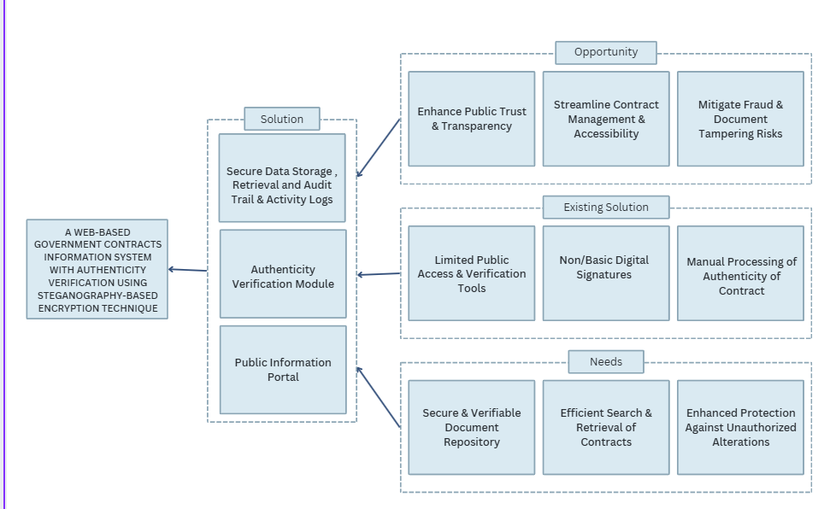
Figure 1.0 Conceptual Framework of the Study

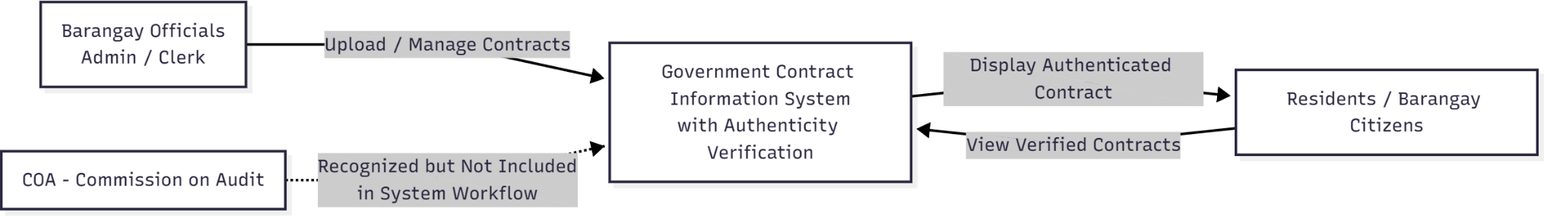
Figure 1.1 Context Diagram of the System

System Architecture
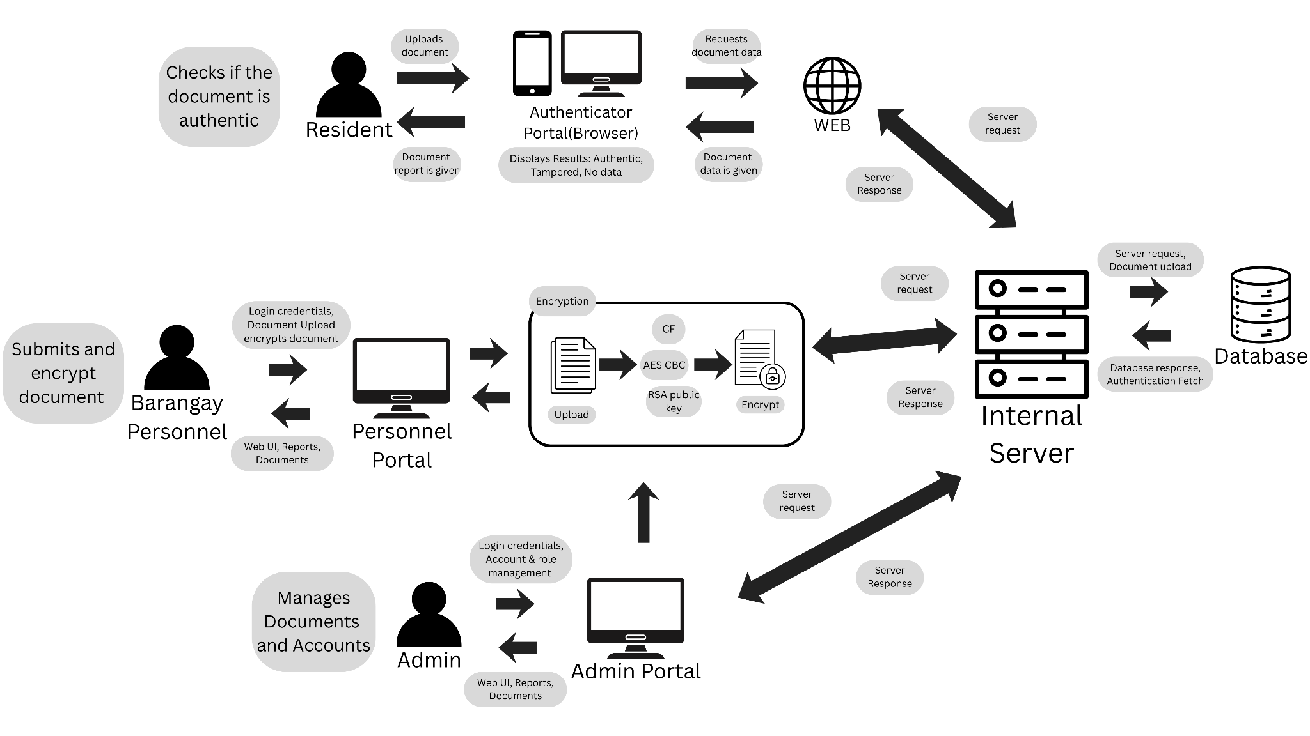
Figure 1.2 System Architecture

The image shows a secure document authentication and verification system architecture illustrating how residents, barangay personnel, administrators, servers, and the database interact to validate document authenticity.
On the left side, a Resident uploads a document through an Authenticator Portal (browser-based) to check whether the document is authentic. The portal sends a request to the web server, which forwards it to the internal server. After processing, the system returns verification results such as Authentic, Tampered, or No Data, which are then displayed to the resident.
Barangay personnel use a Personnel Portal to submit and encrypt official documents before storing them in the system. During upload, the document undergoes a hybrid encryption process, combining AES (CBC mode) for document encryption and RSA public key encryption for secure key handling. This ensures the integrity and confidentiality of stored records.
An Admin Portal is shown at the bottom, where administrators manage accounts, roles, and documents. Admins oversee system operations and ensure that only authorized users can access or process sensitive information.
At the center-right is the Internal Server, which handles server requests and responses. It processes authentication checks, verifies encrypted document data, and communicates with the Database. The database stores encrypted document records and authentication data. When a verification request is made, the internal server retrieves the stored encrypted data, performs validation checks, and sends the result back through the web layer to the user.
Arrows in the diagram represent bidirectional communication between:
- User portals and the web layer
- Web layer and internal server
- Internal server and database
Overall, the image presents a secure document authentication and verification framework where uploaded documents are encrypted, stored securely, and later verified through controlled server-side validation to ensure authenticity, integrity, and protection against tampering.

Definition of Terms

Cryptography and Security Concepts

AES (Advanced Encryption Standard) – A symmetric block cipher used to encrypt and decrypt data using a shared secret key. This study utilizes AES-256 in Cipher Block Chaining (CBC) mode.
Canonical Fingerprint (CF) – A unique hash-based digital identifier that represents the full content of a document, combining textual, visual, and metadata elements. In this study, the CF is used for authenticity verification.
CBC (Cipher Block Chaining) – A mode of operation for AES encryption in which each plaintext block is XORed with the previous ciphertext block before encryption.
Data Encryption Key (DEK) – A symmetric key used to encrypt and decrypt data within AES encryption.
Decryption – Process of restoring encrypted data to its original readable form with a key.
Digital Certificate – An electronic credential issued to confirm the identity of an entity or system involved in secure communications.
Digital Signature – A cryptographic technique that verifies the sender’s identity and ensures that a document has not been altered, providing integrity and non-repudiation.
Encryption – The process of converting readable data into an unreadable format to protect it from unauthorized access.
File Hashing – The process of generating a unique hash value from a file to verify its integrity during upload or verification.
Hashing Algorithm – A mathematical function that transforms input data into a fixed-length hash value, ensuring that even minor changes in the data result in a completely different output.
Least Significant Bit (LSB) – A steganographic method that hides data in the least significant bits of an image or file without visibly altering it.
Public Key – A cryptographic key used to encrypt data in asymmetric encryption systems, accessible to anyone.
SHA-256 (Secure Hash Algorithm 256-bit) – A cryptographic hash function that produces a 256-bit unique digital fingerprint of data, used in this study to verify document integrity and detect tampering.
Steganography – The practice of concealing secret data within another digital medium, such as an image or document. In this study, it is applied through the LSB technique to embed encrypted document hashes within a digital seal.

System and Information Management Concepts
Access Control — A security mechanism that restricts user privileges based on their assigned roles or permissions.
Algorithm — A defined sequence of computational steps used to perform a specific function such as encryption, decryption, or verification.
Audit Trail — A chronological record of user actions and system events that ensures accountability and supports transparency in document transactions.
Authorization — The process of determining which actions or data a verified user is permitted to access.
Information System — A coordinated structure of people, software, and hardware designed to collect, process, store, and distribute information.
Metadata — Descriptive data about a file, such as author, date of creation, modification timestamp, file size, and embedded identifiers. In this study, metadata is included in the Canonical Fingerprint for verification purposes.
User Authentication — The process of verifying a user’s identity before granting access to system resources.
Web-Based System — An application that operates on a web server and is accessed by users through a web browser.

Governance and Legal Framework Concepts
Authenticity Verification — The process of confirming that a document originates from a legitimate source and has not been altered since its issuance.
Document Integrity — The assurance that a document’s content remains accurate, complete, and unaltered throughout its lifecycle.
E-Governance — The application of information and communication technologies to improve the delivery of public services, transparency, and efficiency in government operations.
Local Government Unit (LGU) — A political subdivision responsible for administering a specific area, such as a barangay, municipality, or city.
Procurement Documents — The records produced across the procurement cycle under RA 9184, from the Purchase Request, Request for Quotation, and Abstract of Canvass to the Notice of Award, Purchase Order, and Contract Agreement. In this study, these are the documents that SealGuard authenticates and publishes.
RA 9184 (Government Procurement Reform Act) — The Philippine law that establishes guidelines for public procurement, promoting transparency, accountability, and fair competition in government transactions.

Review of Literature

Topic Section

Government Procurement and Document Management

Government Procurement Contracts

Studies of e-procurement systems demonstrate clear operational benefits for public procurement. An example is the article by Yumang and Mantillas (2025) on the procurement processes in barangays of the City of Manila, which found that while compliance with Republic Act 9184 (RA 9184) was moderate, significant challenges remained such as lack of training, low budgets, and lengthy processes which hindered efficient procurement operations.

Republic Act No. 9841
Republic Act No 9184, also known as the Government Procurement Reform Act was enacted in 2003 to standardize and modernize procurement processes in the Philippines. The law seeks to promote transparency, accountability and efficiency in government transactions by institutionalizing the use of information and communications technology in all stages of procurement. According to De Guzman (2022) the implementation of this law significantly improved the procurement landscape by introducing the Philippine government electronic procurement system or PHILGEPS for short, which gave increased public access to procurement information, allowing the public to monitor how public funds are spent, De Guzman also noted that while the law established a strong legal foundation for transparency, its success is dependent on the capability of local government units (LGU) and as such Yumang and Mantillas (2025) observed that while barangay level procurement units demonstrate moderate compliance to this law, they still rely on manual or semi digital processes, due to their limited training, lack of digital infrastructure and weak document security hinder their full compliance to the Republic Act of 9184. The proposed system aims to address one of the Act’s implicit challenges, verifying the authenticity of electronic procurement documents, through this the study aims to contribute to continuing modernization efforts envisioned by the Republic Act 9184.

Government Procurement Systems

The use of digital tools in buying stuff for government work made things more clear, cutting down chances for shady deals. Back in 2005, Siar found out that when purchasing is done by machines, every step can be tracked so people involved see how contracts move along right away. On top of that, the COA said in 2022 that online-based buying slashed repeated paperwork, sped up checking records, while also pushing local areas to report in a uniform way.

Online Contract Approval and Monitoring Systems:

According to the research, the introduction of PHILGEPS reduced manual processing and paperwork, centralized data management, and simplified contract approvals by providing an online bidding and monitoring environment. The study found that this digital platform made procurement information more accessible to the public, promoting accountability and minimizing corruption risks. However, it also revealed several limitations, including inconsistent internet access, lack of technical training among government employees, and the need for better verification mechanisms to authenticate electronic documents (UST–Legazpi, 2015).

Document Management Systems for Government Use:
Modern document management systems (DMS) in public offices aim to reduce reliance on paper-based filing and improve record retrieval efficiency. Dela Cruz (2024) found that web-based DMS solutions used by selected municipalities in Laguna enhanced collaboration between departments and reduced administrative delays. Despite these improvements, the study warned that weak encryption and lack of authenticity verification mechanisms made sensitive documents vulnerable to unauthorized alterations. This finding supports the integration of cryptographic and steganographic methods for secure document handling in local government systems.

Document Management Systems (DMS) at the LGU level

Research on web-based DMS deployments in Philippine local government units shows benefits in retrieval and collaboration but flags weak encryption, incomplete integrity checks, and low ICT skills among staff as recurring problems. These weaknesses point to the potential value of adding document concealment/authentication layers to existing DMS implementations. World Bank. (2023)

Information System
The field of Information Systems (IS) addresses how organizations capture, process, store, and distribute information using technology. A recent scoping literature review titled Information systems function research: a scoping literature review and research agenda examines the role of the IS function (ISF) in organizations, highlighting emerging opportunities, challenges and the evolving importance of digital transformation Veloso, M., & Varajão, J. (2025).

Information Systems in Public Service
Tahir along with Lamakaraka (2023) take a close look at past studies on Management Information Systems within public administration, showing that when MIS works well, people tend to get better government services. Even though these systems can seriously boost how smoothly agencies run, actual rollout hits snags - like lack of funds, skill gaps, or resistance inside organisations, which keeps benefits out of reach. The research brings solid evidence into conversations about tech use in public work, pointing out how far behind reality lags from expectations when it comes to using MIS in state-run operations.

Government Procedures on Public Rights of Information

Government procedures for public rights of information outline how citizens request, access, and appeal for documents and data held by the state. Literature reviews highlight procedural inefficiencies (delays, high fees, vague exceptions), the role of digital portals for open data, and the importance of clear guidelines and enforcement to make rights of information meaningful in practice (KPMG Philippines, 2021).

Philippines Rights of Information

The right of access to information in the Philippines is framed by public records laws and freedom-of-information initiatives, which require government agencies to provide citizen access to documents, subject to exceptions. Literature explores challenges in implementation: red-tape, inconsistent agency responses, lack of digital systems, and low public awareness. Improving transparency relies on technology, policy and institutional culture. Senate of the Philippines (n.d)

Authenticity Verification and Security in Government Documents
Authenticity Verification
Checking if something's real means making sure it hasn't been changed, comes from a proper place, and matches what it claims to be - whether it's info, ID, or files. Elsbach and Bhattacharya (2020) say being genuine happens when inner traits line up with outward behavior, showing honesty and reliability. Lehman and team (2022) broke this down more, pointing out four aspects - how steady it is, how well it fits norms, personal links, and ongoing presence that shape whether things feel truly legit in different situations. When dealing with tech or data-heavy environments, proving something’s valid keeps shared or sent details trustworthy; Chen, Chen, and Xie (2021) worked on ways to test just how truthful social media content really is. On another front, Nikulchev and others (2021) used these checks on web-based questionnaires, figuring out if answers came from actual people instead of bots. Beyond just numbers, O’Connor’s team in 2022 showed how it helps tell real online feedback apart from made-up comments; meanwhile, media researchers at Fiveable point out that checking facts is key to staying trusted when sharing news. In total, confirming what's authentic works across fields - linking honest people, secure digital spaces, and dependable tech - to block lies and keep info networks reliable.

Authenticity Verification for Philippine Government
Beyond checking who someone really is in person, the Philippines set up ways to confirm if digital papers are real to make online services smoother while cutting down fake docs. The PSA rolled out electronic versions of records like births, weddings, and deaths; each comes with a special code users can check live on the web (PSA, 2023). At the same time, the DFA started using e-Apostilles slapping verified state paperwork with encrypted tags plus scannable squares before sending them overseas (DFA, 2024). People abroad can prove validity simply by snapping the QR symbol or typing the ID into Apostille.gov.ph - a quick way to know it's legit and from an approved source. Still, right now, this first round only includes personal status forms handled by the PSA, so broader use will have to wait. These efforts show how the Philippines is slowly taking stronger steps toward trustworthy online governance. Though issues still exist like helping people everywhere learn digital skills and improving internet access building better tools to check documents on the web moves things forward without relying on paper, while also reducing scams in today’s tech-driven world.

Online Document Verification Frameworks

Recent frameworks for online document verification (including approaches based on self-sovereign identity and cryptographically verifiable credentials) demonstrate practical architectures for web-based verification systems that do not leak private data while enabling public checks of authenticity. Such frameworks inform design decisions for a public authenticator that verifies whether a PDF was legitimately issued by a barangay without exposing hidden content. (Satybaldy, Subedi, & Nowostawski, 2022).

Hybrid cryptographic methods for authenticity:

Hybrid approaches (encryption combined with other verification techniques) have been shown to strengthen document origin and integrity guarantees. For government documents, combining cryptographic signing/verification with additional concealment mechanisms can reduce both tampering and unauthorized visibility (Alanzy, Alomrani, Alqarni, & Almutairi, 2023).

Techniques used to Prevent Forgery and Tampering Government Documents
Techniques used to prevent forgery and tampering include embedding digital watermarks or steganography, using tamper-evident formats, applying digital signatures and timestamping, implementing document version control and audit trails, and establishing verification APIs for public and internal checking. Studies show that integrating cryptographic hashing with logging and public-key infrastructure strengthens document integrity and authenticity (Prashant, Haque, Kaur, & Yadav, 2024).

PDF fake news/forgery
In 2018, the office of the ombudsman reported that a number of barangay officials were ordered jailed for forging barangay, resolutions, falsifying documents and holding sham meeting to illegally appoint officials, according to the ombudsman’s decision, the officials fabricated resolution by falsely recording that a council meeting took place, listing members as “present ” even though no such meeting was held, The fabricated resolution included manually altered signatures.
The investigation revealed that the barangay officials had deliberately altered the resolution’s contents to make it appear legitimate, taking advantage of the fact that barangay documents are often kept only in printed or scanned form without verification features. Once the falsified resolution was digitized and circulated as a PDF, it became nearly indistinguishable from authentic barangay records. This enabled the fraudulent document to pass through several layers of local administration before the inconsistencies were discovered. This shows that even the smallest unit of local governance, document forgery can occur through simple alterations to signatures, timestamps and narrative content. Such vulnerabilities underscore the necessity of implementing secure verification procedures, to ensure integrity and prevent unauthorized alterations.

Security Protocols for Government Documents
The Philippines keeps data safe using clear rules set by law and daily operations, making sure info stays private, accurate, and reachable when needed. Office of the President Memo Circular 78 from ’64 lays out how papers should be labeled split into Top Secret, Secret, Confidential, plus Restricted with each level showing how much damage leaked details might cause to national safety. This order spells out steps like tagging files right, sending them in two envelopes, while keeping them locked up tight or inside areas off-limits to most people. Getting near these documents depends on needing that specific knowledge at that time - not just anyone can look - even if you have clearance fit for certain levels. These steps make up the heart of how officials handle sensitive papers, keeping openness while protecting country secrets. On top of that, there’s a system for paper handling tracking who grabs files, plus ways to shred secret documents so no one digs them back up.
To keep digital info safer, the 2012 Data Privacy Act (RA 10173) requires every govt agency acting as a PIC to use management practices, real-world protections, besides tech tools when handling private or delicate data. Instead of weak options, the National Privacy Commission pushes strong encoding like AES-256 for saving and sending files, according to their memo NPC Circular No. 16-01. Because of these steps, personal records stay shielded against leaks, hacking attempts, or changes done without approval. On top of that, DICT's GIS Plan covering 2022 through 2028 sets out rules on who can view certain materials,
demands locked-down transfer channels, along with reliable login setups. When combined, all these actions show how the Philippines handles docs using
old-school secrecy levels together with up-to-date privacy tactics so both citizen and state data remain protected.
Technical Foundations of Secure Digital Systems
Encryption Algorithms for Securing Files

Recent work in file encryption demonstrates that securing documents—for example contract-PDFs or official records—requires more than simply applying standard encryption. Banga et al. (2023) developed a file encryption/decryption framework using AES for both text and image files, emphasising performance and integrity of large-file sets. Ryu (2023) proposed a hybrid approach combining legacy ciphers with AES-256 to improve resistance to sophisticated attacks on files. Additional studies, such as Musa (2023), evaluate the real‐world suitability of different algorithms for securing files, including considerations of algorithm complexity and resource constraints. Taken together, these works show that encryption algorithm choice, key management, and implementation context (such as file size, storage medium, transmission channel) are critical when securing file-based documents.

Encryption and Cryptography(Overview & Encryption Process):

Crypto relies on math along with clear rules to protect data, ensure correctness, make signatures solid. Encoding information typically involves selecting an approach, reusing one key for large pieces, switching to separate keys if sending hidden messages or applying signatures, while also generating and safeguarding these keys carefully, leaning on trusted methods like AES-GCM, handling their life cycle via changes, deletions, swaps. Recent checks measure pace, difficulty in key control, strengths across environments - AES vs RSA vs ECC - with safe coding habits helping builders match tools to website file security demands. Kshetri, Rahman, Rana, Osama, & Hutson (2024)

Comparison on Digital Document Security Encryptions Techniques
Comparative literature on digital document security and encryption techniques examines symmetric versus asymmetric cryptography (e.g., AES vs RSA/ECC), authenticated encryption modes (GCM, CCM), key distribution and management, performance trade-offs, and implementation contexts (cloud, mobile, archives). Those reviews help researchers decide which cryptographic methods best suit particular document security use-cases (Yin et al., 2022)

Steganography and Data Hiding
Artz (2001) provides a foundational overview of digital steganography, describing it as the art of inconspicuously embedding information within ordinary data such as images, audio files or text, without altering unintended recipients to its existence, it has also noted the difference between encryption and steganography, encryption makes data unreadable while steganography simply hides the data

Steganography on PDF
Tyagi, Dwivedi, and Saxena (2020) discussed that PDF documents, due to their platform independence and wide use, are ideal carriers for information hiding. Their method focused on embedding secret messages within text-based PDFs using imperceptible coding transformations that preserve document readability. The study concluded that PDF text steganography enhances secure document transmission by achieving both high hiding capacity and strong imperceptibility. Koptyra and Ogiela (2020) observed that steganographic techniques can be effectively applied to PDF files by modifying internal document structures such as dereferenced objects and page trees. Their study demonstrated that hidden data can remain completely invisible in standard PDF readers while maintaining the document’s normal appearance. The research concluded that structural steganography in PDFs provides a secure and high-capacity medium for covert communication, especially when combined with content-based hiding methods.

Steganography-Based Encryption Techniques
LSB (Least Significant Bit) Steganography

Patil, P., & Jain, R. (2020) A review on image steganography techniques concluded that the Least Significant Bit (LSB) approach remains one of the most efficient and lightweight methods for concealing data. Their findings emphasize that LSB manipulation can embed information within digital files without noticeably altering their appearance or quality
Reinforcing LSB, Singh, S., & Attri, V. K. (2015) proposed a dual layer mechanism that integrates AES encryption with LSB steganography. Ensuring the even if encrypted data is intercepted, it remains concealed within a cover medium, this research demonstrated combining these two techniques improves data protection and resistance to tampering,

Hidden Data Techniques for Document Authenticity

Hussain and Muhammad (2023) introduced a digital text-watermarking approach that embeds invisible identification codes within PDF documents to verify originality and detect post-creation alterations. Their findings revealed that hidden watermark markers can remain intact even after common document modifications, enabling organizations to validate the legitimacy of official records and prevent undetected tampering. This study demonstrated that embedding concealed watermark data within documents provides a reliable layer of integrity verification alongside traditional security controls.
Blue, Condell, and Lunney (2024) applied steganographic data-embedding techniques to identity and legal documents to ensure non-repudiation and forgery resistance. Their work highlighted that embedding hidden verification codes within the document structure allows authenticity checks without altering readability or format. By concealing validation keys within the document itself, this method enhances tamper-resilience and reduces the risk of fraudulent duplication or the circulation of falsified official records.

Digital Signature and Verification
Sharma and Bhattacharya (2022) reviewed various digital signature mechanisms used to verify the authenticity of electronic documents, including RSA-based and hash based schemes. Their analysis revealed that signatures not only confirm document ownership but also ensure data integrity by detecting unauthorized modifications.
Rashid and Khan (2025) conducted a comparative study on the deployment of digital signatures across individual and organizational contexts, in which they emphasized in the importance of public key infrastructure in establishing trust and compliance with legal frameworks
Titov et al, (2022) further explored this within contractual and legal processes, suggesting a functional symmetry approach that ensures signatures, verification and document lifecycle management remain consistent across systems.
Commission on Audit (COA, 2021) also released formal guidelines on the use of electronic and digital signatures in philippine government transactions.

Hybrid Cryptographic Approaches
Hybrid cryptographic methods for authenticity:
Hybrid approaches (encryption combined with other verification techniques) have been shown to strengthen document origin and integrity guarantees. For government documents, combining cryptographic signing/verification with additional concealment mechanisms can reduce both tampering and unauthorized visibility (Alanzy, Alomrani, Alqarni, & Almutairi, 2023).
Balhaf et al, (2025) designed a hybrid cryptographic system that merges RSA encryption with Least Significant Bit (LSB) steganography to embed ciphertext within image files, This integration made extraction by unauthorized parties significantly more difficult Eswaran et al. (2025) expanded upon this concept by combining public key cryptography with steganographic embedding in multimedia files.
A similar model by Satybaldy, Subedi, & Nowostawski, (2022) introduced an online document verification framework using self-sovereign identity and verifiable credentials.
A 2024 MDPI study on cloud data security presented a four step hybrid encryption process that integrates the use of AES-256, RSA and Steganography to ensure the integrity and security of sensitive files.

Integration of Steganography and Cryptography

Almuhammadi and Al-Shaaby (2013) observed that using cryptography or steganography alone will be insufficient for security, however combining these two can create a more reliable and stronger system. The study concluded that Digital Signature and Verification Methods Furthermore, Subsequent research has further validated this hybrid method. For instance, Singh and Attri (2015) introduced a dual layer mechanism that integrated AES encryption with LSB steganography, showing that even if encrypted data is intercepted, it remains concealed within a cover medium.
Similarly, Balhaf et al. (2025) designed a hybrid cryptographic system combining RSA encryption and steganographic embedding, enhancing both confidentiality and authentication during transmission.
The encryption ensures that only authorized users can decrypt the document while steganography enables authenticity verification by embedding hidden identifiers or watermarks directly within the document file, mitigating risks and unauthorized modification of official records

Web-Based System Architecture and Methodologies
Web Application Security Best Practices
Web applications that expose document upload/verification APIs must follow secure coding and API security guidelines (OWASP Top 10 / API Top 10) especially strong authentication, proper access control, input validation, and secure transport to prevent tampering, replay, and unauthorized access to verification services. These recommendations are essential when building a public authenticator and a private encryption module.

Information System Security in E-Governance
E-governance systems face unique security challenges because they collect, store, and process large volumes of sensitive citizen and institutional data while providing wide public access. Recent literature emphasizes a layered approach (policy, technical controls, and continual monitoring) and aligning controls to standards (e.g., NIST) to maintain availability, confidentiality, and integrity while managing regulatory and privacy requirements. Studies also highlight the need for resilience against increasingly sophisticated attacks and the importance of governance, risk management, and compliance (GRC) frameworks in public-sector deployments (Singh & Karaulia, 2011).
Implementation of Secure File Transmission in Web System:
Sending files safely online usually relies on methods that scramble commands and information together like SFTp, FTPS or API setups built on HTTPS. Experts suggest going with login keys instead of passwords, managing servers and crypto-keys carefully, checking data hasn’t been altered with things like HMACs or secure encryption and setting tight usage limits, keeping close logs, plus scanning devices for malicious software, Most split setups mix encrypted communication layers, say SFTP over TLS, together with app-level safeguards such as one-time upload tokens, automatic virus checks and locking down each file individually according to Bob Ertl(2025)

Data Integrity and Confidentiality in Public Systems:
In public setups, making sure data stays correct and secure usually depends on several layers - encryption hides details, whereas tools like digital signatures or MACs confirm nothing’s been altered. Entry gets closely restricted, yet records show every action taken by users. Rules such as those in NIST SP 800-53 outline different steps aimed at state groups and large orgs; following these builds trustworthy protections that are both reviewable and law-compliant. JTF (2020)

Database Management Systems
A database manage system serves as the backbone of numerous information systems as they provide structured storage, retrieval and manipulation of data while also enabling data organization and security even with multiple users at the same time. (Elmasri & Navathe, 2017), Database Management Systems can reduce redundancy and improve consistency by enforcing data relationships through schemas and constraints, so that stored records can remain accuracy to their source and synchronized across modules.
Firebase Realtime Database, the database that will be used in this study’s proposed system, operates as a cloud-hosted NoSQL database that supports real-time data synchronization and secure authentication features. According to
Google Cloud (2023) firebase ensures security through server-enforced rules and integration with firebase authentication, which regulates user permissions and protects stored data from unauthorized access, in terms of our proposed system this is a good fit, firebase manages encrypted PDF contracts and their metadata, while role-based access control ensures that only verified barangay staff can upload, modify and verify the records.

Role-Based Access Control
Role-Based Access Control (RBAC) is a security mechanism that restrict system access to authorized users based on their assigned roles within an organization, instead of assigning permissions per user, RBAC associates privileges with roles that reflect their job responsibilities RBAC simplifies permission management while maintaining compliance with organizational policies (Ferraiolo & Kuhn, 1992).
Sandhu, Coyne, Feinstein, and Youman (1996) introduced one of the most influential models of RBAC, which outlined how role hierarchies and constraints can efficiently manage permissions across large scale systems. RBAC is applicable because administrative roles inherently map to permissions in system workflows. For example, each official has distinct duties: approvals vs. document uploads vs. record-access. Aligning system permissions the system can then simplify access management and secure sensitive contract documents.

Agile Methodology
Agile methodology emphasises iterative development, frequent delivery of functional increments, close stakeholder collaboration, and adaptive planning. In the context of software and systems development, Agile has been credited with improving responsiveness to change, reducing time-to-market, and enhancing user satisfaction. However, literature also points out challenges: scaling Agile in large organisations, maintaining documentation and governance, and balancing flexibility with control (Daraojimba, Nwasike, Adegbite, Ezeigweneme, & Gidiagba, 2024)

Web Design and UI/UX Principles
Web Design plays a vital role in the usability, accessibility and overall success of web based systems, According to Krug (2014) a well designed website should only prioritize its simplicity and clarity, so users can navigate and perform their designated tasks without being confused by its layout, you can achieve this through consistent layout, clear visual hierarchy and intuitive interface elements, Garett (2011) also mentioned that it’s not merely about its design but also about creating a meaningful interaction between the user and the system, ensuring that design decisions align with users’ needs and goals.
Web systems that adhere to government or institutional functions must also adhere to these design principles. As Marcotte (2011) introduced, responsive web design enables websites to automatically adjust layouts and elements across various devices and screen sizes, so that the user experience is consistent across numerous devices in the context of our system, these web designs ensure that barangay staff and the public can easily access and verify the documents without any confusion or hassle.

Synthesis

The reviewed literature collectively highlights the continuing challenges and opportunities in modernizing document management and procurement processes within the Philippine local government context, studies on government procurement and RA 9184 consistently emphasize the importance of transparency, accountability, and efficiency in public transactions, yet reveal persistent barriers like lack of technicality, manual procedures and the lack of security mechanisms (Uumang & Mantillas, 2025; De Guzman, 2022) which help support the development of our proposed system.
Literature on Document Management Systems and Information systems in public administrations demonstrate that web based solution can help streamline operations (Dela Cruz, 2024; World Bank, 2023), however, the recurring weakness in their encryption, verification and user training highlights the need for security focused enhancements.
The studies on authenticity verification and hybrid cryptographic frameworks further strengthen this direction by proving that the combination of encryption, hashing and concealment methods can significantly enhance document integrity and security (Alanzy et al., 2023; Satybaldy et al., 2022), THe philippine government’s recent moves toward digital authentication such as PSA’s e-certificates and DFA’s e Apostilles mean it aligns with secure and verifiable e governance practices to our proposed system (PSA, 2023; DFA, 2024).
Research on web application security and secure file transmission underscores the need for layered security measures based on standards like OWASP and NIST to mitigate threats from unauthorized access and tampering (Singh & Karaulia, 2011; OWASP, 2023), multiple of these studies collectively validate the adoption of AES-256, SHA-256 and the LSB steganography that will be used for the core mechanisms of the proposed system.
As well as insights from the UI/UX design, Agile Methodology, and database management system emphasize the usability, adaptability as crucial elements in a system’s success (Krug, 2014; Garrett, 2011; Google Cloud, 2023) together these works can give us a foundation for the proposed system’s study giving a technical perspective for development.

CHAPTER 3

Methodology

This presents the methodological function for the development, evaluation and validation of the proposed system, the methods were structured to ensure the system addresses the core problems identified in the barangay’s current workflow such as lack of secure verification, manual workflows, vulnerability to tampering and limited accessibility.
The methodology begins with the research design being quantitative, which provides objective measurements for the system’s accuracy, security and user’s feedback, This is reinforced via through major evaluative components, System Accuracy Testing which measures the reliability of encryption, canonical fingerprint, authentication and verification, and the User Acceptance Testing (UAT) which assesses the usability, functionality and overall readiness of the system.
The research locale, Barangay Sto. Niño, Biñan City, was selected due to its reliance on manual documentation processes and evident challenges in verifying government records. By focusing on an LGU with real operational constraints it helps ensure our study is technically feasible and relevant.
Central to the methodology would be the Agile Development Methodology, which supports iterative development, from the designing, planning and developing modules including authentication, encryption and decryption, LSB-based steganography, document storage and the tools used to verify documents. It also details the technical framework, incorporating AES-256 CBC, encryption SHA-256 hashing for canonical fingerprint generation and least significant bit (LSB) steganography for concealed authenticity embedding within PDF documents. Which also help identify the gaps identified under RA 9184. Finally, an outline of the data gathering, including document review and Testing sessions, The data analysis plan establishes how quantitative results from Accuracy tests, UAT scores and verification outputs will be evaluated to determine the system performance and acceptance.

Research Design

The study will utilize a Quantitative Research Design to evaluate the performance and acceptance of the barangay management system, The quantitative approach is appropriate as Creswell (2018) emphasized, quantitative research enables the collection of measurable data that can be analyzed statistically to draw objective conclusions for the system accuracy and usability which allows the measure of performance, like how accurate the authentication is or how secure the encryption is or the overall experience with the system. Such metrics include the accuracy of generated data and the User Acceptance Testing (UAT) ratings of system respondents.
System Accuracy Testing will focus on evaluating the reliability of the system, in the processing, the encrypting and the authentication of the data, it will measure how accurately the system performs the intended functions compared to the expected results.
User Acceptance Testing (UAT): It will involve the intended end-users, executing a predefined set of critical business tasks. Which will determine if the system meets the functional requirements and is suitable for the live environment.
Combined findings of both the user acceptance testing and system accuracy testing can offer a comprehensive view of the system’s reliability, which can serve as a foundation for interpreting results in the data analysis plan. The proposed system also incorporates a multi layer encryption and verification framework composed of the following key algorithms and cryptographic processes of AES-256 Encryption Key along with Cipher Block Chaining (CBC) mode, SHA-256 Hashing Algorithm and LSB Steganographic Embedding key.

Research Locale/Respondents

The study will be conducted in Biñan City, Laguna, specifically in Barangay Sto. Niño where the barangay office will serve as the testing and information-gathering site. The locale was selected because it represents a highly urbanized and rapidly developing local government unit (LGU) facing contemporary challenges in records management and public service delivery
Barangay Sto. Niño is situated in the landlocked component city of Biñan, Laguna, located in the CALABARZON region (Region IV-A), approximately 35 kilometers south of Metro Manila. Biñan City itself is renowned as a major commercial and trading hub south of the capital, which means a high level of economic activity. According to Philatlas (2020) Sto. Niño is highly accessible, being near major transport routes like the National Highway and the South Luzon Expressway (SLEX). Its proximity to commercial centers like Pavilion Mall further underscores its role as a busy, accessible administrative center within the city. its environment also provides a crucial testbed to ensure that the proposed system is not only technically sound but also implementable. According to data obtained from their Barangay Secretary as of 2025, Barangay Sto. Niño has an estimated population of 12,303 residents, meaning they experience administrative processes daily that’s related to barangay operations, making it an appropriate test environment for the system’s performance
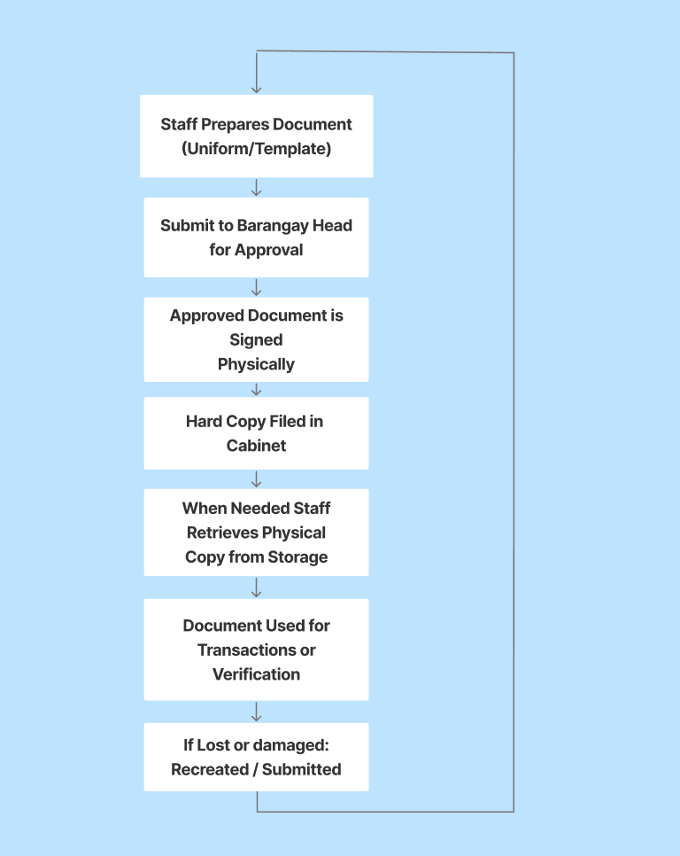

Figure 3.0 Barangay’s Current Workflow

At present, Barangay Sto. Niño utilizes a manual document management process. Procurement records are prepared using standardized printed templates, physically signed by authorized officials, and stored in filing cabinets within the barangay office. Document verification is conducted manually through visual comparison of physical copies and handwritten signatures.
While this workflow satisfies procedural compliance under RA 9184, it presents several security and authenticity vulnerabilities. Because documents are validated solely through physical inspection, subtle alterations—such as modification of financial figures, replacement of pages, or insertion of additional clauses—may go undetected. Physical signatures confirm approval but do not guarantee that the document content has remained unchanged after signing.
For users and requesters such as auditors, contractors, and citizens seeking verification, authenticity is dependent on trust rather than technical validation. There is no cryptographic mechanism to confirm that the retrieved copy is identical to the originally approved contract. In cases where documents are lost, damaged, or recreated, there is no mathematical baseline or integrity reference to determine whether the reproduced version matches the original.
The reliance on physical storage also exposes records to risks such as misplacement, unauthorized access, environmental damage, and delayed retrieval. Additionally, the absence of digital backups increases vulnerability in the event of disasters. These limitations result in reduced traceability, susceptibility to unauthorized alterations, and reliance on manual verification processes that are prone to human error.
The primary target users of the proposed system include barangay officials—such as the Barangay Captain, secretary, treasurer, and administrative staff—who are directly involved in document preparation, approval, and safekeeping. Citizens and external requesters who require document verification will also benefit from improved authenticity assurance mechanisms. Approximately thirty (30) citizens will serve as test users during User Acceptance Testing to evaluate whether procurement documents can be authenticated efficiently and whether tampering can be reliably detected.
Formal permission to conduct data gathering was obtained through a signed letter of request approved by the Barangay Captain. Respondents for system evaluation will be selected using stratified sampling to ensure representation across organizational roles during User Acceptance Testing and cybersecurity evaluation.

Software Methodology

The study will utilize the Agile Development Methodology as the software development framework, Agile was chosen as it supports, iterative design, continuous user feedback, and adaptiveness, which are essential for developing systems intended for real world use in barangay operations, especially since barangay operations often involve evolving workflows and policy adjustments.
The development process will be divided into several sprints, each representing a short and focused development cycle that delivers a working component of the system as based on our sprint schedule.

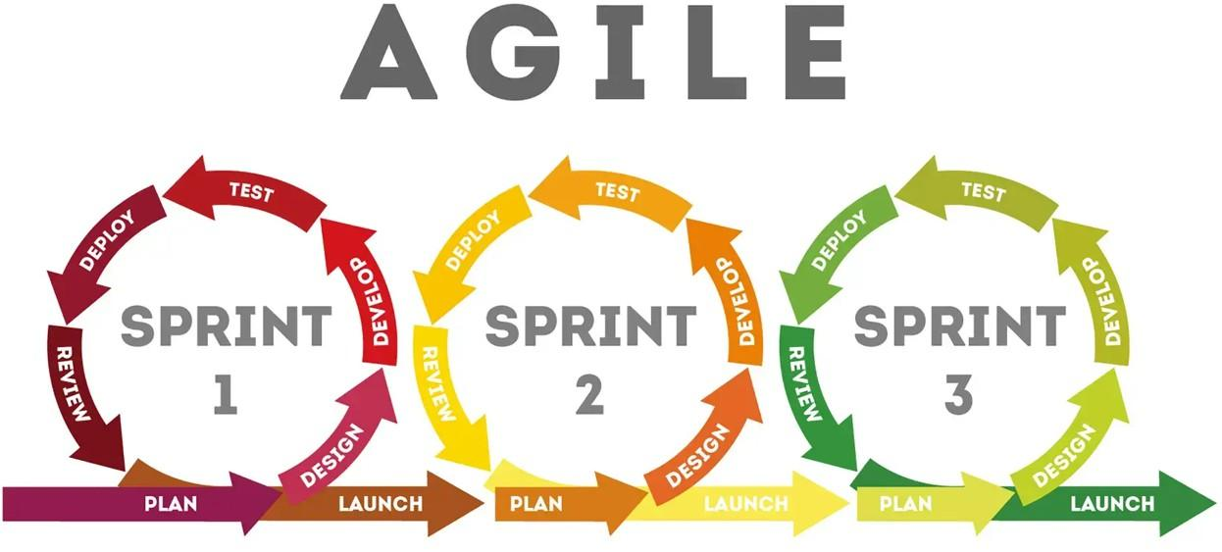

Figure 3.1 Agile Methodology Model Diagram

The process shown on Figure 3.1 provides quick responses to client feedback to create the project’s definite direction during the software development cycle Arsenault (2017) has stated in contrast to traditional web development methodology, like the Waterfall model that uses traditional sequential approaches. Agile provides a non-sequential approach since there will always be technological bugs and new technical limitations to overcome, it also improves communication between the users and the development team utilizing the power of modern technology with a per-sprint-meeting feedback collection.

Seven Phases of the model:

3.3.1.1 Planning Phase

The planning phase will serve as the foundation of the system’s development, focusing on the project’s scope, identifying requirements and aligning all activities with Republic Act 9184, ensuring that the researchers have a clear understanding of the barangay’s workflow before introducing technological interventions.
The researchers conducted an assessment of the current document handling and procurement process within Barangay Sto. Niño, Biñan, Laguna, in which they rely heavily on manual filing and physical storage of contracts, resolutions and procurement related documents. This baseline analysis revealed issues such as delayed document retrieval and absence of a standardized system for verifying documents, These observations then guided the definition of requirements for the proposed system.

Identification and rationale alignment

Consultations were carried out with the barangay captain and staff to determine their needs and expected benefits from the system, the rationale of the project was to assist the barangay in complying with transparency and accountability standards that were mandated by RA 984 and Commision on Audit (COA), The proposed system would also benefit residents who wish to verify uploaded public documents such as barangay procurement documents so they can ensure no unauthorized modifications occur.

Technical Requirements

During this phase the researchers defined the core technical components of the system. This included the Encryption and Decryption mechanisms which are the Advanced Encryption Standard (AES) with Cipher Block Chaining (CBC) mode and SHA-256 hashing to ensure the integrity of the document, each uploaded document will generate a canonical fingerprint, which serves as a unique validation key for authenticity verification. Authentication via Role Based Access Control (RBAC) ensuring that only authorized personnel can approve or verify documents as well as a data flow diagram to outline how documents will move through the system, from the uploading, encryption, draft.
In addition to the web-based system, the researchers defined requirements for a mobile-based authentication application. The mobile application will function as a portable verification tool designed for on-site or remote document authentication. It will allow authorized users to scan digital or printed procurement documents and extract embedded steganographic data for validation.
The mobile application must be capable of:
- Extracting LSB-embedded encrypted fingerprints from the document’s digital seal
- Decrypting AES-protected hash values
- Recomputing the document’s SHA-256 hash
- Comparing extracted and recomputed values
- Displaying a clear authentication result (Authentic / Tampered)
This addition ensures that document verification is no longer restricted to the barangay office computer.

Project Scheduling and Deliverables

An agile sprint schedule was developed to visualize the project timeline and duration of each phase under the Agile Development methodology. Each sprint focuses on a specific module such as user authentication, encryption process, file storage and verification.

3.3.1.2 Design Phase

The design phase will focus on translating the gathered requirements and insights from the planning phase into concrete system specifications. Researchers will begin conceptualizing the system architecture and creating mockups that represent both the administrative and public modules of the proposed system such as a database schema, data flow diagrams, and entity relationship diagrams as well as mockups to represent user interfaces. The design will also define the role-based access structures based on the organization hierarchy Main objective being to ensure the system’s design aligns with the data gathered through the planning phase.
During the design phase, a separate but interconnected mobile authentication module was conceptualized. The mobile application architecture was designed to interact with the same cryptographic framework used by the web system.
The mobile application consists of:
- Scanning Interface Module
- Steganographic Extraction
- AES Decryption Module
- Result Display Interface
The design ensures that the mobile application operates strictly as a verification tool and does not allow document modification, upload, or deletion.
To further reinforce this phase, records such as their procurement charts, organizational charts will be used to guide the creation of realistic data and role-based access structures within the system. Which can help determine which users will have privileges, who can upload and verify and how they will be categorized. Which will also give us insight regarding the design of our system architecture.
This phase will also involve the creation of the system’s core algorithms which define how major functions operate, Including file encryption, user authentication and verification. The researchers will also develop the algorithm to handle the secure upload of document files as it is essential to ensuring that data are processed accurately, securely and in accordance with the system’s intended workflows

Algorithm Design

To ensure the system’s data integrity and security the researchers designed two core algorithms, one algorithm will handle the document encryption and uploading, while the second governs the verification process, Together it ensures that the files when retrieved or stored will remain authentic, confidential and free from tamper.
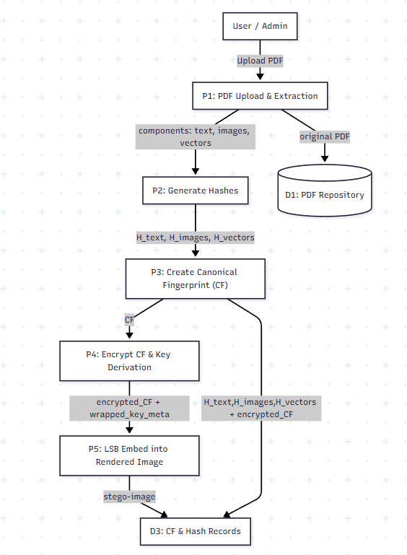

Figure 3.2 Document Upload and Three-Layer Encryption Flow
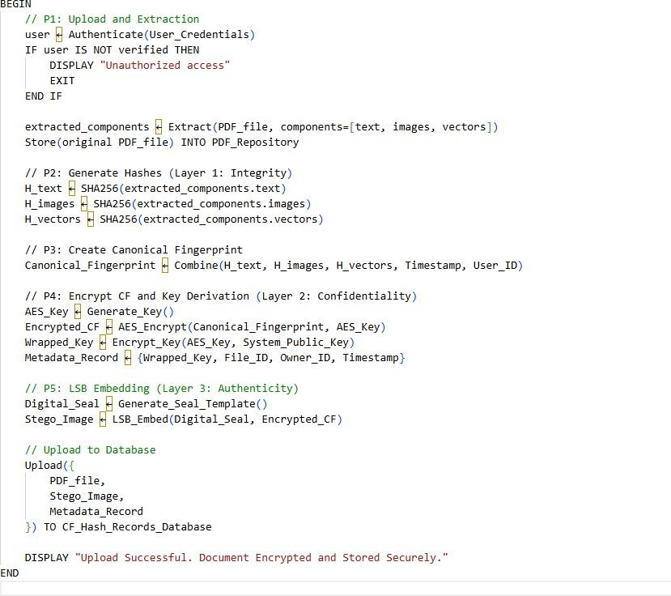

Figure 3.3 Document Upload and Encryption Pseudocode

The following figure 3.1 as well as the figure 3.2 pseudo code illustrates the algorithm for document encryption and uploading, the process begins when the user selects a document for upload, the system then generates an encryption key using AES-256, and a hash value using SHA-256 of the encrypted file, and it is computed and embedded into a digital seal image using the least significant bit (LSB) steganographic technique, This seal, together with the encrypted document will be uploaded to the database along with metadata such as file ID, owner and timestamp, the algorithm ensures that only verified users can perform uploads.
The encryption process implements a three layer encryption model, consisting of: (1) SHA-256 hashing for ensuring that data has not been altered, (2) a digital seal generated through LSB steganography for authenticity validation, and (3) AES-256 encryption for document confidentiality, A cryptographic key is also generated and wrapped as metadata to ensure only authorized users can decrypt the encrypted canonical fingerprint
To enable portable authentication while preserving structural integrity validation, the system introduces a Digital Seal mechanism. The Digital Seal functions as a visible authentication marker placed within the procurement document while simultaneously serving as a carrier of hidden cryptographic data.
The Canonical Fingerprint (CF), generated from the combined hash values of textual content (h_text), images (h_images), and vector elements (h_vectors), is first encrypted using AES-256 encryption. The encrypted CF is then embedded into the Digital Seal image using the Least Significant Bit (LSB) steganographic technique.
Visually, the Digital Seal appears as a standard official marker (e.g., a barangay verification stamp). However, at the pixel level, selected least significant bits contain the encrypted structural identity of the document. This layered design ensures that:
- The document maintains human-readable authenticity through the visible seal.
- The embedded CF preserves cryptographic identity.
- Any digital modification affecting the document structure will invalidate the stored fingerprint.
This approach transforms the seal from a simple visual marker into a cryptographic authenticity carrier.
The implementation of LSB in this study is not a direct textbook embedding of arbitrary data. Instead, it forms part of a layered integrity verification framework. Prior to embedding, a Canonical Fingerprint (CF) is generated to represent the structural identity of the PDF document. This fingerprint undergoes AES encryption before being embedded within a controlled image region of the document. The embedding process is restricted to non-structural components to prevent corruption of the PDF format. This approach demonstrates the application of cybersecurity principles such as confidentiality, integrity assurance, controlled attack surface, and layered defense.

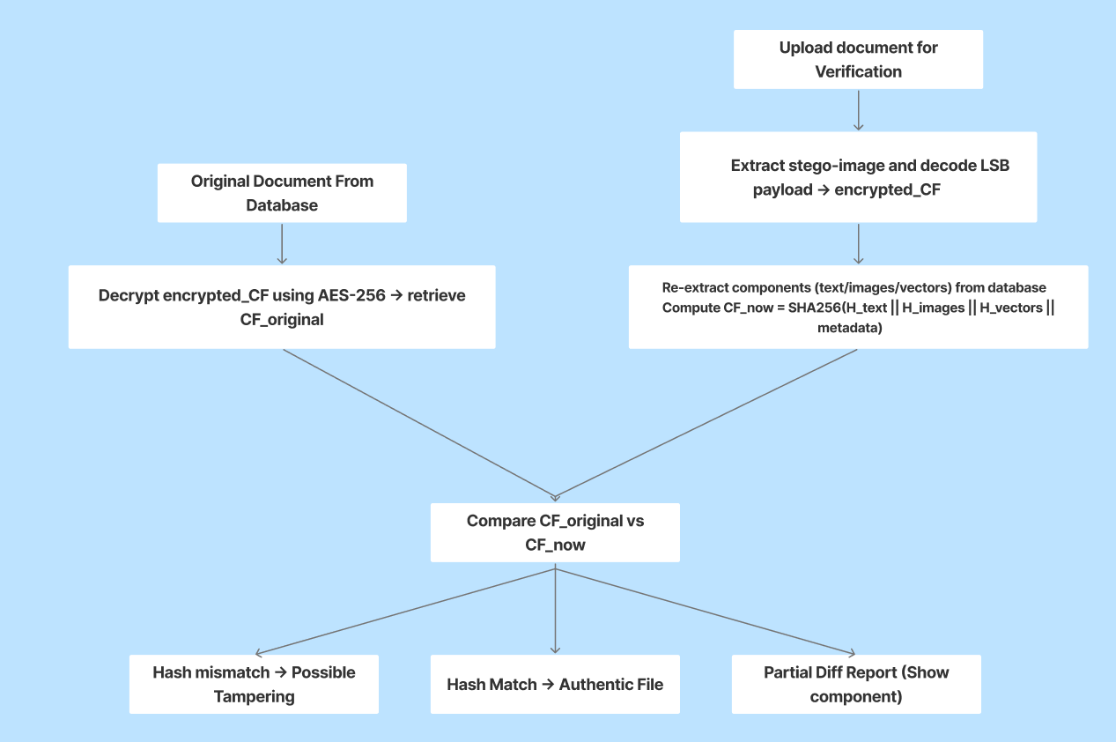
Figure 3.4 Document Verification Flow
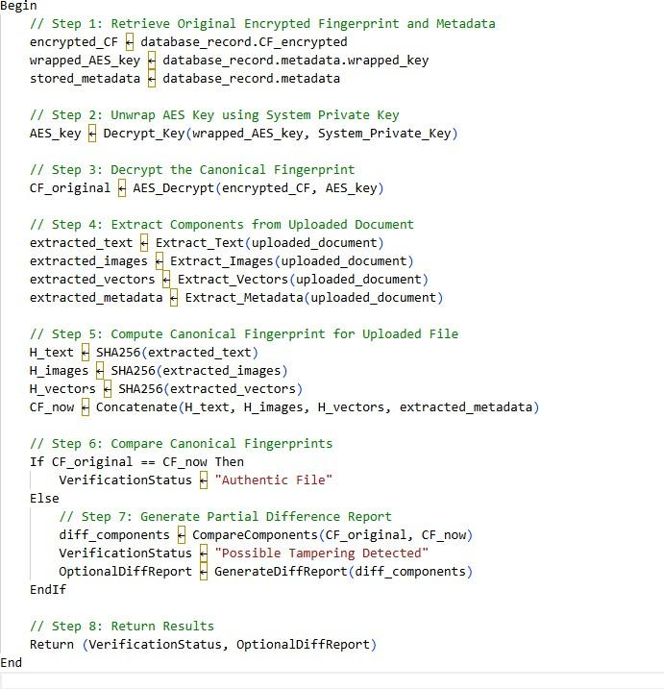

Figure 3.5 Document Verification Pseudocode

The following figures ensures and compares document authenticity by comparing the hash value extracted from the embedded seal image with the hash stored in the database, if both hash values from the document in the database and the document in the user’s hands match, the document can be considered authentic, otherwise it is flagged with possible tampering.
For the key, the system retrieves the wrapped AES key stored in the document’s metadata. This key will then be decrypted using the key’s private data
These algorithms help the system’s backend logic during the development phase, particularly in database integration and encryption modules.
For the key, whenever a verification request happens: The system fetches the stored wrapped_key from the database.

3.3.1.3 Development Phase

Development phase will focus on translating the approved system design and specification into a functional prototype of the system, guided by the agile methodology, the phase will be divided into multiple sprints. Each lasting approximately one to two weeks.
The system will be developed using a dual-platform approach consisting of a web-based administrative system and a mobile-based authentication application.
The web-based system will be developed using HTML, CSS, JavaScript, Django (Python), and Firebase for backend and database services.
The mobile authentication application will be developed using (insert your platform — Android Studio with Kotlin / Flutter / React Native). The mobile application will implement image processing and steganographic extraction mechanisms compatible with the encryption framework used by the web system.
During this stage the researchers will code the system in order for it to be compatible with the development environment establish during the previous two phases. The system will be developed using a modular approach, which presents four core modules of the system: (1) Report Dashboard, (2) User Management and Authentication
(3) Encryption and Verification and (4) Document Management. each module will be implemented following the design and data established during design phase
Throughout the development process the code versions will be regularly reviewed and updated. Researchers will document every iteration by recording changes, issues encountered and the solution that were applied.
Each sprint will focus on developing one or more modules, followed by testing and user feedback, as well as reviewing our progress and adjusting backlog priorities based on encountered issues.

Development and coding practices

During this phase, we will also implement secure coding practices to ensure the system’s integrity. And as such, we will add security controls such as input validation and output encoding to all user-provided data to prevent injection attacks and data corruption.
Multi-factor authentication to verify their identity, make sure the one using the system is the one with the corresponding identity, and based on their identity, least privilege access will be applied to restrict user permissions based on their roles.
Password will not be stored in text, instead hashed and salted storage methods will be implemented, hashing converts the password into a cryptographic value, while salting adds a random value to each password before hashing, using the two would then make hashes unique and resistant to rainbow table attacks. All login events such as logins, failed attempts and unauthorized access will be logged for audit and monitoring. Furthermore, security policies will guide the system’s implementation to further strengthen the security, including (1)access control policy, which defines who can access what in the system and under what conditions to prevent unauthorized access to information
- password policy, sets the rules for creating, using and managing password to keep accounts secure, to strengthen account security and prevent unauthorized logins
- remote access policy, which defines how users can safely connect to the system outside the barangay’s local network as well as prevent unauthorized external access and protect the system from remote intrusions.
- network security policy, to establish how the system and its network are protected from external attacks or unauthorized use.
- Software and Patch management Policy, ensures that all software components, servers and applications are kept up to date with the latest security patches as attackers will often use exploits on outdated or unpatched methods of breach.

3.3.1.5 Testing Phase

The modules created each sprint will be tested to provide the users with full transparency on the system’s status, with great focus on the users to gain additional and substantial feedback, Testing will occur after every sprint and as such the researcher will be conducting numerous testing types in order for the system to be further refined will be conducted during this phase. There will be two testing phases, one is alpha testing where it will identify and resolve functional, performance and security issues before moving on to the beta testing, which will be tested according to the barangay staff’s given requirements
In the alpha test, the researchers will conduct numerous testing such as the (1) unit testing to verify that each module of the system works and functions as intended, (2) integration testing, to ensure that each module when transferring data in between each module will be consistent, (3) stress testing to evaluate the systems stability and performance under a series of heavy loads like simultaneous logins or multiple document uploading, (4) Compatibility testing to check whether the system performs consistently across different browsers, resolutions, aspect ratios and even operating environments that will be used by the barangay. (5) Reliability testing to assess the system’s ability to operate continuously, and lastly the (6) Cybersecurity testing

Cybersecurity testing

Evaluates the robustness of the system’s security mechanisms, to ensure protection against potential threats, like an ethical hacking simulation, to identify vulnerabilities in authentication or encryption,
Brute force Testing, on login attempts,testing out password strength and lockout attempts against repeated login attempts, SQL injection testing to verify that all input fields are properly protected against database manipulation, Cross-Site Scripting (XSS) Testing, to ensure that no unvalidated scripts can be executed through user inputs.
Encryption validation which verifies that the encrypted documents cannot be accessed or verified without proper authorization, and aligning the cybersecurity to the NIST Cybersecurity framework to ensure structured assessment and risk mitigation. All identified vulnerabilities and corresponding mitigation actions will be recorded for continuous improvement.

Mobile Application Testing
The mobile authentication application will undergo:
- Functional Testing – to verify successful scanning, extraction, decryption, and comparison processes.
- Tamper Detection Testing – to validate detection accuracy when document files are modified.
- Performance Testing – to measure scan-to-result response time under normal usage conditions.
- Compatibility Testing – to ensure consistent operation across supported Android devices and screen sizes.
The detection accuracy rate and authentication response time will be recorded as part of system evaluation metrics.

3.3.1.6 Deployment, Review and Launch Phase

After completing all the Testing, the system will proceed to the deployment, review and launch phase, we will have the most stable build of the system, in which it will be deployed in a secure local or cloud-based environment for pilot testing. The researchers will also demonstrate the system’s functionalities, such as document upload, authentication, and verification features. Feedback that will be gathered during this stage will be used to make minor refinements and address any remaining issues.
After deployment, performance monitoring will be implemented to ensure the system’s stability and protection against new threats. There will be activities to be carried out such as checking out the system logs to detect suspicious activity, intrusion attempts or abnormal behavior. And their responses to these incidents regarding threats and swift mitigation. To add to their responses to these incidents, there will be a brief security awareness orientation for end users, as well as simple user guidelines and documentation so they can operate the system safely and confidently without disrupting their regular duties

Implementation

From here will be the technical aspects of the system, the system will be developed using the python programming language under the Django web framework due to its features like Cross-Site Request Forgery (CSRF) protection which ensures that all important actions such as document uploads or deletions, can only be executed through legitimate and authenticated user requests, SQL injection prevention, and secure password-hashing. As well as django’s modular architecture which supports our prototyping during sprints.
For Database management, the system will utilize Firebase Realtime Database as its cloud-hosted NoSQL database as well as its real time data synchronization as well as it’s dedication authentication for user management, however given the sensitivity of the documents it would be easy to assume that a NoSQL database would be a security risk, it would be if it’s not configured properly, by enforcing a strict access control and role based security rules, so that only verified users can access the database, as well as an applied pre-upload encryption and hashing so even if the database were exposed the stored documents would remain unreadable.
For version control, Github will be used, as Novoseltseva (2024) mentioned, in Github you can track the changes in your code, documentation, as well as make it easy for multiple people to contribute in a project through forks and pull requests. A private repository will be configured so that all system files will remain confidential.
Visual Studio Code will be used for coding and debugging, Figma will be used for interface prototyping and UI/UX design mock-ups, for api testing and cybersecurity vulnerability simulation, Postman will be used.

Cybersecurity Implementation

Multiple layers of cybersecurity mechanisms will be integrated into the system, for Authentication and Access Control it will use Firebase Authentication to regulate access. Role-based access control ensured that only verified barangay officials could upload or modify document data, while public users will be limited to document verification functions and reporting.
In the database before uploading the PDF document will be encrypted using the AES-256 encryption so that even if the files are accessed externally, their contents will remain unreadable without the encryption key, upon upload, each document file generated a unique SHA-256 hash value, this hash would then be embedded into a digital seal image using the Least Significant Bit (LSB) steganographic technique. During verification, the system extracted the hidden hash and compared it with the stored record hash in firebase to determine if the document is authentic. To further strengthen this system, the backend system will be tested using Postman to simulate unauthorized requests and validate Firebase security rules. As well as Ethical Hacking simulations such as brute-force login attempts, input injection, and cross-site scripting

Population of the Study/Sampling Design
The population of the study includes the barangay officials and employees who participate in the preparation, management, and archiving of barangay procurement documents. This includes the Barangay Captain, Barangay Secretary, Barangay Treasurer, Bookkeeper, and other staff members who directly interact with the system.
The study employed an interpopulation and stratified sampling design. The respondents were grouped based on their roles within the barangay to ensure a balanced representation of perspectives from different functional areas. The strata included an administrative officials who are responsible for approving and validating official records and contracts, Administrative Staff who are responsible for document encoding, storage and release and the Public citizens who will request, receive or verify official barangay documents
Table 3.1 Population Distribution Per Stratum

Stratum | Description | Sample Size
Administrative Officials | Barangay Captain, Secretary, Treasurer, and Bookkeeper responsible for document  approval and validation | 4
Administrative Staff | Clerks and personnel responsible for encoding, storing, and releasing official  records | 11
Public Citizens | Residents who request, receive, or verify barangay  documents | 30
Total |  | 45

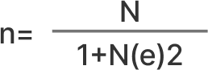

Figure 3.6 Sampling Formula Used

N = Sample Size E = Margin of Error

3.5.0 Data Gathering Tools and Procedures

The methodology that will be employed for this project will utilize a quantitative research approach centered on requirements elicitation through an in-depth interaction with a key administrative official. As well as The primary goal was to obtain comprehensive functional and non-functional requirements for the proposed system

Interviews and Observation

The principal instrument for data collection was a Semi-Structured Interview Protocol. Which was designed to ensure both standardization and flexibility during the requirements gathering phase. Before the Interview, the researchers also prepared a list of core questions that was organized into three areas: Current Workflow Analysis, which focuses on the existing manual processes for document handling; Problem Identification, aimed at uncovering security vulnerabilities and potential risks, and System requirements elicitations to find out the desired features and necessary constraints for the digital system.

System Testing Phases

To ensure the system works as intended before deployment, Testing phases will be conducted, such as the (1) Alpha testing which will be carried out internally, it will simply be identifying bugs and resolving them, validating that all the aforementioned modules function correctly, and penetration testings to check the system’s security after we have completed a series of tests, we will be able to move on and do Beta Testing, in which end users will participate and evaluate its usability and performance. During this phase, data will be gathered through the User Acceptance Testing (UAT) and the System Accuracy Testing

System Accuracy Testing

The procedure was conducted to determine the reliability and precision of the system in processing, encrypting and storing data. A series of predefined test cases were executed to compare the system’s actual outputs against the expected results.
Furthermore we will also test the system’s reliability and responsiveness through how quickly the system identifies the faults, and how quickly it could resolve faults or security-related incidents during testing. During this phase, intentional faults and simulated anomalies such as invalid inputs, unauthorized access attempts or failed encryption tasks will be introduced to evaluate how promptly the system detects and responds to such events.

To ensure the robustness and reliability of the system’s encryption and verification process, a series of test cases will be executed, Each test case will check how accurately the system encrypts decrypts and verifies document authenticity under different content structures, each varying on text length formatting and character composition.
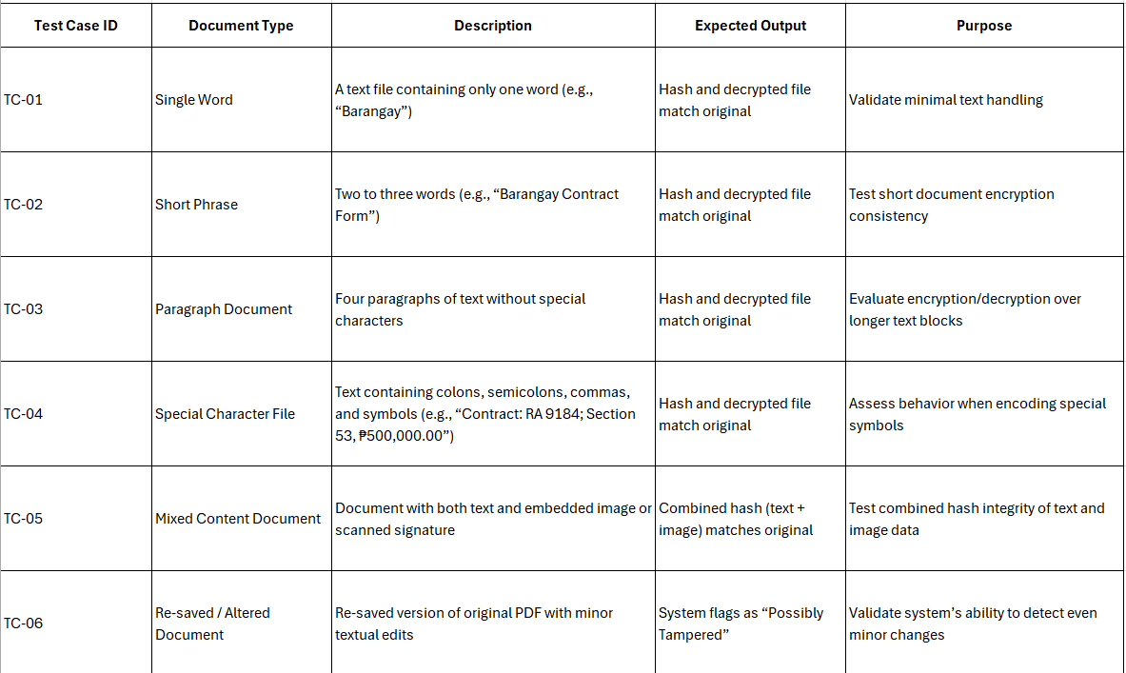

Table 3.2 Document Test Cases

- User Acceptance Testing (UAT)
This is where researchers evaluate the system functionality. Participants of this test will check if login, document management, uploading or authentication works, based on accuracy, speed, and reliability. Researchers will then use the results from the series of tests to validate whether the system works normally under conditions. Researchers will be using performance metrics using logging mechanisms such as Time on Task which is how long it would take to complete a certain function, and its success/error rate to check the efficiency and performance in securing and verifying these PDF files.

3.5.1 Procedures

The data gathering process followed a strict procedure to ensure ethical conduct and methodological integrity.
- Preparation and Authorization: Formal protocol was initiated by drafting and submitting a letter of request to the barangay captain of Sto. Niño,Biñan City, Laguna. This letter detailed the purpose, scope of the research and the nature of the interview. Once authorization was secured, the schedule and venue were finalized as well as the interviewee’s consent for a recording in order to create a transcript.
- Interview Questions Refinement: Before interview, the questions underwent an internal review by the research group so the questions are aligned with the functional goals of the system and the practical constraints of the barangay setting. Thus conducting the interview.
- Quantitative Data Collection: Once the prototype is developed, User Acceptance Testing will be conducted to the barangay staff. Participants will be asked to perform predefined system tasks while their interactions, task completion time, and error occurrences were recorded.
- Data Transcription: Interview recordings will be transcribed. And then the transcripts will be analyzed, translating qualitative data into system requirements. Involving rigorous review of the data to identify recurring concepts, and identifying the stated needs such as the reliance on physical copies and the need for training. These identified themes were systematically mapped for what the system must do and how the system should perform.
- Data analysis: The results of the System Accuracy Testing were presented as percentages to indicate the system’s precision, while UAT results will be analyzed using weighted mean and standard deviation to evaluate user satisfaction and acceptance.
All participants were informed of the study’s purpose and gave their consent prior to participation.

Data Analysis Plan

This study involved the barangay captain of Sto. Niño, Biñan laguna, as well as it’s barangay officials and staff. Based on the data that will be gathered. Since mentioned in the research design that we will be using quantitative, we will be analyzing quantitative data gathered from the system’s performance and user evaluation. The main analyses consist of the System Accuracy Testing and User Acceptance Testing (UAT), which quantitatively assess the performance of the system. Additionally, interviews will be conducted to gather supporting insights from barangay personnel regarding their experiences, The interview responses will be used to support and contextualize the quantitative findings.

Interview and Observation

Qualitative data will be primarily obtained through interviews and observations conducted in barangay Sto. Nino, Aimed at capturing the lived experiences, perceptions and the Processes they do regarding, document management, procurement processes, and security, as well as human-centered insights and offer contextual depth and holistic perspectives. The data analysis will follow the process of Thematic Analysis as proposed by Braun and Clarke (2006). The researchers will perform analysis of data such as transcribing the audio recordings of the interviews in order to gain a comprehensive understanding of the participants' responses. Each relevant statement or response from participants will be assigned a code or label that represents a specific concept like document management, manual handling, in order to make the data more easy to understand, and then group these even more into themes that capture significant insights. And then reviewing these said themes against the data to ensure coherence, repetitive themes will be merged and themes that lack data will be used to gather more data. After all is said and done, we will then interpret the final themes to study’s objectives, linking participants’ insights to the system’s design features.

System Accuracy Testing

This will focus on evaluating the system in processing, encrypting and decrypting records, accuracy will be determined by comparing the number of correctly decrypted and verified outputs against the total number of encryption, which aims to ensure the system performs its intended operations in authentication, file handling and encryption.
The process involved subjecting the system to a series of test cases which are designed to represent common operations within the barangay’s workflow for each test case, the expected output was compared with the actual output generated by the system, any deviation from the expected result was recorded as an error, while correct outputs were counted as successful operation, accuracy was computed using the following figure:

Figure 3.7 Accuracy Formula

This formula quantifies how many operations the system performed correctly out of the total test, a higher percentage would indicate that the system is reliable.
In addition to this, the accuracy of the system’s encryption and decryption functions will be specifically evaluated, in which researchers will be performing various encryption and decryption on various document files to verify whether the decrypted output matched the original file. Each successful match will indicate a correct operation, while discrepancy will be logged as an error. The researchers will use the hash values of both original and encrypted files and check if both hash outputs are identical or not.

Figure 3.8 Integrity Formula

The combination of correct outputs and integrity accuracy by matching hash provides a complete quantitative measure of the system’s data reliability and security performance.
Results of the system accuracy testing would then be summarized, indicating each test case the expected result

Table 3.3 Interpretation of System Accuracy Testing

Point | Accuracy Range | Interpretation
1 | 95-100% | Highly reliable
2 | 90-94% | reliable
3 | 80-89% | Acceptable
4 | 70-79% | Noticeable errors
5 | Below 70% | Unreliable
Both System Accuracy and Integrity Accuracy will be using the same table, but both will be interpreted separately.

User Acceptance Test

Questionnaires will be given to the respondents to evaluate the prototype and assist in the enhancement of the quality of the device and applications. The evaluation of the results will be assessed via calculating the mean or average utilized to modify the prototype further as shown by figure 3.5


Figure 3.9 Weighted Mean Formula

Feedback received during the User Acceptance Testing (UAT) phase will be gathered, organized into distinct categories encompassing design, functionality and reliability concerns. Evaluation of user suggestions will consider their potential impact and feasibility, with the identification of recurring themes within the feedback to inform decision-making in the software development process. To interpret the results, the following scale will be used:

Table 3.4 Interpretation of the UAT Scale

Point | Accuracy Range | Interpretation
1 | 1.0-1.75 | Strongly Disagree
2 | 1.76-2.50 | Disagree
3 | 2.51-3.25 | Agree
4 | 3.261-4.00 | Strongly Agree

3.6.5 Integration

After performing all data analyses, we will integrate results from the data gathering tools to provide a comprehensive assessment of the proposed system. The System Accuracy Test will establish the system’s technicality, determining whether the software correctly processes and secures data through the encryption process, and making sure the documents maintain integrity, the User Acceptance Testing will then reflect on the user’s perceived usability, and satisfaction during the system interaction.
Integration of these findings will follow a triangulated interpretation approach, in which the integrations process follows the approach of Creswell (2018) who emphasized combining quantitative indicators to form a comprehensive interpretation of system effectiveness such as the quantitative technical metrics like accuracy and integrity alongside the UAT. Additionally, insights gathered from interviews will serve as supporting context to explain observed trends.
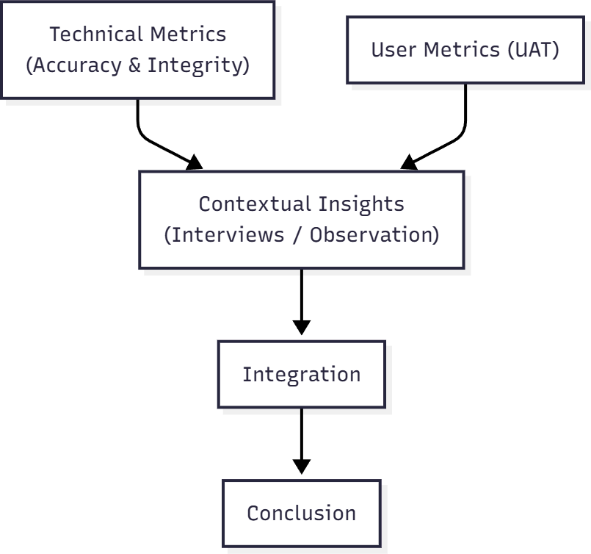

Figure 3.10 Triangulated Interpretation Diagram

Figure shown in 3.6 is the triangulated interpretation diagram that will be used to interpret the data, The Technical Metrics represents all the system-level performance tests, proof that the system works correctly and secure, which includes accuracy and integrity of the system, while the user metrics would then be the user side evaluation, how the users perceive the system and its usability. Contextual has the reasons behind the numbers, the user attitudes, workflows, human factors, the integration factor is the core of the triangulation that simply compares and all the evidence is synthesized, it checks for convergence which is where results are in agreement (system is accurate, users are satisfied), Divergence (secure system but poor usability) and
complementary which explains the low scores via interview. And lastly the output which is where researchers will draw practical conclusions based on the integrated evidence.

CHAPTER 4
RESULTS AND DISCUSSION

A. Hardware Requirements
This section presents the minimum hardware and software requirements for deploying, accessing, and using SealGuard. The server requirements correspond to the hosting configuration of the deployed application. The staff workstation and mobile device requirements are recommended minimums based on the browsers and devices used during compatibility testing.

A.1 Minimum Hardware Requirements
Table 4.1 lists the minimum hardware for the server that hosts SealGuard, the workstations used by barangay personnel, and the mobile devices used for physical document verification.
Table 4.1 Minimum Hardware Requirements
Component | Server (Hosting) | Staff Workstation | Mobile Verification Device
Processor | 0.5 virtual CPU (cloud web service) | Dual-core 64-bit processor, 2.0 GHz or higher | Quad-core smartphone or tablet processor
Memory | 512 MB RAM | 4 GB RAM | 3 GB RAM
Storage | 25 GB persistent disk for the database, keys, and stored PDF documents | Space for the PDF files to be uploaded (15 MB maximum per file) | No local storage required; documents are viewed in the browser
Display | Not applicable | 1366 × 768 resolution or higher | 720p (1280 × 720) screen or higher
Camera | Not applicable | Not required | Rear camera with autofocus, 720p (1280 × 720) or higher, for QR scanning and page capture
Network | Public internet connection served over HTTPS | Stable internet connection | Wi-Fi or mobile data connection
Peripherals | Not applicable | Printer for producing sealed hard copies (optional) | Not required

A.2 Software Requirements
Table 4.2 lists the software required to run the server and to access SealGuard from staff workstations and mobile devices.
Table 4.2 Software Requirements
Component | Requirement
Server operating environment | Linux-based cloud web service (Render) running Python 3.11
Web framework | Django 5.2
Application server | Gunicorn (one worker, four threads), with WhiteNoise serving static files
Database | SQLite, stored on the persistent disk
Document and cryptography libraries | PyMuPDF, Pillow, ReportLab, qrcode, and PyCryptodome (AES-256 and RSA-2048)
Staff workstation browser | Current version of Google Chrome, Microsoft Edge, Mozilla Firefox, or Brave on Windows, macOS, or Linux
Mobile device browser | Current version of Google Chrome (Android) or Safari (iOS/iPadOS) with camera access enabled
Connection security | HTTPS; browsers permit camera access for QR scanning only over secure connections
The server values correspond to the Render web service used for the deployed application, which provided 0.5 CPU, 512 MB of RAM, and a 25 GB persistent disk. Because SQLite allows only one write operation at a time, the deployment runs a single Gunicorn worker. Heavier concurrent use would require a larger instance or a client-server database. The workstation and mobile requirements were derived from the browsers and devices evaluated in Sections C.3 and C.4.

B. Graphical User Interface
This section presents the architecture and data design of SealGuard and the main user interfaces through which barangay personnel and the public use the system.
SealGuard provides functions for uploading, authenticating, organizing, retrieving, and verifying barangay procurement documents. Its interface supports authorized barangay personnel in managing official records while providing a public portal for document verification. The major features include document upload and digital sealing, document management, document verification, and audit monitoring.

B.1 System Architecture
The SealGuard system follows a web-based architecture designed to support secure procurement document management and public document verification. The architecture consists of three main user-facing portals: the Authenticator Portal, Personnel Portal, and Admin Portal, which communicate with the web layer and internal server for processing requests and accessing stored data.
The Authenticator Portal is intended for residents and other public users who need to verify the authenticity of a procurement document. Users submit a document through the portal, after which the request is processed by the web layer and internal server. The server performs the required authentication and verification procedures and returns a result indicating whether the document is Authentic, Tampered, or No Data.
The Personnel Portal is used by authorized barangay personnel to submit and process official procurement documents. Uploaded documents undergo the system's encryption and authentication process before the resulting document information is stored in the database. The Admin Portal provides administrative functions, including account and role management and oversight of stored documents.
At the center of the architecture is the Internal Server, which handles system requests, authentication checks, document processing, verification, and communication with the database. The database stores the document records, authentication information, and related metadata required by the system. During verification, the internal server retrieves the necessary stored information, performs the validation process, and sends the verification result back through the web layer to the requesting user.
The architecture therefore establishes a controlled flow of information between the user portals, application server, and database. This structure separates public verification from administrative and personnel functions while allowing the system to process and verify protected procurement documents through a centralized platform. The architecture and its components are illustrated in Figure 4.1.
Figure 4.1 System Architecture

B.2 Database Design
The database of the SealGuard system is designed to organize the information required for user management, procurement document processing, document authentication, and verification. It serves as the central storage component of the system and communicates with the internal server whenever documents or related information are uploaded, processed, retrieved, or verified.
The database stores information associated with uploaded procurement documents together with the metadata required for identification and authentication. Each processed document is associated with information such as its file identifier, owner or responsible user, and timestamp. Authentication-related information, including the document's unique integrity fingerprint and encrypted authentication data, is also maintained to support later verification.
User information is maintained separately to support the system's role-based access structure. The system has two primary roles: Admin and Barangay Staff. Admin users are responsible for managing staff accounts and system-related administrative functions, while Barangay Staff are authorized to perform the document-management functions assigned to their role.
The database also supports the document processing and verification workflow. When a document is uploaded, its relevant information is recorded and associated with the corresponding processing data. During authentication, the system retrieves the stored authentication information and compares it with the information generated from the document being verified. This allows the system to determine whether the document corresponds to the original authenticated record.
The database structure therefore provides a centralized way of organizing users, procurement document records, document metadata, and authentication information. This supports the system's document management, access control, and authenticity verification functions. The relationships among the system's data entities are presented in Figure 4.2.
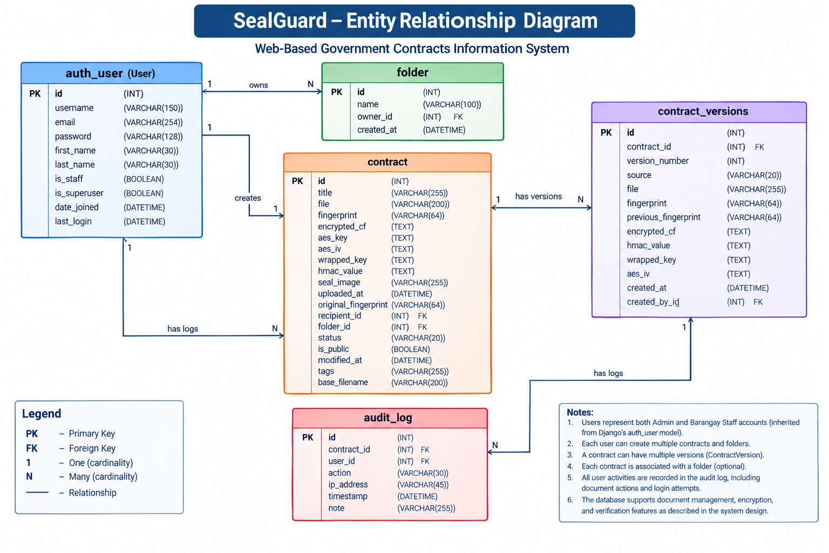
Figure 4.2 Entity Relationship Diagram

B.3 User and Role Management
The system has two user roles, Admin and barangay staff. Barangay Staff accounts are created by an Admin to ensure that only authorized personnel can access the system. Once an account is created, the Barangay Staff can log in using their assigned credentials. Users can also reset their password through their registered email address if they forget their password. A third, read-only group is available for accounts that only need to view documents shared with them. Residents register their own accounts from the sign-in page by providing a name, an email address, and a password; the account is created only after the six-digit code sent to that email address is entered. A resident account can verify documents, use physical verification, open SealGuard packages, and view or download the documents published in Public Verified Documents, and no other part of the system is available to it. A resident who forgets the password resets it with a code sent to the registered email address, while a staff password reset still requires the approval of an Admin.
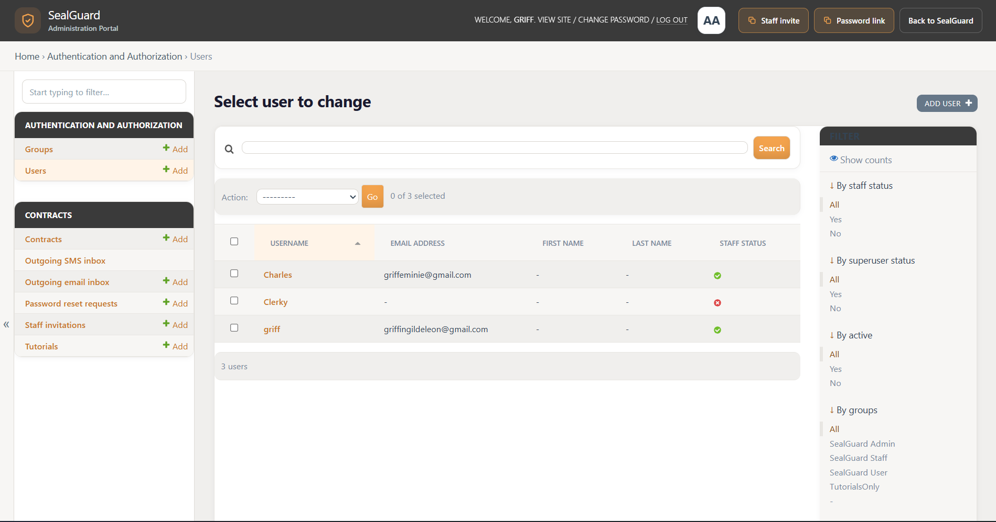
The Admin has access to user and role management functions, including creating and managing Barangay Staff accounts. The Barangay Staff can log in to the system and access the functions provided for managing and handling procurement documents. Each role is assigned appropriate permissions based on their responsibilities within the system.
After signing in, each role opens on the page that matches its daily work. Admins open the audit dashboard, where recent activity and resident usage are reviewed; Barangay Staff open the document list, where records are uploaded and maintained; and residents open the verification portal.

Figure 4.3 User and Role Management Page
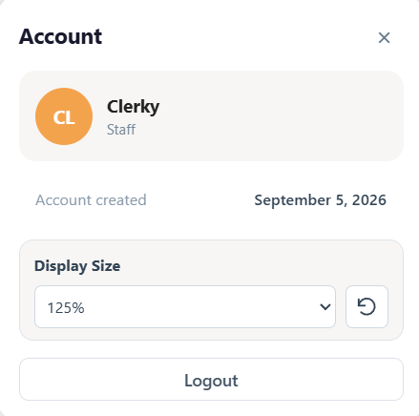
Figure 4.4 Staff Account Panel

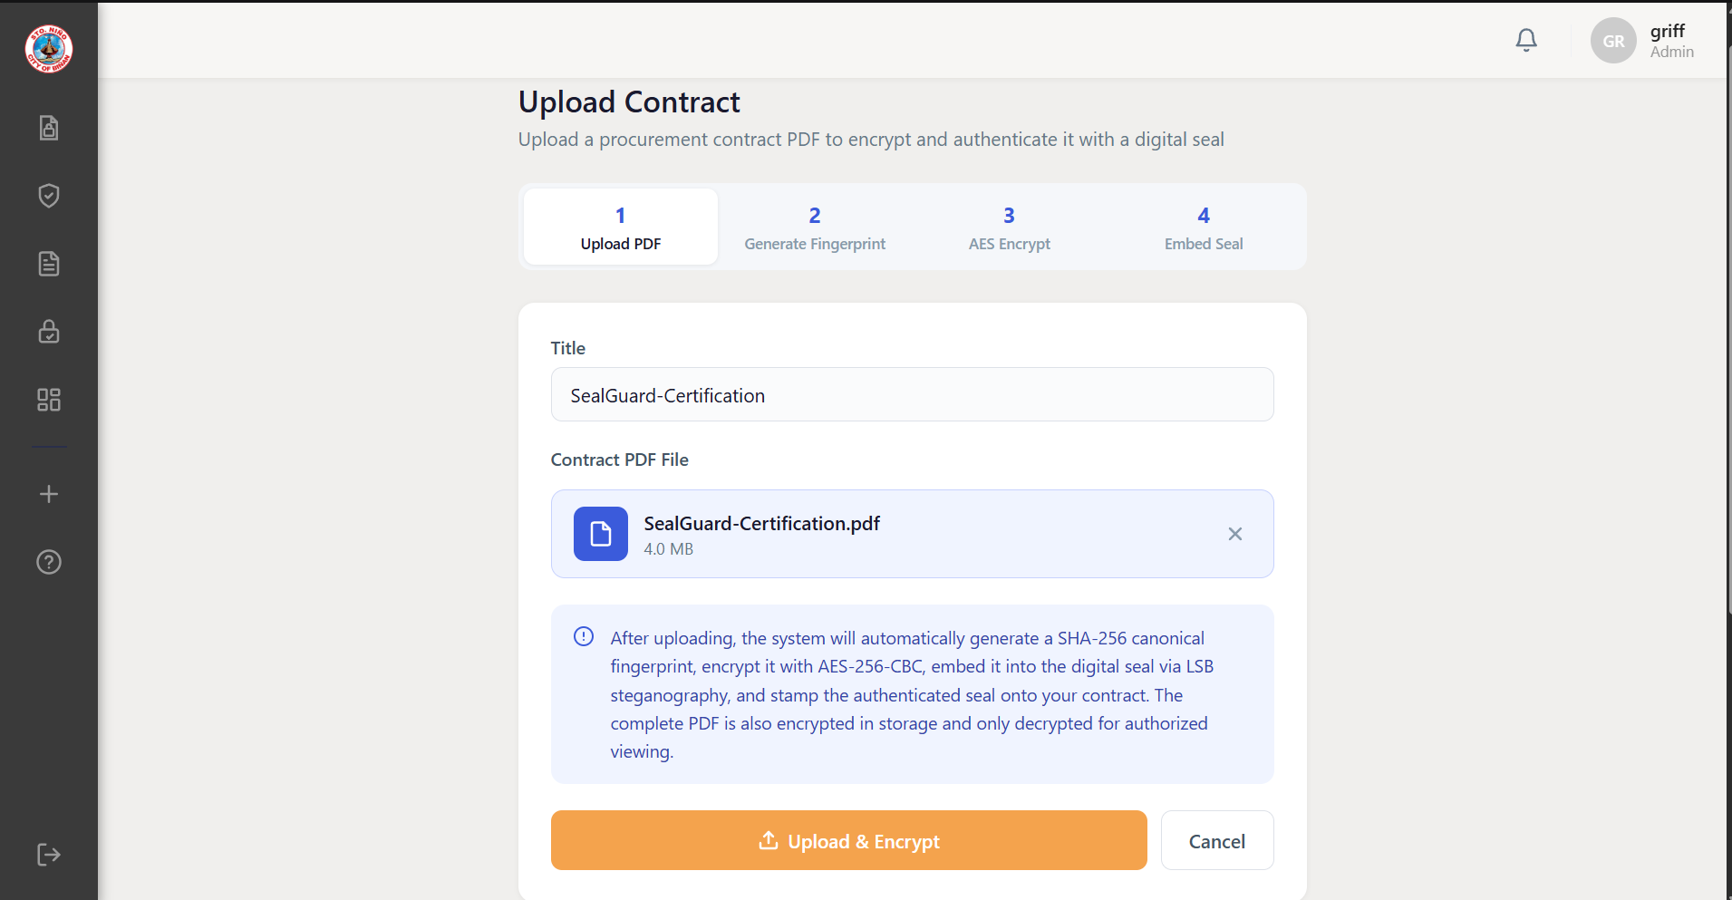
B.4 Document Upload and Digital Sealing

Figure 4.5 Document Upload Page
The document upload feature allows authorized personnel to submit procurement documents in PDF form, such as contracts, purchase orders, and notices of award, for storage and authentication. Personnel enter the document title and may choose the folder where the document is filed; the title is filled in from the file name only when the field is left empty. The system validates the uploaded file before processing it. For an authenticated upload, SealGuard generates a SHA-256 Canonical Fingerprint from the supported document components and protects the fingerprint using AES-256-CBC encryption. The associated cryptographic processing includes HMAC-SHA256 validation and RSA-OAEP key wrapping.
The encrypted verification payload is embedded into a Digital Seal through Least Significant Bit steganography. The system also adds a QR code, an authentication footer, and supporting verification metadata to the PDF. The processed document and its corresponding verification information are stored for subsequent retrieval and comparison. An optional upload-without-encryption mode allows personnel to store a document for later authentication.

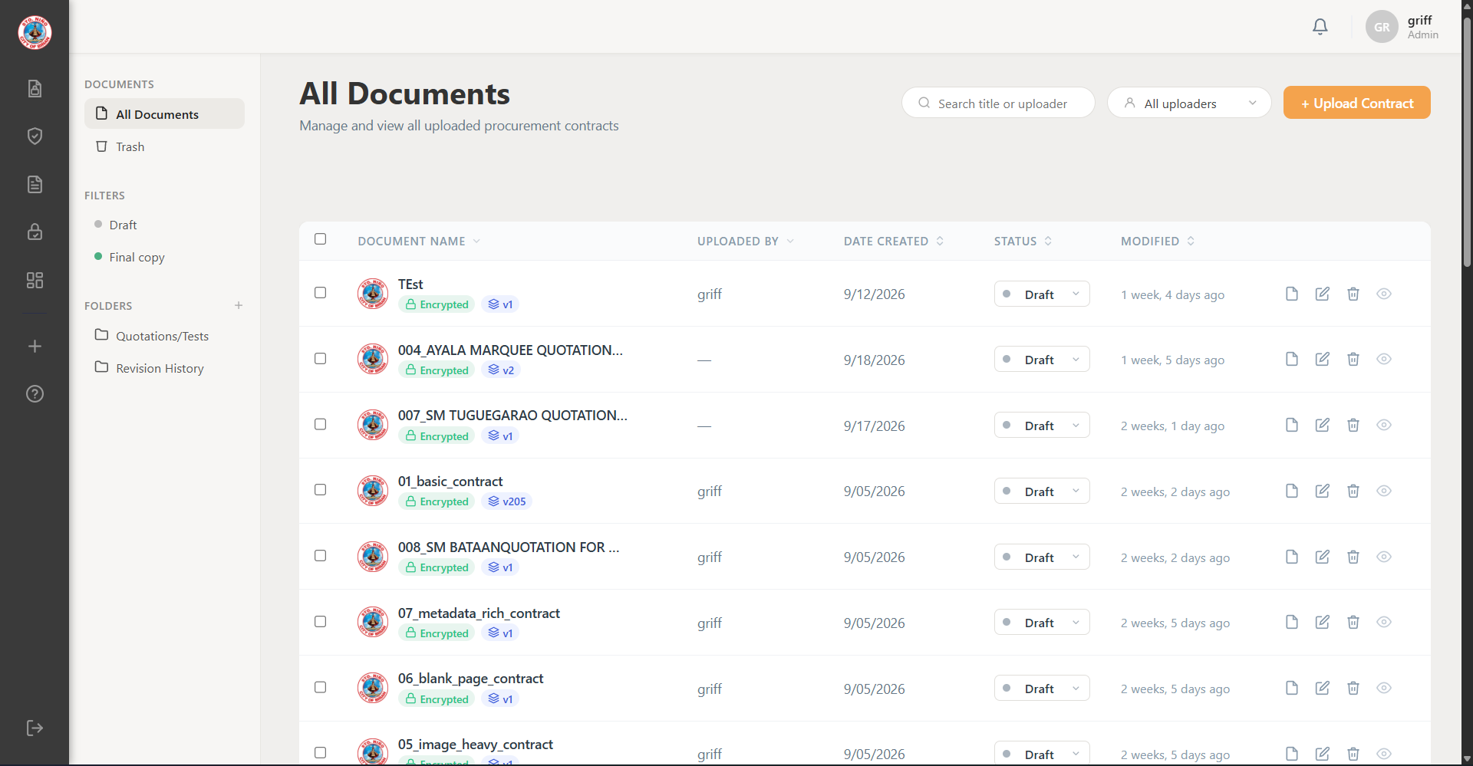
B.5 Document Management and Version History

Figure 4.6 Document Management Page
The document management feature provides a centralized workspace for organizing and retrieving stored documents. Authorized personnel can search for documents, apply filters, organize records into folders, and view documents through the integrated PDF viewer. Pagination limits the number of records displayed while retaining the selected search and filter criteria. Each document in the list shows the folder it belongs to. The folder action reads Add to Folder for an unsorted document and Move to Folder for a document that is already filed, so that personnel can tell whether the action files or relocates a record. Marking a document as the Final copy publishes it in Public Verified Documents, and returning it to Draft removes it from that list immediately; only an Admin can change this status.
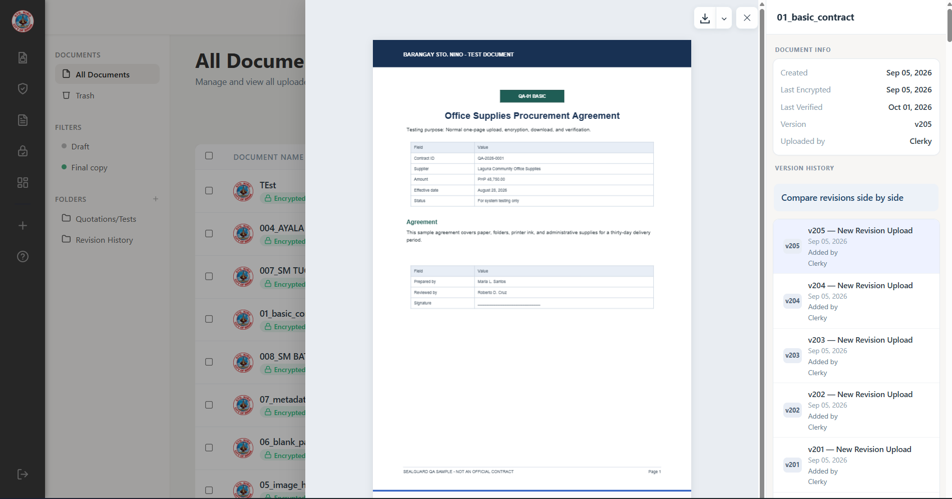
Figure 4.7 Document Version History Panel
Version control preserves successive revisions of a document. Each revision maintains its sequence, timestamp, fingerprint, and relationship to the preceding version. Duplicate detection compares content before names. The Canonical Fingerprint of an incoming file is compared with the current version of every stored document. A file with identical content is reported as already uploaded, because recording it as a revision would add a version with no changes. A matching file name or title is treated only as a suggestion that the file may be a new version. In both cases, SealGuard displays the first page of the current version beside the first page of the incoming file, and the uploader decides whether to add the file as the next revision or as a separate document; the same comparison is shown before a revision is confirmed through the Add Revision action. A file that carries a SealGuard marker and is identical, byte for byte, to a stored version is recognized as a copy that SealGuard itself issued. The system explains that the file is an unchanged copy of that version and does not record it as a revision. A printed copy that was signed by hand and scanned is instead registered through Register Signed Scan, which confirms the scan through its printed QR code and records it as the next version and Final copy of the document. Archive, restoration, Trash, and deletion functions support the document lifecycle, subject to the user’s assigned permissions.
Trash is reserved for records that should not have been uploaded. When a document is moved to Trash, the user selects one of four reasons, namely a duplicate upload, a wrong file, a test or practice upload, or a draft replaced by a newer document, and may add details. The reason is shown in Trash and recorded in the audit log. A Final copy cannot be moved to Trash, because it is the official record of the barangay; an Admin must first return it to Draft. Documents in Trash are permanently deleted after 15 days unless they are restored.

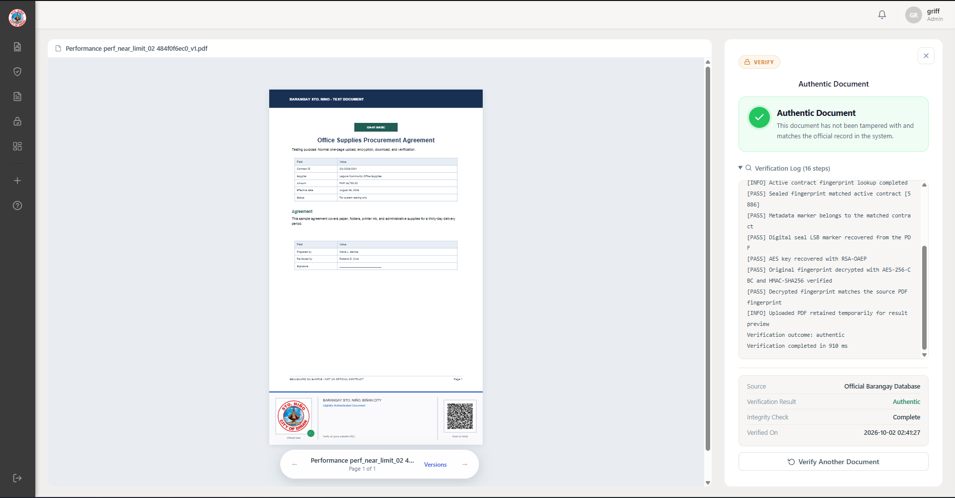
B.6 Public and Physical Document Verification

Figure 4.8 Public Verification Result Page
The public verification portal allows users to submit a PDF for comparison with official records without accessing the staff workspace. The system examines the document’s verification information and compares the applicable fingerprints with the registered baseline. It displays classification such as Authentic, Possible Modification, or Not Found.
An Authentic result indicates that the submitted document satisfies the implemented verification checks. Possible Modification indicates a detected difference or an alteration affecting verification. Such differences may result from editing or re-saving a PDF, even when the user did not intentionally change its visible contents. Not Found indicates that the submitted document cannot be associated with a registered official record.
Final copies are listed in Public Verified Documents beside the verification portal, where they can be filtered by title and opened in the PDF viewer. Viewing or downloading these documents requires a resident account so that every access is attributed to a person in the audit log, while verifying a document does not. A document that is not published can be requested through the QR access sheet printed for it. The requester provides a name, a contact address, and the reason for the request, and only an Admin can approve, reject, or revoke it. Every decision requires a written reason, which is shown to the requester, because the system does not assume that a requester is known to the barangay. When approving, the Admin sets how long access lasts, from 15 minutes to three days, so that a brief consultation and a full working-day review each receive only the time they need.
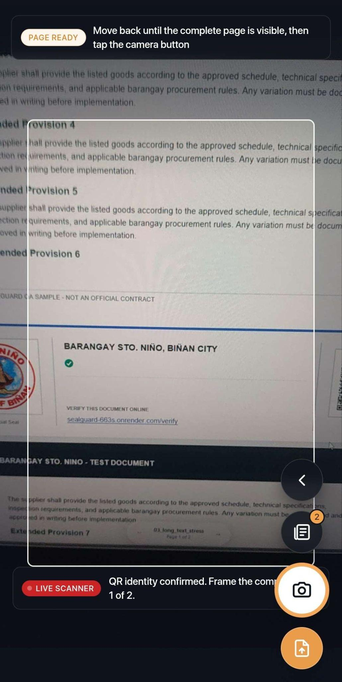
Figure 4.9 Physical Verification Live Scanner
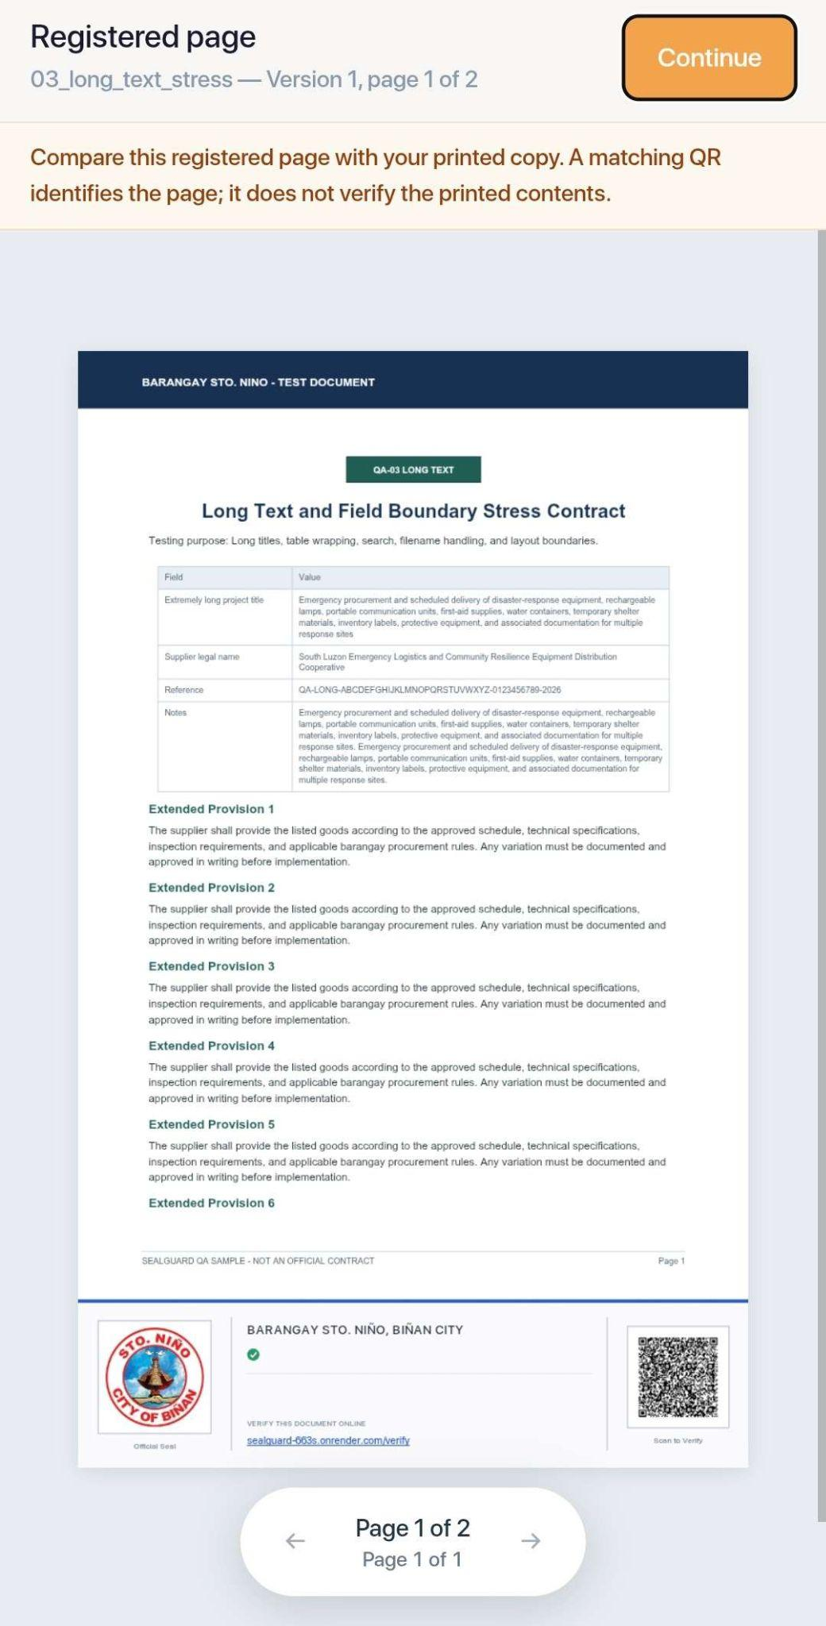
Figure 4.10 Registered Page Comparison for Physical Verification
Physical verification provides a QR-based method of locating the corresponding official document. This supports users who possess printed copies. QR recognition establishes the association with a registered record; it does not independently prove that every part of the printed document remains unchanged. For this reason, the comparison of the captured page with the registered page completes the verification. When the page is captured, SealGuard reads the QR code again from the photographed page instead of relying on the code read by the phone. Because the codes are printed with the highest QR error-correction level, a code can still be read even when part of it has been covered or drawn over. The server therefore measures how much of the error-correction capacity was needed to read the code: a clean code needs none, a small mark leads to manual review, and a code that has been drawn over is rejected with a message stating that the QR code on that page has been defaced. A code that cannot be read, or that belongs to a different page, is rejected with its own message.

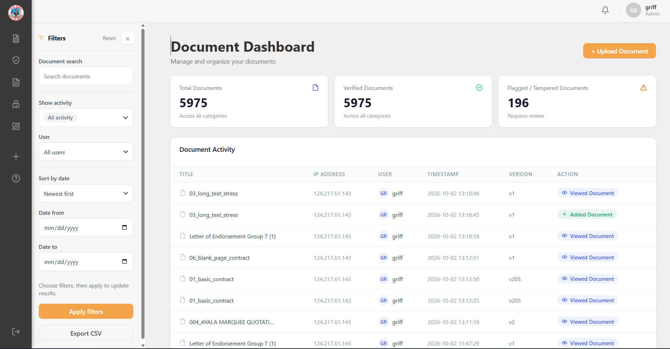
B.7 Audit Monitoring and Reporting

Figure 4.11 Audit Monitoring Dashboard
The audit dashboard records system activities to support accountability and investigation. Recorded events include authentication attempts, document management actions, viewing, downloading, and verification. Each applicable entry identifies the activity, its timestamp, and the associated user or document.
Personnel can filter the displayed records to examine relevant activities and export supported report results in CSV format. Verification entries retain diagnostic details that help explain the corresponding result. These records provide a history of document handling and assist administrators in reviewing failed access attempts or possible document modifications.

C. Alpha Testing
Alpha testing was conducted to evaluate the operation of SealGuard before its separate user evaluation. The assessment covered authentication and authorization, document management, cryptographic functions, integration, system accuracy, cybersecurity, performance and stress, reliability and fault handling, and browser and viewport compatibility. Automated Django tests, controlled manual checks, and workload testing were used according to the requirements of each section. The corresponding test parameters and expected results are presented in Appendices AE–AM.
The Django automated tests executed defined operations and compared the observed results with assertions representing the expected behavior. Where database records were required, testing used an isolated test database to keep test records separate from operational data. These automated executions also served as regression checks after changes to the application. Compatibility, performance, and penetration-testing findings were evaluated through their respective test procedures.
Alpha testing included local and deployed-environment checks, with most test areas also evaluated on the deployed SealGuard application. The deployment used a Render plan costing approximately PHP816.65 per month and operated within the resources allocated to that plan. The reported deployment observations therefore relate to that configuration. The automated Django suite results and Locust measurements below retain their recorded test environments; they are presented separately from the additional deployed-application checks.
The suite totals reported below refer to the executions recorded at different stages of testing. They are not added together as independent tests because focused suites may form part of a larger regression suite. The results are presented according to the scope and environment of each evaluation.

C.1 Unit Testing
Unit testing evaluated individual functions of SealGuard through automated Django tests. It covered authentication and authorization, document management, and the cryptographic components of the system.

C.1.1 Authentication and Authorization Testing
Authentication and authorization testing evaluated login, account lockout, user permissions, shared staff access, protected document downloads, audit recording, and session invalidation. Nine test cases were automated with Django's test framework. AUTH-04, which depends on real elapsed time, was executed against a running SealGuard server using timed login requests. The procedures and expected results for AUTH-01 through AUTH-10 are presented in Appendix AE.
Before the final tests, SealGuard was updated to record authentication events consistently, provide safe feedback for invalid credentials, enforce account lockout, apply Django permissions to restricted functions, protect document downloads, and invalidate sessions after logout.
Table 4.3 Authentication and Authorization Test Results (Appendix AE)
Test case | Procedure and observed outcome | Result
AUTH-01 | Successful Login. Thirty valid login attempts were performed, consisting of 15 Administrator and 15 Clerk attempts. Each attempt verified the assigned role, destination page, authenticated session, and corresponding audit entry. | Passed, 30/30
AUTH-02 | Unsuccessful Login. Thirty invalid login attempts were performed using incorrect passwords, unknown usernames, blank input, whitespace, and overlong values. All attempts were denied without exposing sensitive account information. | Passed, 30/30
AUTH-03 | Brute-Force Lockout. Three disposable accounts were used. For each account, the correct password still worked after four consecutive failures. After the fifth failure, the account was locked and the correct password was refused. | Passed, 3/3 accounts
AUTH-04 | Lockout Duration. Executed against a running server with three accounts. Correct-password attempts made 5, 20, and 25 seconds after the lockout were refused (9/9). A wrong attempt at 12 seconds did not extend the countdown, and the correct password was accepted at about 31 seconds (3/3). | Passed, 12/12
AUTH-05 | Logout. Twenty login-and-logout cycles were completed, consisting of ten Administrator and ten Clerk cycles. After each logout, the authenticated session was invalidated and protected pages redirected the user to the login page. | Passed, 20/20
AUTH-06 | Unauthenticated Access. Eight protected system actions were accessed without an authenticated session. All requests were redirected to the login page or otherwise denied. Private document downloads were also inaccessible without authentication. | Passed, 8/8
AUTH-07 | Role-Based Access Control. Twenty-four permission checks were performed across Administrator, Clerk, and public access. The checks covered restricted functions such as document deletion, publishing, trash management, and tutorial administration. All actions followed the configured permissions. | Passed, 24/24
AUTH-08 | Shared Document Authorization. Authenticated staff members were tested when viewing, editing, deleting, and downloading ten documents uploaded by other staff members (40 checks). These operations were permitted under the shared staff workspace policy, while destructive actions remained controlled through Django permissions. | Passed, 40/40
AUTH-09 | Authentication Audit Logs. A total of 83 expected authentication events were generated and verified. These consisted of 30 successful logins, 30 failed login attempts, three account lockouts, and 20 logout events. | Passed, 83/83
AUTH-10 | Session Reuse. Ten authenticated sessions were captured before logout. After logout, the previous session cookies were reused to access protected pages. All ten reused sessions were rejected. | Passed, 10/10
All ten authentication and authorization cases achieved their expected outcomes in their recorded executions, giving a test-case pass rate of 100% (10/10), computed as shown in Figure 4.12. The pass rate counts test cases, not individual requests. A case passed only when every request within it produced the expected result; AUTH-01 alone contained 30 login attempts, so a single wrong outcome would have failed the whole case. The rate reached 100% because the issues found in earlier test cycles, including the recording of authentication events, Clerk permissions, and the visibility of failed logins in the dashboard, were resolved before the final execution. The nine automated cases passed, and AUTH-04 passed in its timed execution. The five-failure threshold and 30-second lockout operated as configured, failed attempts during the lockout did not extend the countdown, and a successful login cleared the recorded failure count.

Figure 4.12 Authentication Test Case Pass Rate
The shared staff workspace permitted authenticated staff to view, edit, and download shared documents, while destructive actions remained subject to the assigned permissions. Public users could not retrieve private staff documents. The 83 expected authentication events were verified, and all ten attempts to reuse invalidated sessions were rejected, consistent with AUTH-08 through AUTH-10 in Appendix AE.

C.1.2 Document Management Testing
Document management testing evaluated the storage, organization, retrieval, revision, and disposal of procurement documents. Controlled user and document records were prepared through the automated test suite. The tested functions and expected outcomes for DOC-01 through DOC-12 are listed in Appendix AF.
Valid PDFs were accepted, while malformed, empty, oversized, password-protected, and incorrectly formatted files were rejected in the tested paths. Upload validation enforced the 15 MB limit and checked the extension, PDF signature, structure, and readability. Metadata checks verified the title, owner, timestamp, folder, status, and revision information.
Table 4.4 Document Management Test Results (Appendix AF)
Test Case | Document-Management Function | Result
DOC-01 | Valid PDF upload: 30 PDFs (10 small, 10 about 1 MB, 5 near the 15 MB limit, 5 four-page documents) | Passed, 30/30 accepted
DOC-02 | Invalid upload rejection: 30 files (5 each of non-PDF, empty, malformed, renamed non-PDF, over 15 MB, and password-protected) | Passed, 30/30 rejected
DOC-03 | Metadata storage: title, owner, upload time, status, and file checked for 20 documents | Passed, 20/20
DOC-04 | Authorized viewing and downloading: 20 views and 20 downloads, each with an audit record | Passed, 40/40
DOC-05 | Unauthorized viewing and downloading: 20 views and 20 downloads without signing in | Passed, 40/40 denied
DOC-06 | Archive, restore, and delete lifecycle: 10 documents moved to Trash, restored, and trashed again (30 transitions) | Passed, 30/30
DOC-07 | Version control: 10 documents with 3 versions each, checked for sequence, timestamp, and previous-version link (30 versions) | Passed, 30/30
DOC-08 | Altered version-chain detection: 10 version chains with a modified previous-version link | Passed, 10/10 detected
DOC-09 | Document search: 40 queries (10 exact titles, 10 partial titles, 10 case variations, 10 no-match) | Passed, 40/40
DOC-10 | Filtering and pagination: 50 records, 5 status filters at 10, 25, and 50 items per page (15 combinations) | Passed, 15/15
DOC-11 | Duplicate submission detection: the same PDF submitted 20 times | Passed, 20/20 detected; no duplicate record
DOC-12 | Report filtering and CSV export: 20 filter combinations and export | Passed, 20/20; export valid
All 12 document-management cases passed, with zero failures and zero errors. The complete automated test suite recorded at this stage also passed 73/73 tests. The 12/12 result represents this testing group, while 73/73 represents the wider suite executed during the same stage.
The system enforced authorized viewing and downloading, recorded the applicable audit events, and maintained the archive, restoration, and Trash workflows. Revision sequencing and altered version-chain relationships were also checked. Search, filtering, and pagination retained the selected criteria, including page-size options of 10, 25, and 50 records. These functions correspond to DOC-04 through DOC-10 in Appendix AF.
Duplicate submissions followed the intended workflow, allowing the document to be added as a revision or enrolled separately. Document selection, select-all, and bulk movement to Trash were also evaluated. Report filtering and CSV export returned the records corresponding to the selected criteria, supporting the DOC-11 and DOC-12 outcomes in Appendix AF.

C.1.3 Cryptographic Unit Testing
Cryptographic unit testing evaluated SHA-256 hashing, Canonical Fingerprint generation, AES-256-CBC encryption and decryption, HMAC-SHA256 validation, RSA-OAEP key wrapping, LSB payload processing, and sensitive-data handling. Appendix AG presents the corresponding cryptographic test parameters.
Table 4.5 Cryptographic Unit Test Results (Appendix AG)
Test case | Coverage | Result
CRY-01 | SHA-256 consistency: 30 unchanged inputs hashed twice (60 hashes) | Passed, 30/30 matched
CRY-02 | Canonical Fingerprint consistency: 20 unchanged PDFs fingerprinted 3 times each (60 runs) | Passed, 20/20 consistent
CRY-03 | Fingerprint change detection: 50 changes (10 each to text, images, metadata, structure, and vector drawings) | Passed, 50/50 detected
CRY-04 | AES-256-CBC round trips: 30 payloads (10 small, 10 of 1 KB, 10 of 10 KB) | Passed, 30/30
CRY-05 | Incorrect-key handling: 10 decryptions with the wrong key | Passed, 10/10 rejected
CRY-06 | Corrupted-ciphertext handling: 10 modified ciphertexts | Passed, 10/10 rejected
CRY-07 | HMAC-SHA256 validation: 20 valid and 20 altered values | Passed, 40/40
CRY-08 | RSA-OAEP key wrapping: 20 wrap-and-unwrap round trips and 10 wrong-key attempts | Passed, 30/30
CRY-09 | LSB embedding and extraction: 30 payloads (10 small, 10 medium, 10 near carrier capacity) | Passed, 30/30
CRY-10 | Invalid LSB payloads: 10 missing, 10 corrupted, and 10 oversized seals | Passed, 30/30 handled
CRY-12 | Sensitive-data inspection: 20 document records, 20 audit-log records, 20 HTTP responses | Passed, 60/60; no exposure
All 11 implemented cryptographic unit tests passed. The complete automated test suite executed after their integration passed 84/84 tests. The Django system check at that stage also completed without reported issues. These findings relate to the functional system check; the deployment-security findings are presented separately in Section C.6.3.
Unchanged inputs produced consistent hashes and Canonical Fingerprints. Changes to supported text, image, metadata, and structural components altered the Canonical Fingerprint. Vector drawing commands were evaluated through the separate SHA-256 vector fingerprint described in Section C.2.2 and Appendix AI. This distinction preserves the scope of CRY-03 in Appendix AG while accounting for the later vector-detection implementation.
Correct cryptographic keys recovered the original data, while incorrect keys, altered authentication values, and corrupted ciphertext were rejected. LSB embedding and extraction preserved the payload, and invalid or oversized payloads produced controlled errors. Inspection of 20 document records, 20 audit records, and 20 HTTP responses found no exposure of plaintext passwords, plaintext AES keys, or protected document contents in the inspected locations. Protected cryptographic values required for operation were distinguished from exposed secrets.
CRY-11 in Appendix AG is an authorization coverage reference. User permissions were evaluated through the authentication and document-management layers in Sections C.1.1 and C.1.2 because the low-level decryption function does not itself determine user authorization.

C.1.4 Encryption Algorithm Efficiency
Encryption algorithm efficiency testing measured the processing time of the four algorithms that implement the specific objectives of the study. The SHA-256 Canonical Fingerprint and AES-256-CBC encryption with HMAC-SHA256 generate and protect each document's integrity data (Objective 1), and the same fingerprint comparison supports verification through the public portal (Objective 2). RSA-2048 OAEP key wrapping and LSB steganographic embedding secure the encryption key and conceal the encrypted data in the Digital Seal (Objective 3). Each algorithm was executed three times on a two-page sample procurement contract using SealGuard's own processing functions. Table 4.6 reports the time of each trial and the mean of the three trials.
Table 4.6 Encryption Algorithm Efficiency
No. | Algorithm | Trial 1 (ms) | Trial 2 (ms) | Trial 3 (ms) | Mean (ms)
1 | SHA-256 Canonical Fingerprint | 3.90 | 3.75 | 3.67 | 3.77
2 | AES-256-CBC encryption with HMAC-SHA256 | 0.03 | 0.02 | 0.02 | 0.02
3 | RSA-2048 OAEP key wrapping | 0.80 | 0.78 | 0.77 | 0.78
4 | LSB steganographic embedding | 172.21 | 169.75 | 175.95 | 172.64
 | Total per document |  |  |  | 177.21

All four algorithms completed in less than one second for each document, with a combined mean of 177.21 milliseconds. LSB steganographic embedding accounted for most of this time (172.64 milliseconds) because it writes the encrypted payload into the pixels of the seal image. Fingerprint generation, AES-256-CBC encryption with HMAC-SHA256, and RSA-2048 OAEP key wrapping each completed in under 4 milliseconds. The three trials of each algorithm produced closely matching times, showing that the algorithms perform consistently and add little processing time to the document workflow.
Expert Findings. SealGuard was also evaluated by an external reviewer, Manuel V. Go, Service Delivery Program Manager of TELUS Digital Solutions, who issued a Certificate of Quality Assurance and File Integrity (Document Reference QA-VER-2026-SG01; Appendix AN). The evaluation covered core functionality, system response times, alert dispatching, and system resilience under load, and it gave SealGuard a status of Passed, stating that the system complies fully with the specified functional and quality requirements. The certificate also confirmed that the PDF files generated and exported by SealGuard are encrypted to restrict unauthorized access, viewing, and permission changes. In a file comparison between an original PDF hosted on the official website and a downloaded copy that was then edited, examined through bitstream and visual content comparison, the edited copy was verified as modified, and all of its structural and content changes were identified against the original web-hosted baseline. Annex A of the certificate shows the corresponding SealGuard results: Authentic Document for the original file and Possible Modification for the edited copy. The certificate concludes that SealGuard meets all required quality assurance benchmarks and document security standards.

C.2 Integration Testing
Integration testing evaluated whether the components of SealGuard operated correctly together across the complete document workflow, and whether the combined verification process classified documents accurately.

C.2.1 Component Integration Testing
Integration testing evaluated how document management, cryptographic processing, storage, verification, and audit logging exchanged information during complete workflows. Actual PDF documents were processed through upload, fingerprint generation, cryptographic protection, Digital Seal and QR code generation, storage, retrieval, and verification. Appendix AH identifies the integration cases and their relationship to the original end-to-end test identifiers.
Encrypted upload remained the default option. The optional Upload without encryption mode stored the PDF and its Canonical Fingerprint for later processing through bulk encryption. This provided a second entry path into the document-management and cryptographic workflow.
Table 4.7 Integration Test Results (Appendix AH)
Test case | Integrated workflow and observed outcome | Result
INT-01 | Complete lifecycle (E2E-01). Thirty PDFs were uploaded through the upload function, fingerprinted, encrypted, sealed, stored, and retrieved. For every document, the retrieved file matched the stored file. | Passed, 30/30
INT-02 | Staff and public verification (E2E-03). Each of the 30 sealed PDFs was verified once in a signed-in staff session and once in an anonymous public session: 60 operations. All returned Authentic, and each produced an audit record. | Passed, 60/60
INT-03 | Persistence after restart (E2E-04). After 20 documents were processed, the server process was stopped and started again. Every document then opened as a valid PDF (20/20), downloaded as an encrypted SealGuard package (20/20), and was verified as Authentic through the public portal (20/20). | Passed, 20/20
INT-04 | Storage and record linkage (E2E-05). For each of the 20 documents, the stored file existed and was encrypted on disk, its fingerprint and encrypted marker were stored, its version record pointed to the same file, and an upload audit entry existed. After verification, each document also had an Authentic audit entry. | Passed, 20/20
INT-05 | Cross-session persistence (added). Ten documents were uploaded in each of two separate sign-in sessions by two staff accounts. Both sessions were ended, and all 20 documents were retrieved and verified in new sessions after the restart. | Passed, 20/20
All five integration cases passed. INT-01 and INT-02 have different maximum scores because they count different units. INT-01 counts documents: each of the 30 PDFs either completed the full processing lifecycle or did not, giving 30 possible passes. INT-02 counts verification operations: each of the same 30 documents was verified twice, once in a signed-in staff session and once in an anonymous public session, giving 30 × 2 = 60 operations. Both were executed as automated Django tests and passed.
INT-03 to INT-05 were executed against a running instance of the final build. Twenty PDFs were uploaded through the web interface in two separate sign-in sessions by two staff accounts (INT-05). The stored files and database records were then inspected (INT-04), the server process was stopped and started again, and every document was retrieved, downloaded, and verified in new sessions (INT-03). All 20 documents passed each check. E2E-02 is reported as ACC-05, and the failure handling planned under E2E-06 is reported under REL-02 to REL-08 (Appendix AH).

C.2.2 System Accuracy Testing
System accuracy testing evaluated how SealGuard classified authentic, modified, and unregistered PDFs. The test was executed through the upload and public verification functions of the final build, using an isolated database, storage folder, and key pair. Thirty control PDFs were enrolled through the upload function, 50 modified copies were made from the sealed controls, and 20 PDFs were never registered. Neutral filenames were used so that no filename-based demonstration condition could influence the result. Appendix AI lists every document, its modification, its source control, and its result in each repetition. The 100 PDFs and the 300 recorded results are kept in the study's evidence folder.
A separate SHA-256 vector fingerprint was implemented to normalize and hash PDF drawing commands. During verification, the submitted document’s vector fingerprint was compared with the official baseline, and a mismatch contributed to a Possible Modification result. For existing records without a stored vector fingerprint, the official PDF provided the comparison baseline.

Table 4.8 System Accuracy Dataset and Classification Results (Appendix AI)
Dataset Category | Number of Files | Expected Classification | Correct Classifications
Authentic registered documents (5 each: single word, short phrase, paragraph, special characters, text with image, procurement layout) | 30 | Authentic | 100%
Text modifications (4 inserted, 3 replaced, 3 deleted) | 10 | Possible Modification | 100%
Image modifications (4 inserted, 3 removed, 3 replaced) | 10 | Possible Modification | 100%
Vector modifications (5 lines added, 5 rectangles added) | 10 | Possible Modification | 100%
Metadata modifications (4 Subject, 3 Author, 3 Title) | 10 | Possible Modification | 100%
Structural modifications (4 pages added, 3 pages deleted, 3 pages reordered) | 10 | Possible Modification | 100%
Valid unregistered documents | 20 | Not Found | 100%
Total | 100 | — | 100%
Each of the 100 files was submitted three times, producing 300 verification operations. All 300 returned the expected classification, and every document received the same result in all three repetitions. The authentic controls produced 90 operations, the modified documents 150, and the unregistered documents 60. Every operation created an audit record containing its verification result.
Table 4.9 System Accuracy Test Results (Appendix AI)
Test case | Measurement and observed outcome | Result
ACC-01 | Overall classification accuracy: 300/300 correct classifications. | Passed
ACC-02 | False-positive rate among authentic documents: 0/90 or 0%. | Passed
ACC-03 | False-negative rate among modified documents: 0/150 or 0%. | Passed
ACC-04 | Unregistered-document classification accuracy: 60/60 returned Not Found. | Passed
ACC-05 | Encrypted Canonical Fingerprint recovery: 30/30 decrypted fingerprints matched their original fingerprints. | Passed
ACC-06 | Digitally sealed document distinction: 30/30 sealed-document hashes differed from their source-document hashes. | Passed
ACC-07 | Overall reliability interpretation: 100% accuracy. | Passed
Overall classification accuracy was 100%, with a false-positive rate of 0% and a false-negative rate of 0%. All 60 unregistered-document operations returned Not Found. Under the interpretation in Table 3.3 of the manuscript, the controlled accuracy result was classified as Highly Reliable. These measurements correspond to ACC-01 through ACC-04 and ACC-07 in Appendix AI.
In ACC-05, all 30 decrypted Canonical Fingerprints matched their original values. In ACC-06, all 30 digitally sealed PDFs had different hashes from their source PDFs after the seal, QR code, verification footer, and supporting metadata were added. The latter result established document distinction after sealing; the cryptographic recovery measurement concerned the encrypted fingerprint and associated verification data. Both measures are identified in Appendix AI.
The 300 operations took 83.3 seconds in total, with a median of 191 milliseconds per verification request.

C.3 Web Browser Compatibility Test
Browser and viewport compatibility testing checked whether SealGuard's pages, PDF viewer, and controls displayed and worked correctly in different browsers and window sizes. Viewport testing resizes a desktop browser window to the screen size of a phone (360 × 800), a tablet (768 × 1024), a laptop (1366 × 768), and a desktop monitor (1920 × 1080). It checks the responsive layout quickly on one computer, but it does not reproduce a phone's touch input, camera, or mobile browser, so testing on actual mobile devices is reported separately in Section C.4. Initial checks identified horizontal scrolling, clipped menus, PDF viewer overflow, and controls extending beyond small screens; the navigation, viewer, filters, document list, verification page, folders, and Trash interface were refined before the final checks.
The final checks were performed manually in Google Chrome, Microsoft Edge, Mozilla Firefox, Brave, and Zen on two Windows computers, a Lenovo Legion 5 Pro laptop and a desktop computer, including checks of the deployed application. COMP-01 was carried out as manual cross-browser checks in these five browsers.
Table 4.10 Browser and Viewport Compatibility Results (Appendix AM)
Test case | Coverage and observed outcome | Result
COMP-01 | Cross-browser compatibility (manual). Login, upload, document list and search, viewing, download, archive, folders, dashboard, and public verification were checked in Chrome, Edge, Firefox, Brave, and Zen, including the deployed application. No browser-specific error affected these workflows. | Passed, 5/5 browsers
COMP-02 | Viewport compatibility. The same pages were checked at 360 × 800, 768 × 1024, 1366 × 768, and 1920 × 1080. Content and controls displayed without clipping, overlap, or horizontal page overflow. | Passed, 4/4 viewports
COMP-03 | Windows browser compatibility. The workflows were repeated on two Windows computers (a Lenovo Legion 5 Pro laptop and a desktop computer) in Chrome, Edge, and Firefox with the same functional results. | Passed, 6/6 (2 computers × 3 browsers)
All three browser categories passed after the interface refinements. The Android phone and orientation checks formerly listed as COMP-04 and COMP-05 are reported with the mobile authentication tests in Section C.4.

C.4 Mobile Compatibility Test
Mobile authentication allows a user to confirm a printed document's authenticity from a phone or tablet. The user scans the QR code printed on the sealed document with the device camera; SealGuard confirms the registered page and displays it for comparison with the printed copy, and the complete document can also be verified through the public portal (Figures 4.9 and 4.10). The mobile authentication function runs as a responsive web application in the device's browser, so no separate installation is needed. Testing was not limited to Android. Three Android phones (POCO F5, POCO F4, and Samsung Galaxy A24, all on Android 15) and two Apple devices (an iPhone 13 and a 13-inch iPad Pro) were used, each running the latest operating-system version available to it at the time of testing. Android phones formed the larger group because they were the devices most available to the researchers and are common among the intended users.
Table 4.11 Mobile Authentication Test Results (Appendix AO)
Test ID | Test and devices | Expected outcome | Result
MOB-01 | Mobile authentication on Android sign-in, public browsing, document viewing, and public verification in Chrome on a POCO F5, a POCO F4, and a Samsung Galaxy A24 (Android 15). | Pages, viewer, and verification remain usable without lost controls. | Passed, 3/3 phones
MOB-02 | Orientation mobile authentication and document viewing in portrait and landscape on the phones and the iPad. | Layout adapts without lost content or controls. | Passed, 8/8 (4 devices × 2 orientations)
MOB-03 | Mobile authentication on iOS and iPadOS: the same workflows in Safari on an iPhone 13 and a 13-inch iPad Pro, each on the latest iOS or iPadOS version available to it. | Same as MOB-01. | Passed, 2/2 devices
MOB-04 | Mobile authentication by camera QR scan: physical verification of printed sealed documents on the three Android phones, the iPhone, and the iPad, under normal conditions and adverse conditions (dim light, glare, an angled page, and partial blur). | Registered page identified; no failed scan reported as Authentic. | Passed, 25/25 (5 devices × normal and 4 adverse conditions)
MOB-05 | Mobile authentication response time: 130 QR checks (90 registered, 40 unregistered), measured during development and again on the final build (Table 4.12). | Correct response for every check; average, median, and 95th-percentile times recorded. | Passed, 130/130 (31.78 ms average)
MOB-01 to MOB-04 were performed manually by the researchers. The public pages, PDF viewer, sign-in, permission checks, and verification workflow remained usable on all five mobile devices in portrait and landscape orientation, and the camera QR scan identified the registered page under both normal and adverse conditions.
For MOB-05, the recorded timing log contained 130 QR verification requests: 90 with registered codes and 40 with unregistered codes. All 90 registered codes returned Authentic Seal, all 40 unregistered codes returned Invalid Seal, and every request returned its expected result, producing a 100% successful-request rate (130/130). The average response time was 31.78 milliseconds, the median was 28.52 milliseconds, and the 95th percentile was 55.31 milliseconds. The same 130-request mix was measured again on the final build using the QR codes printed on 20 registered documents; all 130 again returned the correct response, with an average of 34.83 milliseconds and a 95th percentile of 54.11 milliseconds (Table 4.12).

Figure 4.13 Mobile Verification Request Success Rate
Table 4.12 MOB-05 QR Verification Response Times
Measurement | Recorded timing log (development) | Final build
Requests measured | 130 (90 registered, 40 unregistered) | 130 (90 registered, 40 unregistered)
Correct responses | 130/130 | 130/130
Average response time | 31.78 ms | 34.83 ms
Median response time | 28.52 ms | 47.58 ms
95th-percentile response time | 55.31 ms | 54.11 ms
Minimum / maximum | 26.65 / 64.22 ms | 1.85 / 57.70 ms
Registered QR average | 32.13 ms | 49.25 ms
Unregistered QR average | 30.97 ms | 2.38 ms
The two measurements agree closely: the averages differ by about 3 milliseconds and the 95th percentiles by about 1 millisecond. In the final build, a registered code takes longer than an unregistered one because the server also checks the signed page manifest and prepares a preview of the registered page, while an unregistered code is rejected immediately. The 95th percentile was calculated with linear interpolation across the 130 observations.
All five mobile authentication test cases passed. Tables 4.11 and 4.12 present the device results and the response times, respectively.

C.5 Stress Testing
Stress testing evaluated the behavior of SealGuard under increasing workloads, sudden spikes, sustained use, and fault conditions.

C.5.1 Performance and Stress Testing
Performance and stress testing evaluated response time, request failures, and operational stability under sequential, concurrent, sudden-spike, and prolonged workloads. The environment used Windows, a local Django development server, Locust, SQLite, local filesystem media storage, and a disposable Clerk account. Approximately 3,000 disposable document records and 60 GB of free disk space were present. The planned workloads and expected outcomes for PERF-01 through PERF-09 are provided in Appendix AK.
The workloads exercised login, document-list access, search, dashboard access, public verification, and uploads. Thirty valid PDF fixtures were prepared: ten at 1,000,000 bytes, ten at 5,000,000 bytes, and ten at 14,500,000 bytes, all within the configured 15 MB limit. Unique titles and filenames were used in the corrected upload workload.
Table 4.13 Performance and Stress Test Results (Appendix AK)
Test case | Workload and recorded findings | Result
PERF-01 | Sequential baseline. Login, document list, search, public verification page, and public verification submission. All operations completed without failure. The p95 response time of every normal page remained below the proposed three-second threshold. | Passed, 0 failures
PERF-02 | Load ramp. 1, 5, 10, 20, 30, and 50 concurrent users. The corrected run recorded zero failures at the 20-, 30-, and 50-user levels. One failure occurred during the completed 10-user run. The observed aggregate p95 at 50 users was approximately 8.4 seconds. | Passed, all 6 load levels recorded
PERF-03 | Concurrent login. Three repetitions involving 30 concurrent users. The three repetitions completed 332, 337, and 336 requests, respectively, with zero failures. Average response times ranged from 865 to 945 milliseconds. | Passed, 1,005/1,005 requests
PERF-04 | Concurrent upload. 105 uploads across 5-, 10-, and 20-user levels using 1 MB, 5 MB, and 14.5 MB PDFs. All recorded fixture-upload windows completed without HTTP failures. | Passed, 105/105 uploads
PERF-05 | Concurrent verification. 15,302 verification requests. A total of 15,300 requests completed successfully, while two failed, producing a 0.013% failure rate. The average response time was 2.55 seconds, with a p95 of 10 seconds and a p99 of 17 seconds. | Passed, 15,300/15,302 requests (99.99%)
PERF-06 | Mixed workload. 50 users for 15 minutes performing login, viewing, searching, verification, uploading, and dashboard operations. The initial run completed 15,674 requests with 732 failures, equivalent to a 4.67% failure rate. After correcting duplicate upload titles and filenames, the focused follow-up upload test completed with zero failures. | Passed, 4.67% failure rate (within the 5% limit)
PERF-07 | Sudden spike. Three repetitions involving 50 users spawned at five users per second. The three repetitions completed 1,476, 1,609, and 1,351 requests without failure. The system remained operational without requiring a restart. | Passed, 4,436/4,436 requests
PERF-08 | Endurance. Ten concurrent users continuously performing mixed operations for two hours. The test generated 82,259 requests, of which only 23 failed, resulting in a 0.028% failure rate. The average response time was 555 milliseconds, with a p95 of 1.8 seconds and a p99 of 2.6 seconds. No application crash or restart occurred. | Passed, 82,236/82,259 requests (99.97%)
PERF-09 | PDF response-time workload. Thirty fixture uploads consisting of ten 1 MB, ten 5 MB, and ten 14.5 MB PDFs. All fixture windows completed without HTTP failures. The recorded aggregate p95 values were 1.2 seconds for the 1 MB files, 1.2 seconds for the 5 MB files, and 2.7 seconds for the 14.5 MB files. | Passed, 30/30 uploads
Table 4.14 Sequential Baseline Response Times (Appendix AK)
Operation | Requests / failures | Average / p95
Login | 104 / 0 | 370 ms / 400 ms
Document list | 101 / 0 | 26 ms / 32 ms
Search | 101 / 0 | 15 ms / 17 ms
Public verification page | 103 / 0 | 13 ms / 15 ms
Public verification submission | 103 / 0 | 103 ms / 120 ms
All baseline operations completed without failures and remained below the proposed three-second p95 threshold. Concurrent login generated a combined 1,005 requests with no failures. At 50 users, the load-ramp interface displayed an aggregate p95 of approximately 8.4 seconds. These findings correspond to PERF-01 through PERF-03 in Appendix AK.
The concurrent verification test completed 15,300 of 15,302 requests successfully. The initial mixed workload recorded 732 failures in 15,674 requests, or 4.67%. Investigation associated most failures with identical upload titles and filenames that triggered duplicate and revision-processing paths under concurrency. A focused follow-up workload using unique upload identifiers completed without HTTP failures. The follow-up confirmed the corrected upload behavior.
The sudden-spike repetitions completed 4,436 requests without HTTP failures or a required restart. During the two-hour endurance test, 82,259 requests produced 23 failures, giving a 99.972% successful-request rate. The average was 555 milliseconds, with p95 and p99 values of 1.8 and 2.6 seconds. No application crash or restart occurred. Appendix AK identifies the PERF-07 and PERF-08 workload parameters.
The PDF-size tests recorded aggregate p95 values of 1.2 seconds for the 1 MB and 5 MB windows and 2.7 seconds for the 14.5 MB window. These figures included the request window for login, upload-page access, and upload submission.
The performance results describe HTTP behavior and stability in the local test environment. Cryptographic correctness, record consistency, authorization, and fault recovery were assessed through their corresponding sections. The application remained operational during all workloads.

C.5.2 Reliability and Fault Testing
Reliability and fault testing evaluated repeated document workflows, interrupted uploads, database and storage interruptions, application restarts, duplicate requests, and cryptographic failures. Controlled interruption checks used disposable local data. Records, stored files, document status, and audit history were examined for consistency and recovery. Appendix AL presents REL-01 through REL-08 and their expected outcomes.
Table 4.15 Reliability and Fault Test Results (Appendix AL)
Test case | Procedure and observed outcome | Result
REL-01 | Repeated lifecycle. Performed 100 consecutive upload-and-verification cycles. All 100 cycles passed. Documents were uploaded and verified without observed silent corruption or incomplete records being presented as successfully processed. | Passed, 100/100 cycles
REL-02 | Interrupted upload. Ten uploads were cut off at different points of the transfer, from 10% to 95% of the file. None created a document, version, or stored file, and the next normal upload completed successfully. | Passed, 10/10
REL-03 | Database interruption. Made the database unavailable during 10 controlled operations and restored access afterward. All 10 controlled operations passed the recovery checks. No corrupted records were observed, and existing records remained usable after database access was restored. | Passed, 10/10
REL-04 | Storage interruption. Document storage was made unavailable during 10 operations (5 uploads and 5 document retrievals). None reported success or left a partial record. After storage was restored, the same 10 operations succeeded and all stored documents opened correctly. | Passed, 10/10
REL-05 | Application restart. Completed operations, stopped and restarted the application, and verified the resulting documents and records. All restart checks passed. Completed records remained retrievable, usable, and verifiable after application restart. | Passed, 20/20 documents after restart
REL-06 | Duplicate request. Replayed identical state-changing requests, including duplicate upload requests. All duplicate-request checks passed. No unintended duplicate documents or inconsistent audit behavior were observed. Duplicate PDFs followed the expected new-document or revision workflow. | Passed, 20/20
REL-07 | Failed cryptographic task. Used invalid keys and corrupted encrypted payloads in the cryptographic unit tests. All corresponding cryptographic failure tests passed. Invalid inputs were rejected safely and were not accepted as valid plaintext or authentic documents. | Passed, 30/30 (10 wrong AES keys, 10 corrupted ciphertexts, 10 wrong RSA keys)
REL-08 | Fault-response handling. Introduced invalid inputs, unauthorized access attempts, and encryption-related failures, then observed the system response. All fault-handling checks passed. Invalid or unauthorized operations were rejected without exposing sensitive failure details to users. | Passed, 100/100 (30 invalid uploads, 40 unauthorized requests, 30 encryption failures)
All eight reliability cases passed, producing a 100% test-case pass rate (8/8). REL-01 completed 100 upload-and-verification cycles, and REL-03 completed ten controlled database-interruption operations with successful recovery. Following corrective work and repeated checks, the final executions showed no observed silent corruption, unintended duplicate documents, or incomplete documents presented as successfully processed.
REL-08 confirmed that all recorded fault-handling checks achieved the expected controlled response.
Completed documents remained accessible after the tested restarts and service interruptions. Duplicate PDFs followed the defined new-document or revision workflow, and invalid cryptographic inputs were rejected. These findings support the reliability of the evaluated operations under the conditions defined in Appendix AL.

C.6 Information Assurance and Security
Security considerations guided SealGuard’s planning, development, testing, and operational requirements. The implemented controls address the risks identified in the barangay’s document workflow, while the proposed policies and maintenance procedures support continued secure use.

C.6.1 Pre-Development and Planning

Initial Security and Information Assurance Assessment
The requirements-gathering interview and workflow assessment identified risks involving unauthorized access, record loss, delayed retrieval, and undetected changes to document contents. These findings guided the design of controlled document access, integrity verification, and audit recording.

Threat and Vulnerability Identification
Potential threats were considered across login, upload, retrieval, verification, and administrative functions and addressed through the security controls described in Section C.6.2.

C.6.2 Development and Coding Practices
SealGuard combines authentication, access restrictions, password protection, input validation, cryptographic integrity checks, and audit logging. These mechanisms protect system functions and document records while maintaining a public verification service. Security controls are applied at the application level so that access decisions do not depend solely on which buttons are displayed in the interface.

Input Validation and Output Encoding
SealGuard validates submitted form values and uploaded documents before accepting them for processing. The evaluated upload workflow enforces a 15 MB limit and checks the file extension, PDF signature, structure, and readability. Empty, malformed, incorrectly formatted, oversized, and unsupported password-protected files are rejected with an appropriate error.
Django forms provide validation for required fields and supported values. Template escaping and controlled handling of submitted content reduce script-injection risks, while database operations use Django’s query mechanisms. CSRF protection checks applicable requests that change system state. These controls complement authentication and authorization checks.
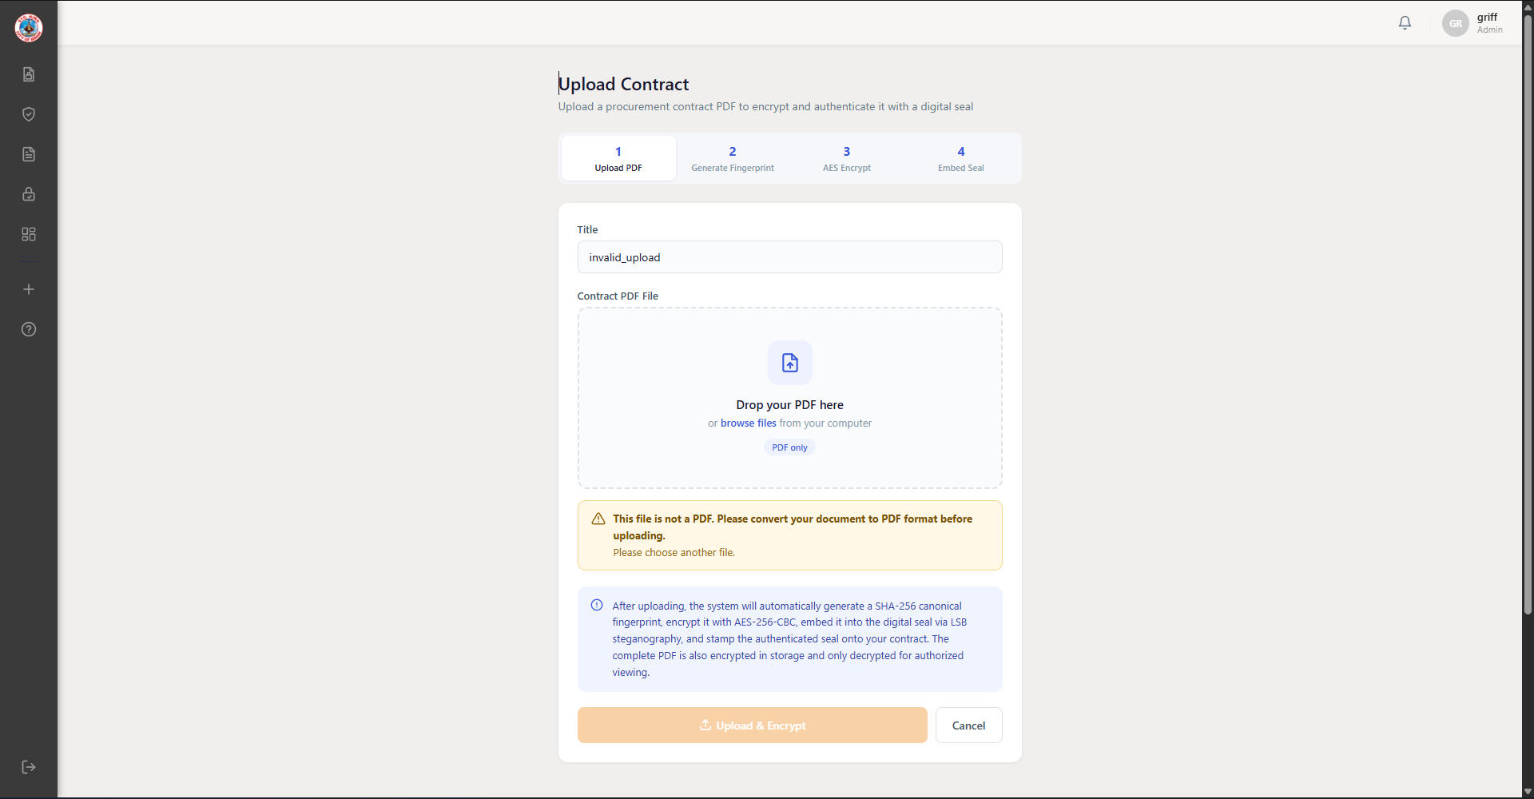
Figure 4.14 Upload Validation for Non-PDF Files

Authentication and Multi-Factor Authentication
SealGuard uses the authentication framework of Django 5.2. Staff sign in with a username and password on the login page (Figure 4.15). The submitted password is checked against its stored hash, and a successful sign-in creates a server-side session. Signing out deletes the session, so an old session cookie cannot be reused. Invalid credentials receive the same general message whether the username or the password was wrong, together with the number of attempts left.
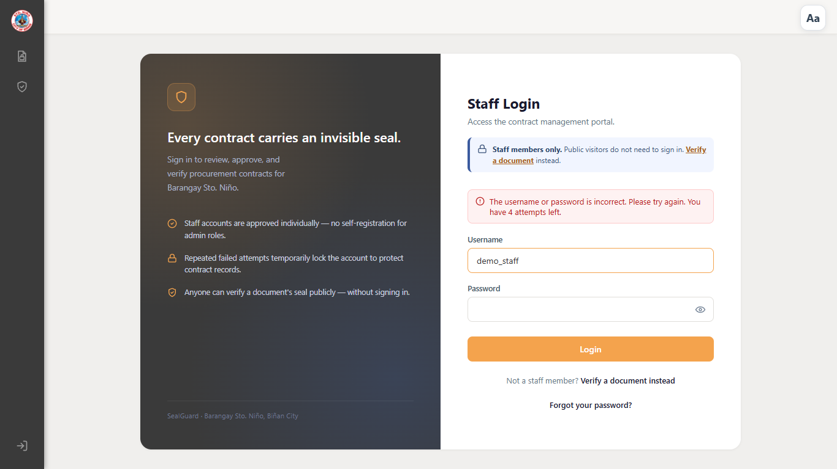
Figure 4.15 Staff Login with Remaining-Attempt Warning
After five consecutive failed attempts on an existing account, the account is locked for 30 seconds (Figure 4.16). Failed attempts during the lockout are recorded but do not extend it. A custom authentication backend refuses locked accounts before the password is checked, and every successful login, failed login, lockout, and logout is written to the audit log.
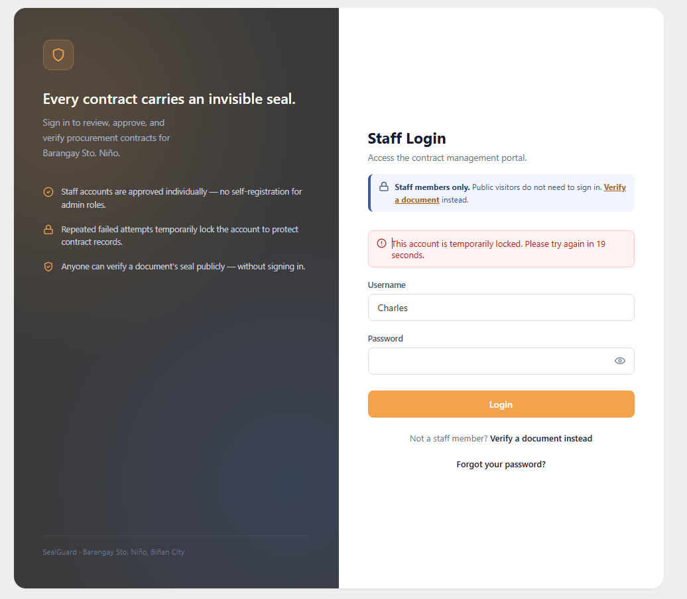
Figure 4.16 Account Lockout After Failed Login Attempts
SealGuard uses six-digit one-time verification codes as an additional factor for account actions outside the sign-in page: completing staff registration from an administrator's single-use invitation link (Figure 4.17), verifying a contact address, recovering a password after an administrator approves the reset request (Figure 4.18), creating a resident account, and recovering a resident password, which needs no administrator approval because a resident account can only verify and read published documents. Each code is generated with a cryptographically secure random number generator, stored only as an HMAC-SHA256 digest, expires after ten minutes, and allows five attempts; a new code can be requested once per minute. Codes are sent by email through an n8n workflow that relays the message to an SMTP mail server. New accounts receive a temporary password that must be changed at the first sign-in. Table 4.16 summarizes the methods and the software used.
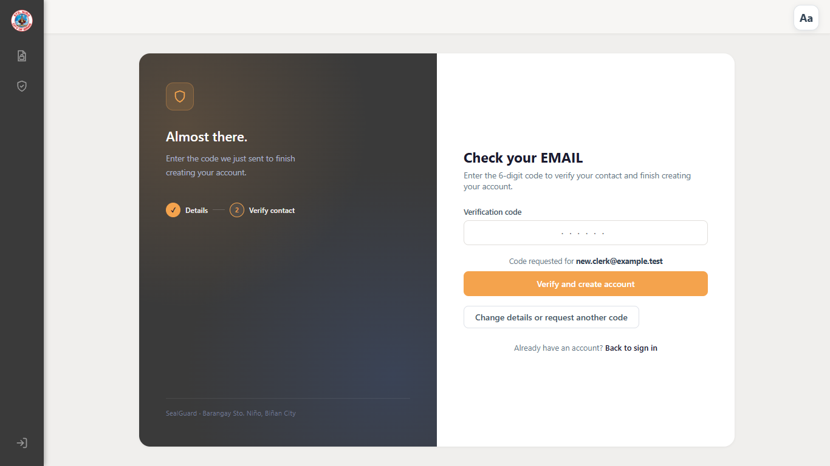
Figure 4.17 Six-Digit Verification Code During Staff Registration
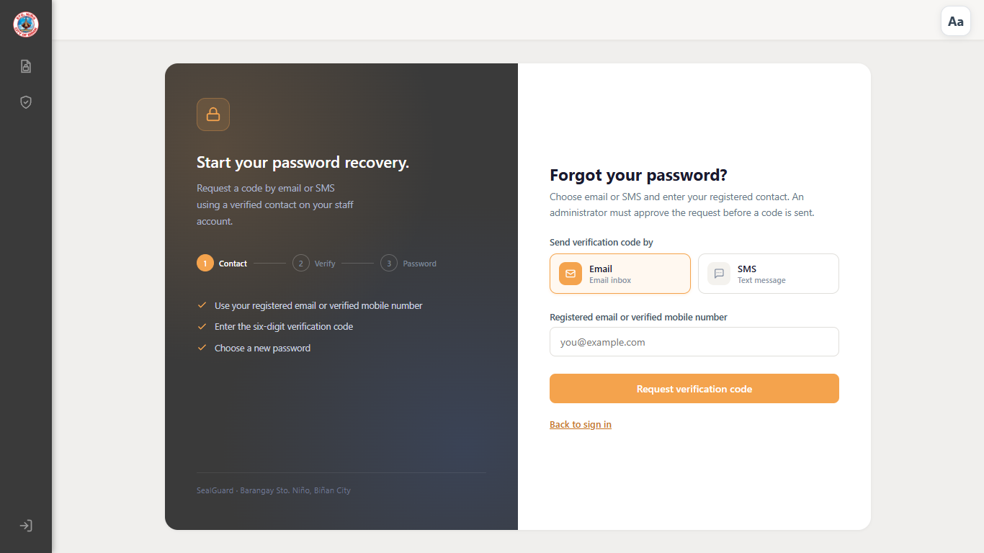
Figure 4.18 Password Recovery Request
Table 4.16 Authentication Methods and Software
Method | Software and implementation | Used for
Username and password | Django 5.2 authentication framework (LoginView with a custom form and authentication backend) | Staff, administrator, and resident sign-in
Account lockout | SealGuard authentication backend and Django cache: five failures, 30-second lock | Brute-force protection at sign-in
Server-side sessions | Django session framework; the session is deleted at logout | Keeping users signed in and preventing reuse after logout
Six-digit verification code | Python secrets module; HMAC-SHA256 digest; 10-minute expiry; five attempts | Staff and resident registration, contact verification, and password recovery
Email delivery of codes | n8n webhook workflow with an SMTP email node | Sending verification codes and account notices
Invitation link | Single-use random token stored as a SHA-256 hash; 24-hour expiry | Limiting registration to invited staff
Temporary password change | Required password change at first sign-in | New staff accounts

Least Privilege Access Control
Permissions are assigned through three Django groups. SealGuard Admin accounts manage staff accounts, invitations, password-reset approvals, and administrative settings. SealGuard Staff accounts upload, manage, and verify documents according to the permissions assigned to the group (Figure 4.19). A read-only SealGuard User group can view only documents made available to it. Destructive actions, such as permanently deleting a document, require the corresponding permission, and changes to a document are limited to its uploader or assigned collaborators. These checks use Django's permission and group framework, the login_required check on 45 views, and SealGuard's object-level access functions.
Public users access public verification functions and documents explicitly made available to them. They do not receive access to private staff records or administrative functions. Requests to protected functions are checked by the server, including requests made directly through a URL. A request for a document that the user may not open returns Not Found, so the response does not reveal whether the document exists. Staff accounts are refused by the administration site (Figure 4.20). Resident accounts belong to a separate group from the read-only SealGuard User group. A resident can reach only the verification portal, physical verification, the SealGuard package viewer, and documents published in Public Verified Documents. This restriction is applied as an allowlist checked on every request, so a page added to the system later remains closed to residents unless it is deliberately opened to them. Approving, rejecting, and revoking document access requests is limited to Admin accounts, because granting access to a document that is not public is a security decision; Barangay Staff can view the request queue but cannot decide a request.
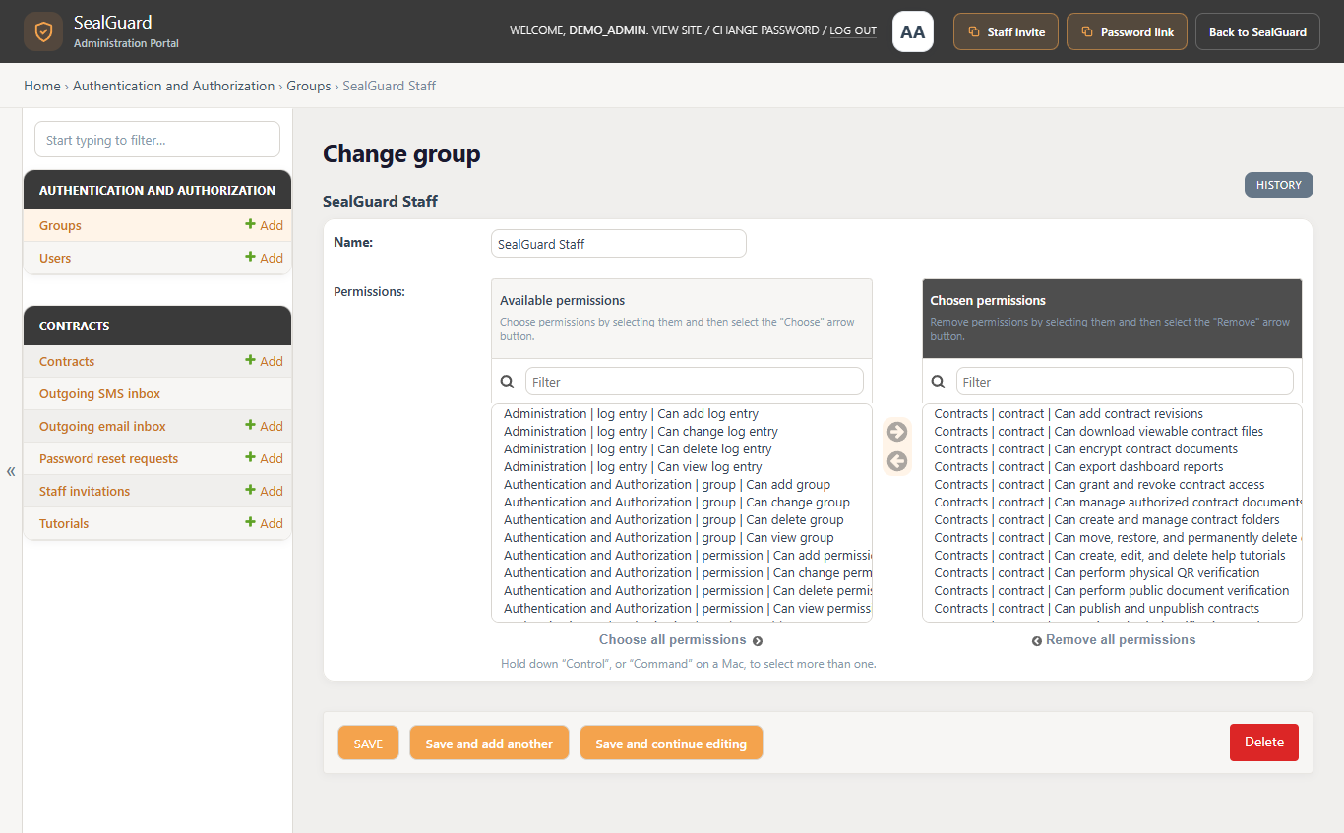
Figure 4.19 Permissions Assigned to the SealGuard Staff Group
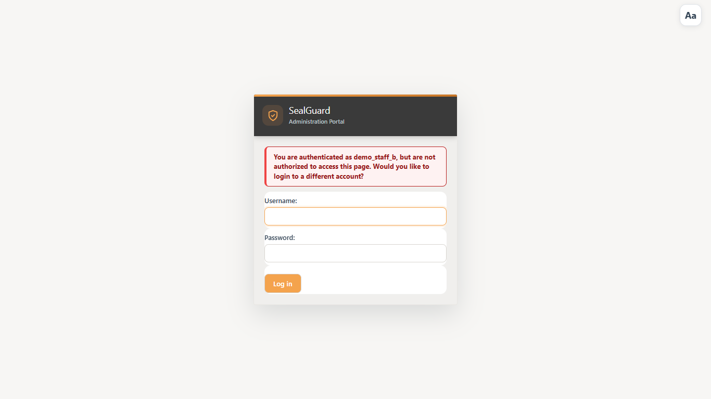
Figure 4.20 Staff Account Refused by the Administration Site
The user and role management interfaces used to assign these permissions are shown in Figures 4.3 and 4.4.

Password Storage
Passwords are never stored in readable form. Django's default password hasher, PBKDF2 with SHA-256, stores each password as a salted hash. In Django 5.2 it applies 1,000,000 iterations, and hashes created with older settings are upgraded automatically at the user's next successful sign-in. During sign-in, the submitted password is hashed with the same salt and iteration count and compared with the stored value. The administration site shows only the algorithm, the iteration count, and a masked salt and hash (Figure 4.21).
Configured password validators check password length, similarity to user information, commonly used passwords, and entirely numeric passwords when applied through the account-management workflow. These controls reduce the acceptance of weak passwords. Authentication messages and audit records do not display the submitted password.
Figure 4.21 Stored Password Shown as a Masked PBKDF2-SHA256 Hash

Security-Event Logging
Security-relevant events are written to the AuditLog table in the database: logins, failed login attempts, lockouts, logouts, uploads, edits, views, downloads, deletions, approvals, and verification results. Each entry records the user, the action, the IP address, the timestamp, the document and version where applicable, and, for verifications, the result and a step-by-step verification log. Authorized personnel filter and export these records from the audit dashboard (Figures 4.11 and 4.22). Application processing messages are also written to the server console through Python's logging module.
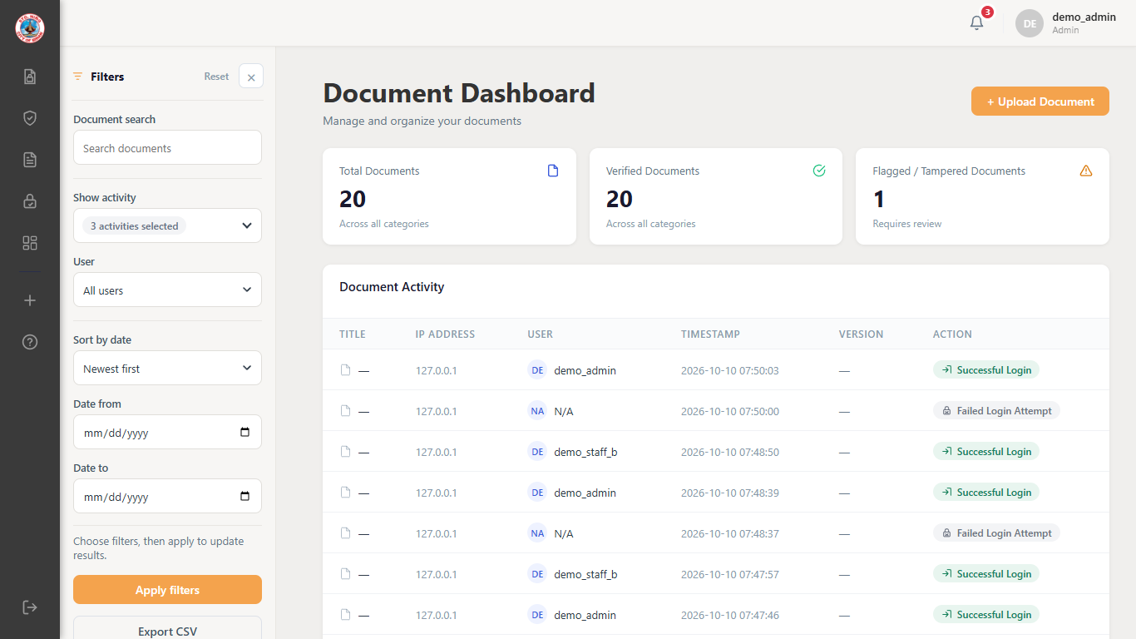
Figure 4.22 Audit Dashboard Filtered to Sign-In, Failed Sign-In, and Lockout Events

Cryptographic Integrity Protection and Protected Document Access
SealGuard generates a SHA-256 Canonical Fingerprint to represent the PDF components covered by its canonicalization rules. AES-256-CBC protects the fingerprint, HMAC-SHA256 checks the integrity of the protected fingerprint data, and RSA-OAEP with a 2048-bit RSA key pair wraps the associated AES key. LSB steganography embeds the encrypted verification payload into the Digital Seal.
Verification compares the submitted document against its official baseline. A separate SHA-256 vector fingerprint supports detection of changes to PDF drawing commands. These checks help identify modifications to the document components covered by the implemented rules.
Each verification records the checks it performed. For an authentic copy, the log shows the recomputed fingerprints matching the official record, the seal marker recovered by LSB extraction, the AES key unwrapped with RSA-OAEP, and the decrypted fingerprint passing the HMAC-SHA256 check (Figure 4.23). For an edited copy, the fingerprint comparison fails and the document is reported as Possible Modification (Figure 4.24).
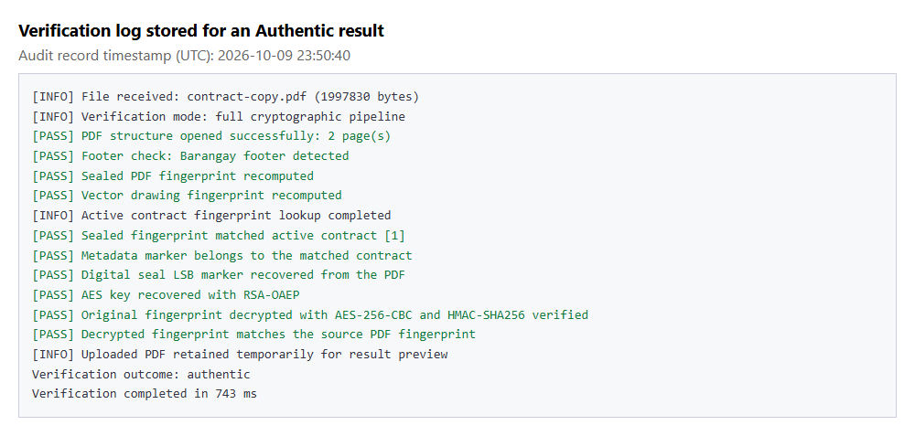
Figure 4.23 Verification Log for an Authentic Copy
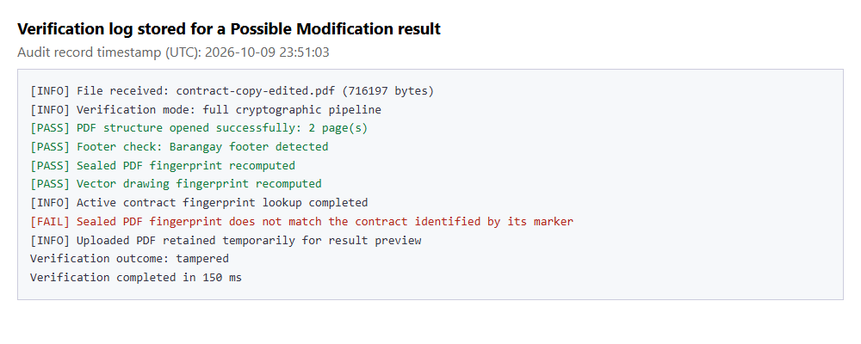
Figure 4.24 Verification Log for an Edited Copy
Protected document retrieval checks the applicable access permissions before a file is returned. Downloads are delivered as SealGuard packages that open through the SealGuard viewer (Figure 4.25). A user who is not signed in and requests a protected document is redirected to the sign-in page instead (Figure 4.26). A package (.sgpdf) is encrypted and cannot be read on its own, so a copy that is forwarded or leaked is unusable to whoever receives it. When someone opens a package without permission to view the document, SealGuard records the attempt and offers an access request for that exact document version. The package opens only after an Admin approves the request, only in the browser that submitted it, and only until the approved time ends; revoking the approval closes it again.
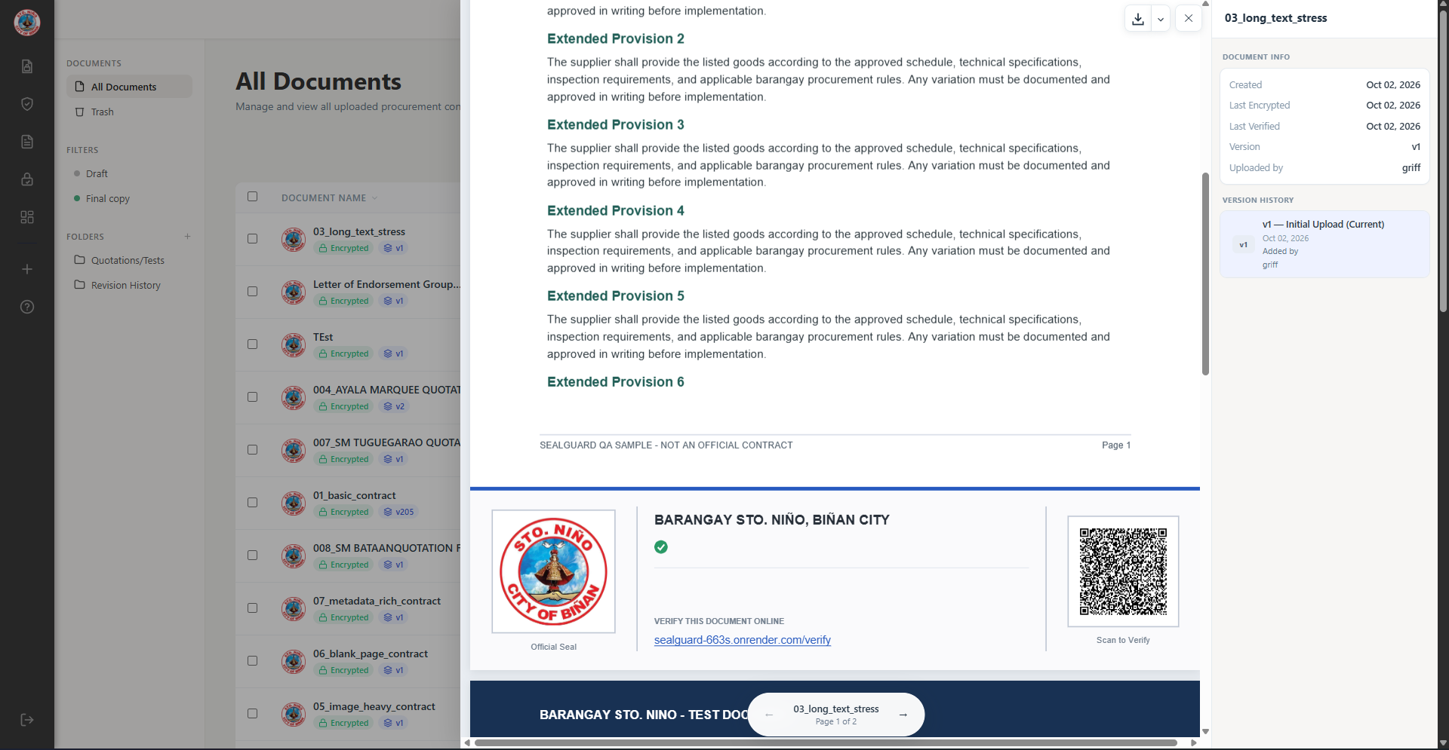
Figure 4.25 Protected Document Viewer
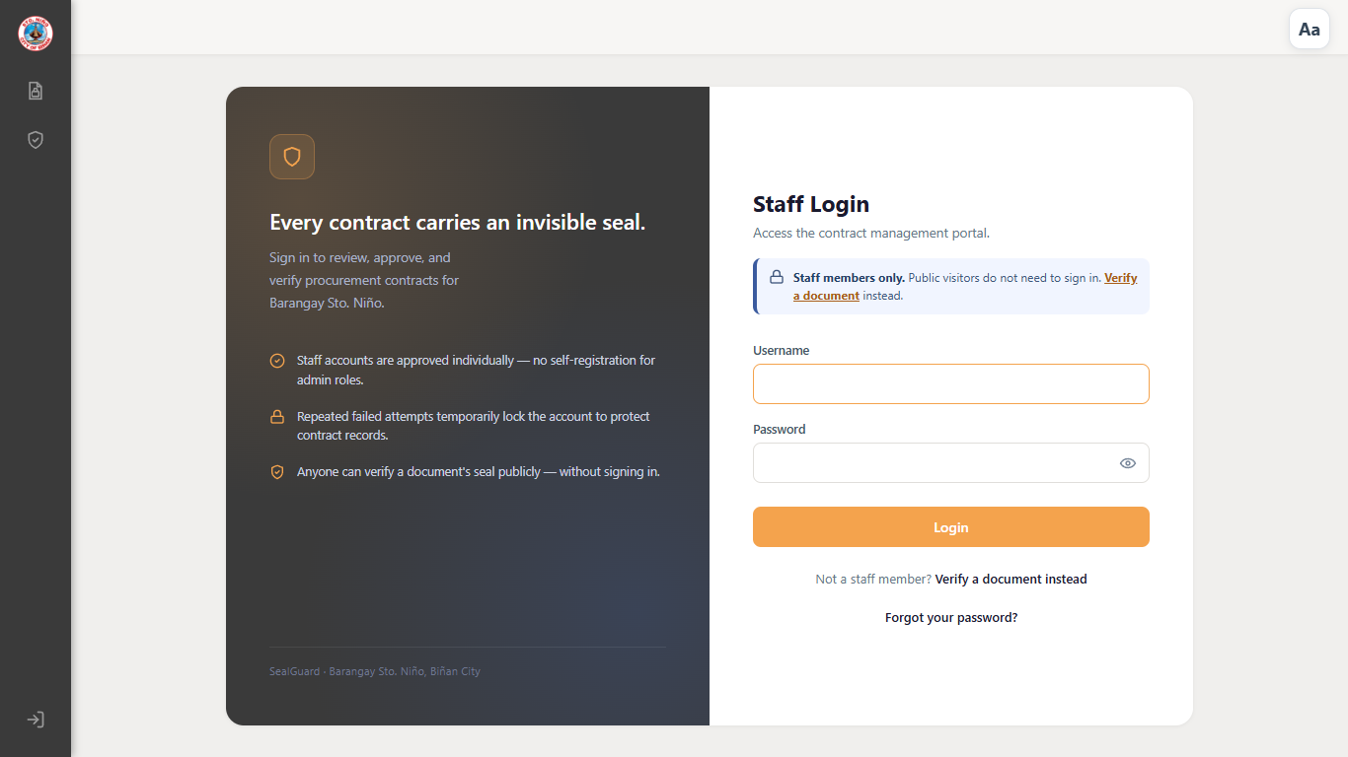
Figure 4.26 Signed-Out Request for a Protected Document Redirected to Sign-In

Security Policies
The following policies are proposed for adoption by the barangay. Items marked "(enforced)" are already applied by SealGuard; the others are procedures for barangay personnel.
- Access Control Policy
a. Each person uses an individual account; shared accounts are not allowed.
b. Staff accounts are created only through a single-use administrator invitation that expires after 24 hours (enforced).
c. Each user receives the lowest role that fits the job: SealGuard Admin, SealGuard Staff, or the read-only SealGuard User (enforced).
d. Delete, publish, and Trash permissions are granted only with the approval of the Barangay Captain or the designated System Administrator.
e. Accounts of personnel who resign or change duties are deactivated within one working day, and all accounts are reviewed every month.
f. Only Admin accounts approve, reject, or revoke document access requests, and each decision records a written reason that is shown to the requester (enforced).
g. A document is moved to Trash only with a recorded reason, and a Final copy cannot be moved to Trash (enforced).
- Password Policy
a. Passwords must have at least eight characters and must not be entirely numeric, commonly used, or similar to the username or email address (enforced).
b. The temporary password of a new account must be changed at the first sign-in (enforced).
c. Five consecutive failed sign-ins lock the account for 30 seconds (enforced).
d. Passwords are never shared, written on paper, or sent through chat or email.
e. A password is reset through the administrator-approved recovery process as soon as exposure is suspected.
f. Resident accounts reset their password with a six-digit code sent to the registered email address (enforced).
- Remote Access Policy
a. Administrative functions are used only from barangay-issued or approved devices.
b. The system is accessed only through its HTTPS address; public Wi-Fi is not used for administrative work.
c. Users sign out after each session and do not save passwords in browsers on shared computers.
d. Sign-ins from outside the barangay network are reviewed in the audit dashboard every week.
- Network Security Policy
a. The production site runs only over HTTPS with HTTPS redirect, secure cookies, and HSTS enabled (configured in the deployment settings).
b. The secret key, the RSA private key, and the email webhook secret are kept outside the source code in protected environment settings.
c. The database and stored documents are reachable only through the application; files are served only after a permission check (enforced).
d. The database, stored documents, and RSA key pair are backed up every week, and the backups are kept encrypted and offline.
- Software and Patch Management Policy
a. Security releases for Django and the other dependencies are reviewed every month, and security patches are applied within 14 days.
b. The automated regression suite is run before every release; failing tests are fixed or documented before deployment.
c. Every update is recorded in a change log with its date, version, and test result.
d. Dependency versions are pinned in the requirements file so that releases are repeatable.

C.6.3 Testing and Verification
Security testing used the following software. Automated checks were written with Django's test framework (django.test with Python's unittest runner, executed with manage.py test). Its test client sends HTTP requests to the application inside the same process and uses a separate in-memory SQLite database that is deleted after each run. AUTH-04 and the screenshots in this section used a running SealGuard server, timed requests sent with the Python requests library, and the Brave browser controlled through Playwright, which was also used to render the XSS payloads. OWASP ZAP was used for the three automated staging scans (SEC-10). The related test results are shown under each heading below.
- Brute-force testing: AUTH-03 and AUTH-04 tested the lockout threshold and duration (Table 4.17). The lockout message is shown in Figure 4.16.
Table 4.17 Brute-Force Test Results (Appendix AE)
Test case | Tool and procedure | Recorded outcome | Result
AUTH-03 | Django test framework (test client). Three accounts: four wrong passwords followed by the correct password, then five wrong passwords followed by the correct password. | The correct password was accepted after four failures and refused after the fifth failure for all three accounts. | Passed
AUTH-04 | Running server, Python requests library. Three accounts were locked with five wrong passwords; the correct password was tried at 5, 20, 25, and about 31 seconds, and one wrong password at 12 seconds. | All 9 attempts during the lockout were refused; the wrong attempt did not extend the countdown; all 3 attempts after 30 seconds were accepted. | Passed
- SQL injection: SEC-01 tested SQL-input handling (Table 4.18).
Table 4.18 SQL Injection Test Result (Appendix AJ)
Test case | Tool and procedure | Recorded outcome | Result
SEC-01 | Django test framework (test client, signed-in staff session). Five harmless injection strings (' OR '1'='1' --, 1' UNION SELECT NULL --, '/**/OR/**/1=1--, ;SELECT 1;--, and admin'--) were sent in 23 query parameters of the document list, dashboard, and public verification pages: 115 requests. | No response returned a server error, traceback, or database error message, and all database queries are built with Django's parameterised ORM. | Passed
- Cross-Site Scripting (XSS): SEC-02 tested the handling of script payloads (Table 4.19).
Table 4.19 Cross-Site Scripting Test Result (Appendix AJ)
Test case | Tool and procedure | Recorded outcome | Result
SEC-02 | Django test framework. Twenty XSS payloads, such as <script>alert(1)</script> and <img src=x onerror=alert(1)>, were checked in three ways: reflected in the document-list search, passed through the HTML sanitizer used for stored tutorial content, and reflected in the dashboard filter: 60 checks. | No payload containing markup was returned unescaped, and the sanitizer removed every payload and javascript: link. Rendered in a headless Brave browser (40 reflected, 20 stored and displayed again), none of the 60 payloads executed. | Passed

Cybersecurity and Penetration Testing Results
Cybersecurity testing evaluated selected security controls through authorized checks against the SealGuard Django application in a local or disposable environment. The assessment covered SQL-input handling, XSS contexts, CSRF rejection, authorization, private-object access, invalid uploads, direct-file access, error disclosure, and session behavior. Appendix AJ presents the SEC-01 through SEC-10 procedures and expected security outcomes.
The original coverage was expanded with isolated Django security tests. Assertions were refined to distinguish submitted executable payloads from legitimate application JavaScript and safely reflected text. The full regression suite passed 101/101 tests, and the security module passed all four of its test groups. Database migration and Django system checks also passed. These results describe separate executions and are not cumulative totals.
Table 4.20 Summary of Cybersecurity Test Results (Appendix AJ)
Test case | Coverage and observed outcome | Result
SEC-01 | SQL injection: 115 safe-payload requests (23 parameters × 5 payloads) produced no server error, traceback, or database error output. | Passed, 115/115
SEC-02 | XSS: 60 checks across reflected, sanitized stored, and dashboard contexts confirmed safe encoding or removal of submitted payloads; none of the 60 executed when rendered in a headless browser. | Passed, 60/60
SEC-03 | CSRF: all 30 requests involving missing, invalid, or cross-origin CSRF conditions were rejected with HTTP 400. | Passed, 30/30
SEC-04 | Authorization bypass: authentication, role-based access, unauthenticated-access, and security regression checks enforced the tested route and role boundaries. Prohibited unauthenticated actions did not succeed. | Passed, 24/24
SEC-05 | Object-level authorization: all 40 unauthenticated requests for private document records were denied, and shared staff access followed the workspace policy evaluated in AUTH-08. | Passed, 40/40
SEC-06 | Upload abuse: 30 invalid-upload requests using malformed, empty, invalid-type, and over-limit inputs were rejected without creating a document record. | Passed, 30/30
SEC-07 | Direct protected-file access: all 20 guessed or copied media/storage-path requests returned HTTP 404 or were denied. Protected media was not directly exposed. | Passed, 20/20
SEC-08 | Error disclosure: 30 malformed requests across login, upload, search, verification, and folder endpoints disclosed no stack trace, secret key, password, storage path, or sensitive configuration. | Passed, 30/30
SEC-09 | Session protection: logout invalidated the session and old session cookies were rejected; the production configuration enables HTTPS redirect, secure cookies, and HSTS. | Passed, 10/10
SEC-10 | Automated staging scan: three authorized OWASP ZAP scans were run against a staging deployment of SealGuard. No security issues were flagged in any of the three runs. | Passed, 3/3 runs
All 30 SEC-03 requests were rejected (HTTP 400), so no state-changing request was accepted without a valid CSRF token.
SEC-02 confirmed safe handling in all tested contexts: no submitted payload was returned as executable markup, and rendering the same 60 payloads in a headless browser confirmed that none executed. Legitimate application scripts and safely reflected plain text were distinguished from submitted payloads. SEC-05 is read together with AUTH-08, because the workspace policy permits authenticated staff to view shared documents while private records remain closed to the public.
SEC-06 confirmed that upload validation rejected every invalid file before a document record was created. In SEC-08, the Password label on the login page was identified as an ordinary form label rather than a disclosure.
The final configuration enables HTTPS redirect, secure session and CSRF cookies, and HSTS whenever debug mode is off, and the Render deployment file sets these options explicitly. The frame policy is set to SAMEORIGIN so that SealGuard can display PDFs in its own embedded viewer.

SealGuard passed the security scenarios described above, with no recorded bypass in the tested paths.

C.6.4 Post-Implementation and Maintenance

Real-Time Monitoring
The audit dashboard supports review of authentication events, document actions, and verification outcomes. Designated personnel should examine these records and relevant application logs for repeated login failures, unusual access attempts, and abnormal system behavior. Automated real-time alerts are proposed as an additional monitoring capability.

Incident Response
The proposed incident-response plan in Table 4.21 assigns each phase to a responsible person and a target time. Findings and responses are documented and used to update the policies, user guidance, and technical controls.
Table 4.21 Proposed Incident Response Plan
Phase | Actions | Responsible | Target time
1. Detection and reporting | Staff report suspicious sign-ins, lockouts, unexpected Possible Modification results, or missing documents. The System Administrator confirms the event in the audit dashboard. | Any user; System Administrator | Same day
2. Containment | Deactivate affected accounts, reset their passwords, revoke document access links, and take the public portal offline if the keys may be exposed. | System Administrator with approval of the Barangay Captain | Within 4 hours
3. Preservation | Export the audit log to CSV, copy the database, stored documents, and verification evidence files, and record what was observed. | System Administrator | Before any change is made
4. Recovery | Apply the fix or patch, change the secret key and webhook secret, restore from backup if needed, and re-verify the affected documents. | System Administrator and developer | Within 3 days
5. Notification | Inform the Barangay Captain. If personal data was exposed, notify the National Privacy Commission and the affected persons as required by the Data Privacy Act of 2012. | Barangay Captain | Within 72 hours of discovery
6. Review | Record the cause, the response, and the lessons learned; update the policies and training. | Barangay Captain and System Administrator | Within 2 weeks

Security Awareness and Training
The proposed training plan in Table 4.22 covers new staff, all staff, and the public, so that each group knows how to protect accounts, handle documents, read verification results, and report suspicious activity.
Table 4.22 Proposed Security Awareness and Training Plan
Activity | Participants | Content | Schedule
Onboarding orientation | New staff | Password rules, account lockout, verification codes, document handling, meaning of verification results, and how to report an incident | When the account is created (about 1 hour)
Refresher session | All staff | Phishing and fake login pages, password hygiene, recent incidents, and changes to the system | Every 6 months
Public verification guide | Residents | How to verify a document and what Authentic, Possible Modification, and Not Found mean | At launch; posted on the portal and barangay bulletin board
Post-incident briefing | Affected staff | What happened and what changed | After each incident

Policy Review and Audit Schedule
The proposed review and audit schedule in Table 4.23 sets how often each control is checked and what record is kept.
Table 4.23 Proposed Policy Review and Audit Schedule
Activity | Frequency | Responsible | Record kept
Review failed sign-ins, lockouts, and Possible Modification reports in the audit dashboard | Weekly | System Administrator | Review note
Review accounts and permissions; deactivate unused accounts | Monthly | System Administrator and Barangay Captain | Updated account list
Review security updates and run the regression tests | Monthly | System Administrator or developer | Change log entry
Export and archive the audit log | Monthly | System Administrator | CSV archive
Test restoring a backup | Quarterly | System Administrator | Restore test record
Review all security policies | Yearly and after any major change or incident | Barangay Captain and System Administrator | Revised policy document

D. Beta Testing
Beta testing evaluated SealGuard with its intended users through User Acceptance Testing (UAT) after alpha testing was completed.
The User Acceptance Testing (UAT) evaluation for the system was conducted using a 4-point Likert scale. The evaluation covered four criteria: User Interface Design, Functionality, Usability, and Reliability. The following statements were used to evaluate the system.
User Interface Design
1. The website is user-friendly and visually appealing.
2. I was able to locate the information I needed easily.
3. The website layout and navigation are clear and intuitive.
Functionality
4. Uploading/viewing documents is simple.
5. I can easily review the number of pending incidents and the type of report being sent.
6. The system shows if a document is authentic.
Usability
7. I did not experience any technical difficulties while using the website (e.g., slow loading times, broken links).
8. I was able to learn how to use the system without needing assistance.
9. The system is easy to navigate even for first-time users.
Reliability
10. The website functions without frequent crashes or errors.
11. The system keeps documents safe from being changed or stolen.
12. The document's integrity and contents remain the same after encryption.

D.1 UAT for Research Locale 1: Barangay Sto. Niño, Biñan City
The barangay official evaluation yielded a grand mean of 3.74, interpreted as Strongly Agree on the 4-point Likert scale, indicating a consistently positive reception of the system across all evaluation criteria. Functionality obtained the highest mean of 3.84, suggesting that respondents found core actions such as uploading and viewing documents, monitoring pending incidents, and verifying document authenticity to be working as intended. Usability received the lowest mean of 3.62, which, while still within the Strongly Agree range, suggests occasional friction such as slower loading times or a modest learning curve for first-time users. User Interface Design and Reliability both scored strongly as well, at 3.78 and 3.71 respectively, reflecting confidence in the platform's visual clarity, navigation, and its ability to keep documents secure and unaltered after encryption. The narrow spread of only 0.22 between the highest and lowest criterion means reflects a well-balanced system with no single area showing significant weakness.
Among supplementary feedback, most respondents (13 of 15) reported no difficulty locating needed information, and the majority completed document verification tasks within a short timeframe. Respondents most frequently cited the document authenticity verification feature as the system's strongest aspect, followed by ease of navigation. Suggested areas for improvement included faster load times for larger files and clearer status indicators for pending incident reports.
Table 4.24 Summary of Barangay Official UAT Results
Criterion | Items Evaluated | Overall Mean | Interpretation
User Interface Design | 3 | 3.78 | Strongly Agree
Functionality | 3 | 3.84 | Strongly Agree
Usability | 3 | 3.62 | Strongly Agree
Reliability | 3 | 3.71 | Strongly Agree
Overall Mean | 12 | 3.74 | Strongly Agree
(Scale: 3.26–4.00 Strongly Agree, 2.51–3.25 Agree, 1.76–2.50 Disagree, 1.00–1.75 Strongly Disagree)

D.2 UAT for Research Locale 2
The User Acceptance Testing (UAT) conducted among 30 residents of Barangay Sto. Niño, Biñan City, yielded a grand mean of 3.69, interpreted as Strongly Agree on the four-point Likert scale. This indicates a generally positive reception of the proposed system among residents, particularly regarding its potential to provide a convenient way to verify the authenticity of government contract documents. Functionality obtained the highest mean of 3.76, suggesting that residents found the document verification process and the system's ability to determine whether a document is authentic straightforward and useful.
User Interface Design received a mean of 3.71, reflecting positive perceptions of the website's layout, navigation, and accessibility of information. Reliability obtained a mean of 3.69, indicating that residents generally expressed confidence in the system's ability to provide consistent document verification results. Meanwhile, Usability received the lowest mean of 3.58, although it remained within the Strongly Agree range. This suggests that some residents may benefit from clearer instructions and a more straightforward verification process, particularly those with limited experience using online document verification systems.
Overall, the sample results indicate that residents may find the proposed system useful for improving public access to government contract authenticity verification. The positive evaluations across all four criteria suggest that the system has potential to support transparency and public trust by allowing residents to check documents without relying entirely on manual verification by barangay personnel. Actual conclusions should be based on the collected responses of the 30 residents.
Table 4.25 Summary of Resident UAT Results
Criterion | Items Evaluated | Overall Mean | Interpretation
User Interface Design | 3 | 3.71 | Strongly Agree
Functionality | 3 | 3.76 | Strongly Agree
Usability | 3 | 3.58 | Strongly Agree
Reliability | 3 | 3.69 | Strongly Agree
Overall Mean | 12 | 3.69 | Strongly Agree
(Scale: 3.26–4.00 Strongly Agree, 2.51–3.25 Agree, 1.76–2.50 Disagree, 1.00–1.75 Strongly Disagree)

D.3 Summary of UAT Results
The User Acceptance Testing (UAT) results for the two research locales indicate that the proposed SEALGUARD system received a positive evaluation from both barangay officials and residents of Barangay Sto. Niño, Biñan City. The barangay officials obtained an overall mean of 3.74, while the 30 residents obtained an overall mean of 3.69, both interpreted as Strongly Agree on the four-point Likert scale.
Among the four evaluation criteria, Functionality received the highest mean for both groups, with 3.84 from barangay officials and 3.76 from residents. These results suggest that the system's core features, particularly document uploading, viewing, and authenticity verification, were positively evaluated. User Interface Design and Reliability also received favorable ratings, indicating positive perceptions of the system's navigation, presentation, and consistency in verifying document authenticity.
Usability received the lowest mean for both groups, with 3.62 from barangay officials and 3.58 from residents. Although these scores remain within the Strongly Agree range, they suggest opportunities to improve the user experience through clearer instructions, simpler navigation, and faster processing of larger PDF files.
Overall, the UAT results suggest that SEALGUARD is acceptable to both barangay officials and residents and demonstrates potential to support document authenticity verification, public access to government contract information, and transparency. Further improvements in usability and system performance may enhance the user experience and strengthen the system's effectiveness in meeting the needs of its intended users.

D.4 UAT Results and the Specific Objectives
Table 4.26 relates the UAT results to the three specific objectives and the algorithms that implement them. Respondents evaluated the visible results of these algorithms, such as whether a document was shown as authentic and whether its contents stayed unchanged, not the algorithms themselves; their technical performance is reported in Sections C.1.3, C.2.2, and C.6. Item-level means were not computed, so the table uses the criterion means. Responses were summarized with the weighted mean (Figure 3.9) and interpreted with the scale in Table 3.4.
Table 4.26 UAT Results Related to the Specific Objectives
Specific objective | Algorithm or mechanism used | Related UAT criteria and items | Mean (officials / residents)
1. Extract and embed encrypted data within PDF documents | SHA-256 Canonical Fingerprint of page text, images, and metadata; AES-256-CBC encryption of the fingerprint; HMAC-SHA256 integrity check; RSA-2048 OAEP key wrapping; QR code and metadata marker | Functionality, item 4 (uploading and viewing); Reliability, item 12 (contents unchanged after encryption) | Functionality 3.84 / 3.76; Reliability 3.71 / 3.69 (Strongly Agree)
2. Public access and verification portal | Public portal that recomputes the submitted PDF's fingerprints and compares them with the official record (Authentic, Possible Modification, or Not Found); QR-based physical verification | Functionality, item 6 (shows if a document is authentic); User Interface Design, items 1-3; Usability, items 7-9 | Functionality 3.84 / 3.76; User Interface Design 3.78 / 3.71; Usability 3.62 / 3.58 (Strongly Agree)
3. LSB steganography with encryption | LSB embedding of the AES-encrypted fingerprint in the seal image's least significant bits | Reliability, items 10-12 (no crashes, documents kept safe, integrity after encryption) | Reliability 3.71 / 3.69 (Strongly Agree)
CHAPTER 5
CONCLUSION AND RECOMMENDATIONS
Conclusion
This chapter presents the conclusions drawn from the implementation, testing, and user evaluation of SealGuard, followed by the summary of findings, a discussion of the overall results, and recommendations for further improvement and broader application.
Conclusions Based on Objectives
Objective 1
To design and implement a web-based application/system that can extract and embed encrypted data within PDF documents.
The study achieved this objective through the implementation of SealGuard and its document-processing workflow. The system generates document-specific integrity information, encrypts the verification payload, and embeds it into a Digital Seal associated with the processed PDF. Successful cryptographic tests confirmed payload encryption, decryption, embedding, and extraction. Integration testing completed the document lifecycle for all 30 test PDFs, demonstrating that the processing components operated together from upload through retrieval and verification.
Objective 2
To design and implement a structured web-based public access and verification portal that enables transparent viewing and independent authenticity checking of barangay procurement documents.
The study achieved this objective by providing public document verification alongside controlled document management for barangay personnel. Public access is governed by the availability and permissions assigned to the document, while private staff records remain protected. Integration testing completed 60 successful staff and public verification operations with corresponding audit records. The Functionality mean of 3.84 and overall UAT mean of 3.74 further support user acceptance of the implemented functions.
Objective 3
To apply Least Significant Bit (LSB) steganography for embedding encrypted data within PDF files while integrating an encryption technique to further enhance data security.
The study achieved this objective by integrating LSB steganography with AES-256-CBC encryption, HMAC-SHA256 validation, RSA-OAEP key wrapping, and SHA-256 fingerprinting. Cryptographic testing confirmed successful payload recovery, correct key handling, rejection of altered cryptographic data, and LSB embedding and extraction. The verification mechanism correctly classified all 300 operations in the accuracy evaluation. These findings demonstrate the successful integration of cryptographic protection and steganographic transport for document verification.
Overall Conclusion
SealGuard achieved the study’s objectives by providing a web-based platform for managing and verifying PDF-based barangay procurement documents. The system integrated document organization, controlled access, cryptographic protection of verification data, Digital Seal processing, integrity comparison, and audit recording into a working document workflow.
The 100% classification accuracy across 300 verification operations, successful cryptographic and integration tests, and 100% reliability-test pass rate provide evidence that the evaluated functions performed according to their expected outcomes. The browser and mobile compatibility checks support access to verification functions on the evaluated browsers and devices. The UAT overall mean of 3.74 further indicates positive user acceptance of the system’s interface, functionality, usability, and reliability.
The study therefore concludes that SealGuard provides a functional and technically evaluated approach to improving the digital management and authenticity verification of barangay procurement documents. The platform supports existing procurement procedures and administrative controls by making document retrieval, verification, and activity review available through a centralized system. The findings establish a basis for continued improvement and expansion to other government document-management settings.
Summary of Findings
The study developed and evaluated a Web-Based Government Contracts Information System with Authenticity Verification Using Steganography-Based Encryption Technique for Barangay Sto. Niño, Biñan City. SealGuard provides a centralized platform for procurement document management, authenticity verification, and controlled access. Its verification workflow combines Canonical Fingerprinting, SHA-256 hashing, AES-256-CBC encryption, HMAC-SHA256 validation, RSA-OAEP key wrapping, and Least Significant Bit (LSB) steganography. The encrypted verification payload is embedded into a Digital Seal, while a separate vector fingerprint supports the detection of changes to PDF drawing commands.
Authentication and authorization testing passed all ten defined cases, and document management testing passed all 12 cases. These results confirmed the tested login, lockout, permission, session, upload, retrieval, revision, archive, and reporting functions. Cryptographic unit testing passed all 11 implemented cases. Integration testing also passed all five cases, including the complete processing lifecycle for 30 documents, 60 verification operations through the staff and public interfaces, and 20 documents that remained retrievable and verifiable after a server restart and across separate sessions.
System accuracy testing used 100 PDFs consisting of authentic registered documents, documents with inserted, deleted, replaced, or reordered text, image, vector, metadata, or page content, and valid unregistered documents. Each file was verified three times, producing 300 verification operations. All operations returned their expected classifications, resulting in 100% measured classification accuracy, a 0% false-positive rate among authentic documents, and a 0% false-negative rate among modified documents. All 60 operations involving unregistered documents returned Not Found.
The cybersecurity evaluation confirmed the expected outcomes for the application checks covering SQL-input handling, safe handling of executable payloads, rejection of invalid requests, access restrictions, upload validation, protected-file access, error disclosure, and session invalidation. The full regression suite passed 101 of 101 tests.
Performance testing demonstrated successful baseline operations below the proposed three-second p95 response-time threshold. Concurrent login completed 1,005 requests without failure, and the sudden-spike tests completed 4,436 requests without failure or a required restart. During the two-hour endurance test, the system processed 82,259 requests with a 99.972% successful-request rate and no application crash or restart. Higher concurrency increased response times. The initial mixed workload recorded a 4.67% failure rate associated mainly with duplicate upload identifiers; after the upload workload was corrected to use unique titles and filenames, the focused follow-up completed without HTTP failures.
Reliability and fault testing passed all eight defined cases. These included 100 consecutive upload-and-verification cycles and ten controlled database-interruption operations with successful recovery. The final checks confirmed that completed records remained retrievable and verifiable after the tested interruptions and restarts. Browser and viewport compatibility testing passed all three categories in the tested desktop browsers and window sizes.
All five mobile authentication test cases passed. On three Android phones, an iPhone, and an iPad, the web system supported browser access, document viewing, verification, and both screen orientations, and the camera QR scan identified registered pages under normal and adverse conditions. In the recorded response-time evaluation, all 130 verification requests returned their expected results, with a mean of 31.78 milliseconds, a median of 28.52 milliseconds, and a 95th percentile of 55.31 milliseconds; a repeat measurement on the final build averaged 34.83 milliseconds.
User Acceptance Testing yielded an overall mean of 3.74, interpreted as Strongly Agree under the scale reported in Chapter 4. Functionality received a mean of 3.84, User Interface Design received 3.78, Reliability received 3.71, and Usability received 3.62. All four criteria were interpreted as Strongly Agree. Respondents identified document authenticity verification and ease of navigation as strengths and suggested faster loading for larger files and clearer status indicators as areas for improvement.
Overall Results and Discussion
The overall results of the study indicate that the developed web-based information system was able to perform its intended functions for document management, encryption, authentication, and verification within the defined scope of the study. The system was evaluated through system accuracy, security, performance, reliability, browser and mobile compatibility, and User Acceptance Testing. The combined findings show that the major functions of the system operated as intended under the conditions and test cases defined in the study.
The system accuracy and security testing demonstrated that the document authentication process was able to distinguish documents based on their stored authenticity information. The use of encryption, canonical fingerprinting, and LSB steganography provided multiple layers for protecting and verifying PDF documents. The security tests also showed that the tested unauthorized requests, invalid inputs, and common attack scenarios were appropriately rejected. These results support the effectiveness of the implemented security controls.
Performance and reliability testing showed that the system remained operational under the tested workloads. During the two-hour endurance test, the system processed 82,259 requests with a 99.972% successful-request rate, with no application crash or restart observed. The reliability evaluation also achieved a 100% test-case pass rate, with all eight reliability cases passing. A follow-up mixed workload using unique upload identifiers completed without HTTP failures.
The browser and viewport tests showed that the system remained usable in the tested desktop browsers and window sizes, and manual checks on three Android phones, an iPhone, and an iPad showed that the web system, including verification, worked in mobile browsers. Camera QR scanning identified registered pages under normal and adverse conditions, and all 130 timed QR verification requests returned the correct result, with an average response time of 31.78 milliseconds.
Overall, the findings indicate that the proposed system achieved its primary purpose within the defined scope of the study. The system successfully integrated document management, encryption, steganographic protection, integrity checking, and document verification into a web-based platform.
Recommendations
1. Feature Enhancement
The following enhancements would extend SealGuard beyond the present study. Each was considered during development but not implemented, either because it falls outside the study's defined scope, requires the participation or authority of agencies beyond the barangay, or demands time, resources, or specialized expertise beyond those available to the researchers.
a. Independent Tamper Evidence. SealGuard currently keeps the fingerprints of official records on its own server. Future developers may anchor each fingerprint in an independent record, either through an RFC 3161 trusted timestamping authority or a permissioned ledger shared with the city government or the Commission on Audit, so that no one with access to the system could rewrite the history of a record without detection. This was not implemented because it requires inter-agency agreements beyond a single barangay and recurring timestamping fees beyond the budget of the study, both of which fall outside its scope.
b. Shared Custody of the Master Key. Future developers may store the private key of the system in a hardware security module or a cloud key-management service, rotate it on a fixed schedule, and divide it among designated barangay officials using Shamir's secret sharing, so that no single person can decrypt or reseal documents alone. This was not implemented because hardware security modules and managed key services cost considerably more than the hosting plan used for the deployed system, and shared custody requires a formal key-management arrangement among named officials, which is beyond the scope of a student-developed system.
c. Anomaly Detection on the Audit Log. Future developers may analyze the audit log to automatically flag unusual activity, such as bulk downloads, activity outside office hours, and repeated failed verifications or account lockouts, and alert the administrator when these occur. This was not implemented because a reliable detection model or baseline requires months of real usage data, which a newly deployed system does not yet have.
d. Offline Mobile Verification. Future developers may allow residents to verify a document on their phones without a server connection by checking the signed QR page manifest against the public key of the system. This was not implemented because it requires a native or offline-capable mobile application with its own key distribution, while the mobile authentication in this study was designed to run as a responsive web application in the browser.
2. Performance Improvement
Further optimization should focus on response times during higher concurrent workloads and the processing of larger PDFs. Database optimization, caching, asynchronous processing, and scalable storage and server configurations may be evaluated. A complete mixed-workload test should be repeated after the upload correction, extending the successful focused follow-up. Additional workload measurements on the deployed infrastructure would help establish capacity targets for wider use.
3. Additional Security Enhancements
Future releases should include periodic authorized security assessments, such as automated scanning with OWASP ZAP, authenticated cross-user access testing, and verification of the HTTPS settings on each deployment.
4. Mobile and Accessibility Improvements
Future mobile evaluations should extend the completed tests to more devices, including lower-end phones and older Android and iOS versions, and to printed copies with missing or damaged seals. Recording the full scan-to-result time on each phone, together with the device model and browser version, would complement the server response times reported in Chapter 4. Further accessibility testing should examine text readability, navigation, control placement, and assistance for users with different access needs.
5. System Integration
Future versions may integrate SealGuard with authorized government information systems or document repositories. Possible integrations include standardized government document identifiers, centralized authentication services, procurement information systems, and document-verification services. Integration should preserve role-based access, audit logging, document integrity mechanisms, and applicable privacy and information-security requirements.
6. Future Research
Future researchers may extend the study to other barangays or local government settings with different document workflows and infrastructure. Larger respondent groups and longer-term evaluations could examine user acceptance, operational use, and maintenance requirements. Additional research may evaluate larger repositories, higher concurrent workloads, a wider variety of PDF structures, and further document-modification scenarios.
Comparative studies may examine the implemented steganography-based approach alongside digital signatures, public-key infrastructure, and other document-authentication mechanisms. Further mobile research may measure camera-based verification on a larger sample of devices and in extended field use. These studies would provide additional evidence for the scalability and application of document authenticity verification in government records management.

References

Alanzy, M., Alomrani, A., Alqarni, F., & Almutairi, R. (2023). Hybrid cryptographic techniques for document authenticity verification. Journal of Information Security Engineering
Alanzy, M., Alomrani, R., Alqarni, B., & Almutairi, S. (2023). Image steganography using LSB and hybrid encryption algorithms. Applied Sciences, 13(21), 11771.
Aliazas, J. V., Dela Cruz, R. A., & Ilagan, N. (2024). Enhancing University Operations: A Study of the Electronic Document Management Systems (EDMS) of one higher education institution.
Almuhammadi and Al-Shaaby (2013) A survey on recent approaches combining cryptography and steganography.
Arsenault, C. (2017, March 3). Agile web development – comprehensive overview. KeyCDN Blog.
Artz, D. (2001). Digital steganography: Hiding data within data. IEEE Internet Computing

Balhaf, A. M., Al-Khalifa, H. S., Al-Habeeb, M. M., & Al-Hakeem, M. S. (2025). Digital steganography and cryptography hybrid system combining LSB and RSA algorithms. Everant Journal of Emerging Technologies.
Banga, P., Nirottam, Singh, S. K., Shubham, & Singh, P. (2023). A secure file encryption and decryption system using AES for text and images. International Journal of Research - GRANTHAALAYAH,
Bhattacharyya, D., Das, P., & Kim, T. (2020). Digital watermarking and steganography: Fundamentals and techniques. Springer.
Braun, V., & Clarke, V. (2021). Thematic analysis: A practical guide. SAGE Publications Ltd.

Commission on Audit (COA). (2021). Guidelines on the use of electronic documents and digital signatures in government transactions. eLegal Philippines.
Commission on Audit (COA). (2022). Annual audit report on local government units. COA Philippines.
Daraojimba, E. C., Nwasike, C. N., Adegbite, A. O., Ezeigweneme, C. A., & Gidiagba, J. O. (2024). Comprehensive review of agile methodologies in project management.
De Guzman, M. L. (2022). Evaluating the implementation of Republic Act 9184 in local government procurement systems. Journal of Public Administration and Governance
Department of Foreign Affairs – Office of Consular Affairs. (2024, March 19). DFA launches first e-Apostille service in the ASEAN region.
Department of Information and Communications Technology (DICT). (2023). National cybersecurity plan 2023–2028. Republic of the Philippines.
Dwivedi, R. K., & Saxena, A. K. (2020, January). Secure PDF text steganography by transforming secret into imperceptible coding.
Elmasri, R., & Navathe, S. B. (2017). Fundamentals of database systems (7th ed.). Pearson.

Eswaran, S., Krishnan, R., & Vijayalakshmi, P. (2025). Enhancing secure communication through hybrid steganography and public key cryptography. STM Journal of Modern Communication and Computing Networks.
Garrett, J. J. (2011). The elements of user experience: User-centered design for the web and beyond (2nd ed.). New Riders.
Google Cloud. (2023). Firebase Realtime Database: Security, performance, and architecture overview.
Hazel I. Harley G.(2015) THE IMPLEMENTATION OF THE PHILIPPINE GOVERNMENT ELECTRONIC PROCUREMENT SYSTEM (PhilGEPS) IN THE BICOL REGIONAL OFFICES
John W. Creswell. (2014). Research design: Qualitative, quantitative, and mixed methods approaches (4th ed.). SAGE Publications
Johnson, N. F., & Jajodia, S. (1998). Exploring steganography: Seeing the unseen. Computer, 31(2), 26–34.
Juanita., & Joan (2024) Identity document authentication using steganographic watermarking in PDF documents.
Khan, M., Siddiqa, A., & Alasmary, W. (2020). EnCoD: Distinguishing compressed and encrypted file fragments.
Kiteworks. (2025, July 6). SFTP best practices: Secure file transfer for enterprises.

Koptyra, K., & Ogiela, M. R. (2020). Distributed steganography in PDF files — Secrets hidden in modified pages. Entropy
Kozachok, A. V., Kots, G. V., & Sinelnikov, A. A. (2022). An Encrypted File Detection Algorithm. Information
KPMG Philippines. (2021, December 7). Right to access information: Not all the time!
Krug, S. (2014). Don’t make me think, revisited: A common sense approach to web usability (3rd ed.). New Riders.
Kumar, S., & Gupta, A. (2021). Secure document transmission using hybrid steganography and encryption techniques. International Journal of Computer Applications, 183(42), 12–18.
Macapagal, D. (1964). Memorandum Circular No. 78: Prescribing security measures for government documents and matters. Office of the President of the Philippines.
Marcotte, E. (2011). Responsive web design. A Book Apart.

National Privacy Commission. (2016). NPC Circular No. 16-01: Security of personal data in government agencies.
NIST. (2020). NIST SP 800-53 Rev. 5: Security and Privacy Controls for Information Systems and Organizations (Final).
Novoseltseva, E. (2024, April 15). 7 benefits of using GitHub. Apiumhub Blog

Office of the President. (1964, August 14). Memorandum Circular No. 78, s. 1964 – Safeguarding official information in the interest of the security of the state. Official Gazette of the Republic of the Philippines.
OWASP. (2023). OWASP Top 10 API Security Risks – 2023.

OWASP. (2023). Transport Layer Security Cheat Sheet. OWASP. (2024). OWASP Web Security Testing Guide (WSTG).
OWASP. (2025). OWASP Top 10 – web application security risks.
Patil, P., & Jain, R. (2020). A review on image steganography techniques. International Journal of Computer Applications, 176(29), 1–5.
PhilAtlas. (2020). Santo Niño, Biñan, Laguna profile.

Philippine Senate Legislative Reference Bureau. (2009.). Right of access to information.

Philippine Statistics Authority. (2022, April 22). PSA unveils PhilSys Check, a PhilID verification system.
Philippine Statistics Authority. (2023, September 8). PSA public advisory on viewable online civil registry documents.
Philippine Statistics Authority. (2024, February 1). PhilSys authentication services strengthen transaction security.
Philippine Statistics Authority. (2024, January 19). PSA enhances identity verification with PhilSys integration for civil registry document requests.
Prashant, Haque, M. S., Kaur, A., & Yadav, P. (2024). Comparative analysis of AES and RSA with other encryption techniques for secure communication. International Journal of Scientific Research in Computer Science, Engineering and Information Technology
Rashid, S., & Khan, N. (2025). Establishing trust through digital signatures: A comparative study of deployment strategies and infrastructure models. International Journal for Research in Applied Science and Engineering Technology (IJRASET)
Republic Act No. 10173. (2012). Data Privacy Act of 2012. Official Gazette of the Republic of the Philippines.
Republic Act No. 12009 – New Government Procurement Act. (2024, July 20). Philippines.
Republic Act No. 9184. (2003). Government Procurement Reform Act. Official Gazette of the Republic of the Philippines.
Rose, A Haralambos M (2022) Dynamic Four-Step Data Security Model for Data in Cloud Computing Based on Cryptography and Steganography. (2024).
Ryu, H. J., & Kim, Y. (2023). Design and implementation of a document encryption system combining classic ciphers with AES-256 encryption.
Sahu, P., & Swain, D. (2021). Comparative analysis of steganographic techniques for secure data hiding. International Journal of Engineering Research & Technology, 10(5), 450–456.
Satwinder Singh , & Varinder Kaur Attri (2015), Dual Layer Security of data using LSB Image Steganography Method and AES Encryption Algorithm
Satybaldy, A., Subedi, A., & Nowostawski, M. (2022). A framework for online document verification using self-sovereign identity technology. Sensors (Basel), 22(21), 8408.
Satybaldy, A., Subedi, R., & Nowostawski, M. (2022). Online document verification frameworks using self-sovereign identity and verifiable credentials. Frontiers in Blockchain
Sharma, N., & Bhattacharya, S. (2022). A review on digital signature schemes and verification techniques for secure document transmission. Journal of Information Security and Applications

Singh, S., & Karaulia, D. S. (2011, December). E-Governance: Information Security Issues. In International Conference on Computer Science and Information Technology (ICCSIT 2011)
Stallings, W. (2017). Cryptography and network security: Principles and practice (7th ed.). Pearson.
Tahir, A., & Lamakaraka, F. (2023). Management Information System in Public Service: A Review of Literature. West Science Social and Humanities Studies, 1(5), 270–281.
Tewari, P. (2025). UX Principles for Modern UI/UX Design and Their Measurement. Journal of Computer Science and Technology Studies
Titov, E., Orekhov, V., & Kostyukhin, A. (2022). Digital transformation of signatures: Suggesting functional symmetry approach for loan agreements. Informatics
Torrance, S., Lee, S., Sharp, M., Xing, L., Tirini, S., San Andres, E. A., & Vasquez, G. N. A. (2025, June). Technologies for preventing, detecting and combating anti-corruption (Issues Paper No. 15). Asia-Pacific Economic Cooperation Policy Support Unit.
Uy, E. M. (2022). Government Information Systems Plan (GISP) 2022–2028. Department of Information and Communications Technology.
- SIAR (2005). E-governance at the Local GovernmentLevel in the Philippines: An Assessment of City Government Websites
Veloso, M., & Varajão, J. (2025). Information systems function research: A scoping literature review and research agenda. Information Systems and e-Business Management.
World Bank. (2023). Assessment of Philippines public procurement system (Volume I – Main Report). The World Bank.
Yin, H.-L., Fu, Y., Li, C.-L., Weng, C.-X., Li, B.-H., Gu, J., Lu, Y.-S., Huang, S., & Chen, Z.-B.

(2022, June 9). Experimental quantum secure network with digital signatures and encryption
Yumang M. Christopher C. (2025) The Procurement Process in the Barangays of the City of Manila: Examining Practices and Alternative Systems and Problems Towards a Procurement Primer
Commission on Audit. (2023). Annual Audit Reports on Local Government Units. COA Publication Office.
Tabia, R. (2025). Vulnerabilities in LGU digital record management: A governance perspective. Journal of Local Government Studies
Kaur, G., Singh, R., & Kaur, P. (2022). A review of steganography vulnerabilities in legal and administrative document management systems. International Journal of Information and Computer Security,
Juco, M. (2024). Documentation and accountability gaps in local government project monitoring: An analysis of LGU compliance practices. Philippine Journal of Public Administration
Dela Cruz, J. M. (2024). Challenges in digital document management among Philippine barangays: Implications for public accountability. Philippine Journal of Local Governance
Santos, R., & Gatchalian, L. (2023). Vulnerabilities in barangay-level procurement and record-keeping systems under RA 9184. Journal of Public Administration and Governance
World Bank. (2023). Improving local government digital capacity in developing regions: Governance and infrastructure assessment. World Bank Publications.

Appendices

Appendix A. Data Flow Diagram

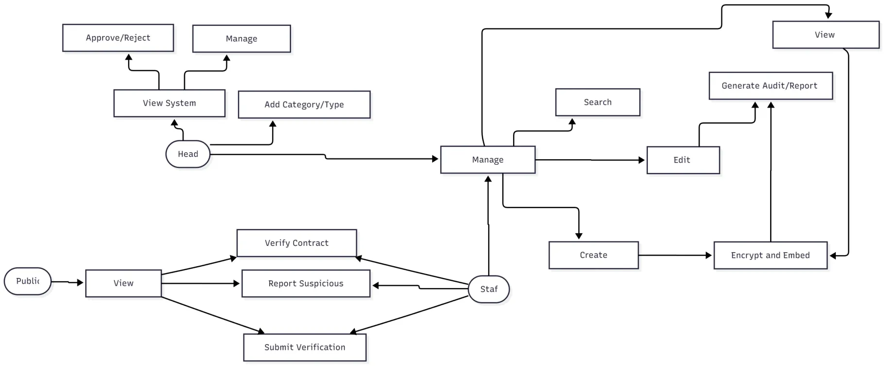

Appendix B. System Architecture Diagram
The figure illustrates the overall system architecture of the proposed system, highlighting the flow of data and interactions among users

Appendix C. Entity Relationship Diagram

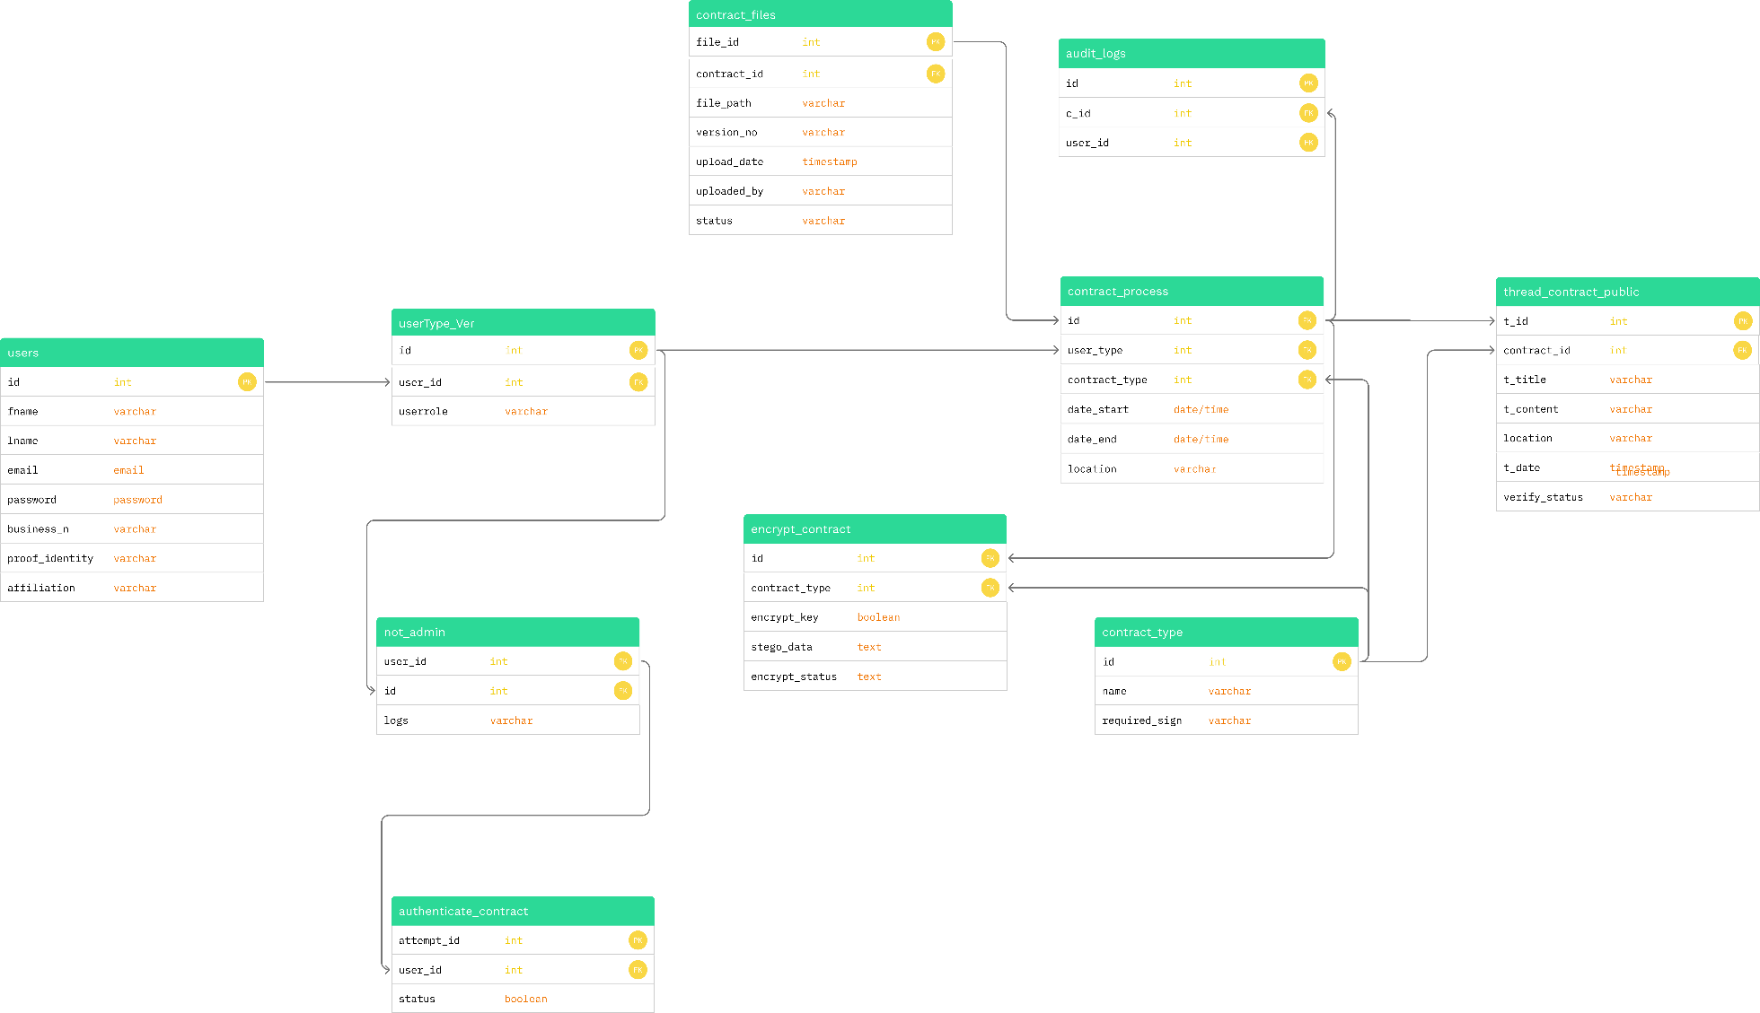

The ERD illustrates how user data, document processing, encryption, and verification modules interact to ensure secure document management and public transparency.

Appendix D. Use Case Diagram
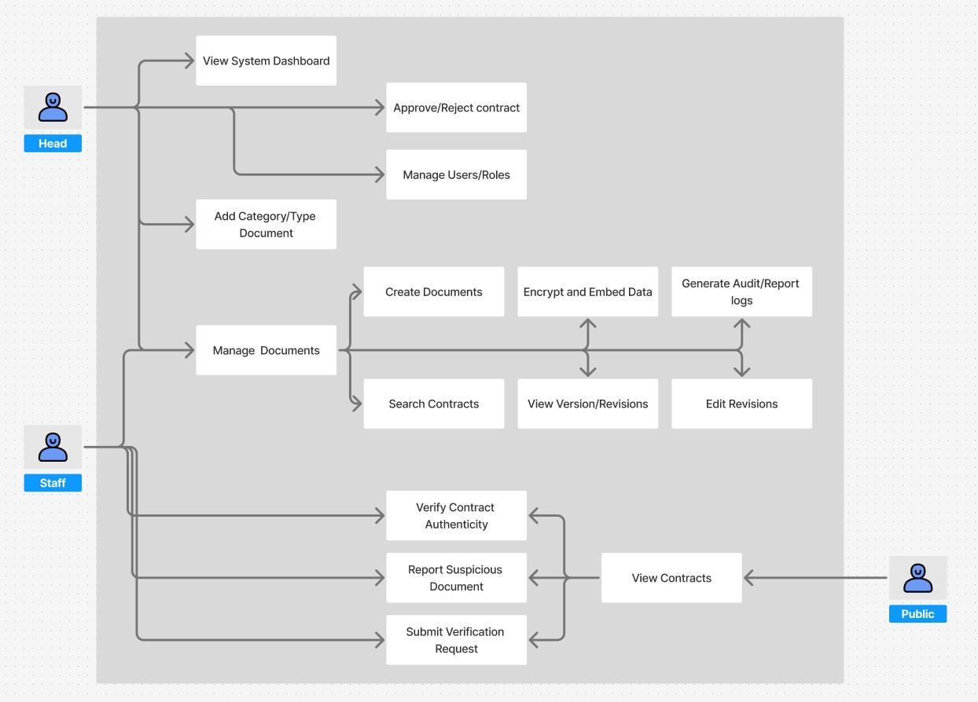

This use case diagram illustrates the overall interaction between the users and the system

Appendix E. Sprints Deliverables

Sprint | Duration | Main Deliverable | Features
Sprint 1 | Weeks 1–2 | User Management | Core user registration, login/logout, role-based permissions, and audit logging features.
Sprint 2 | Weeks 3–4 | Encryption & Authenticator | Implementation of encryption algorithms for documents, authentication logic, and decryption features for authorized users.
Sprint 3 | Weeks 5–6 | Document Management | Document upload/retrieval system, version control, metadata tagging, and access tracking functionalities.
Sprint 4 | Weeks 7–8 | Report Dashboard | Data analytics dashboard with charts, activity summaries, exportable reports, and responsive visualization tools.
Sprint 5 | Weeks 9–10 | Integration Testing | Integration of all modules, debugging, and system-wide testing for interoperability and performance.
Sprint 6 | Weeks 11–12 | Final Review & Tweaks | System demonstration, refinement based on feedback, final documentation, and deployment preparation.

Appendix F. Interview Questions:

General Procurement Practices

What types of contracts does your barangay usually engage in?

On average, how many procurement contracts are processed in a month?

Does your barangay use any information system or digital platform to manage procurement
activities? If yes, can you describe how it works?

Procurement Process and Approval

Can you describe the step-by-step process your barangay follows for drafting, reviewing, and approving procurement contracts? At what level or office are contracts typically approved?
How are contracts evaluated and approved in accordance with Republic Act 9184?

After a contract is signed and approved, which office or staff member is responsible for reporting or monitoring the implementation?
RA 9184 Implementation and Compliance How familiar is your barangay with the guidelines and procedures under Republic Act 9184?
What challenges does your barangay face in complying with the requirements of RA 9184?
Has the barangay received any training or orientation regarding the procurement rules under RA 9184?
In your opinion, how has RA 9184 affected transparency and efficiency in your barangay’s procurement process?
How are procurement documents currently stored — digitally or in hard copy?

Are there any existing procedures to verify whether a document is genuine or has been tampered with?
Has your barangay experienced issues such as lost, altered, or falsified documents?

Digitalization and Security

Has the barangay considered adopting digital tools or systems to manage procurement records?
What concerns do you have about using digital systems for handling sensitive government contracts (e.g., privacy, tampering, technical difficulties)?

Appendix G. Interview Questions SIGNED

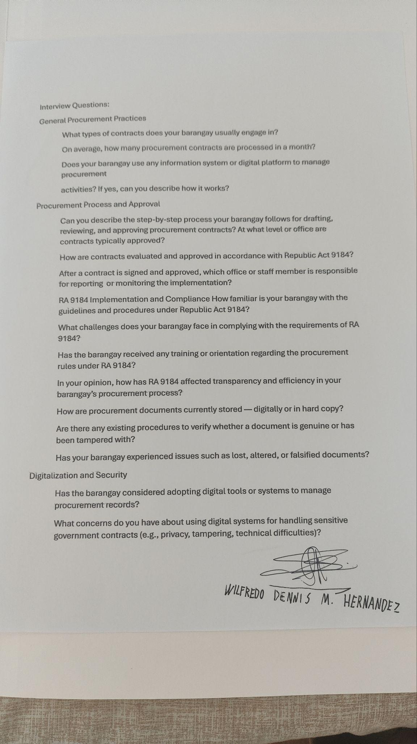

Appendix H. UAT Questions

No | Statement | Strongly  Agree | Agree | Neutral | Disagree | Strongly  Disagree
No | Statement | 5 | 4 | 3 | 2 | 1
User Interface Design
1 | The website is user-friendly  and visually appealing.
2 | I was able to locate the  information I needed easily.
3 | The website layout and navigation are clear and  intuitive.
Functionality
4 | Uploading/viewing  documents is simple.

5 | I can easily review the number of pending incidents and the type of report being  sent
6 | The system shows if a document is real
Usability
6 | I did not experience any technical difficulties while using the website (e.g., slow  loading times, broken links).
Reliability
7 | The website functions  without frequent crashes or errors.
8 | The system keeps documents safe from being  changed or stolen.
9 | The documents integrity and contents are still the same  after encryption

Appendix I. Letter of Request of Interview.

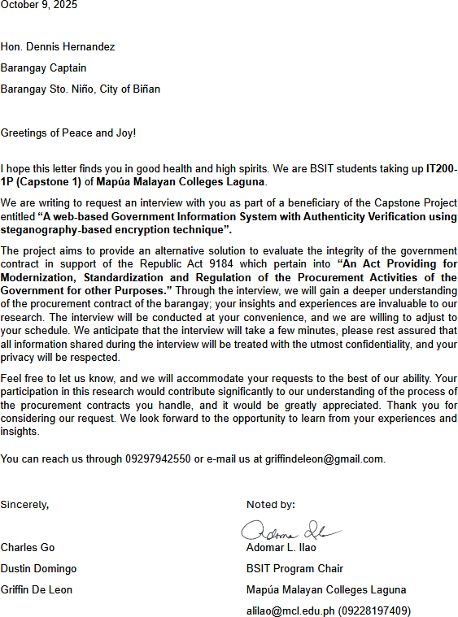

Appendix J. Interview Letter Signed
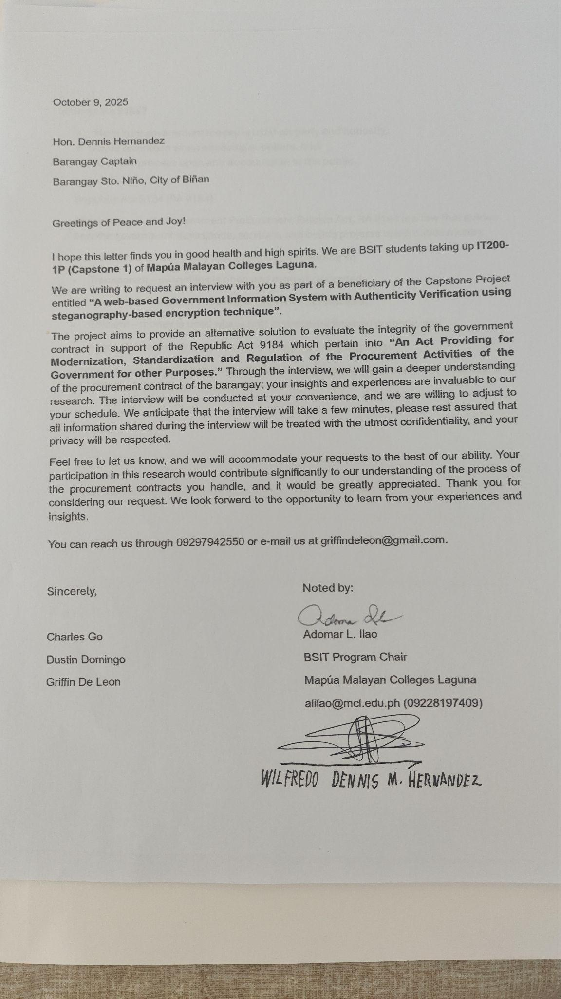

Appendix K. INTERVIEW TRANSCRIPT:

Griffin: Hello ako si Griffin Gil De Leon at ang kasama ko ngayon ay ang barangay captain ng sto nino binan, sir Wilfredo Hernandez
Barangay Captain: Hello, ako si Wilfredo Hernandez, Captain ng Sto nino binan for 2 years

Griffin: firstly ano po yung usually ine-engage ng barangay na mga contracts or documents? (What types of contracts does your barangay usually engage in?)
Barangay Captain: Mga maliliit na kontrata, kasi kalimitan naman dito sa barangay, kapag malaki na project, city ang sponsor, katulad ng pinapagawang school, na galing kay senator joel villanueva, so through Cong. Len dahil sa kanila ni request ko sa kanila, galing siya sa national pero kung ang paguusapan ay yung mga binibili, na mga gamit o yung mga ginagawa ng barangay, maliit lang naman kasi ang budget natin, eh napakaliit din kasi maliit lang na barnaggay tayo, next question
Griffin: Next question po ay, ano po yung mga na pprocesso niyo na kontrata?

Barangay captain: normally up to 1-2 times lang eh, kunyari yung cctv, eh mahilig 300,000php ang halaga so kailangan siyang iba bidding, kailangan siyang may contractor, kailangan siya meron na bidding na mangyayari
Griffin: Sa mga documents niyo po gumagamit po ba kayo ng digital o halos physical lang?
Barangay Captain: puro physical kami
Griffin: magtatanong po ako sa proceso niyo po sa procurement pano po yung step by step niyo dun, pano po yung pagddraft niyo, pano po yung pag review, or yung pag approval. Kung pwede po itanong.
Barangay Captain: Ganito yun, halimbawa may project kami dito, so through resolution during budget, katulad ngayon naggagawa na kami ng budget, so sa budget inaallocate na namin yung mga project gusto na namin gawin o kung may mga gamit na kailangan sa barangay na gusto namin bilhin pag ang halaga, pag ang halaga ay 99,000 pababa, hindi siya kailangan ng bidding, pwede na namin kaagad mabili, pero kapag ang halaga ay more than 99,000 so let’s say halimbawa 102k, 200k, 800k, 1 million kung bibili ng firetruck, two million, so pag ka ganun ibibidding mo na siya, kukuha ka ng tatlong supplier, ibibidding mo na. Ipag-ugnayan ang barangay meron pag-uusap, nagkakaroon ng proper documentation at ng resolution na may nagmumungkahi may pumapangalawa at sinasangayon ng buong sanggunian na bibili ng ganun gamit, and then nakikipag ugnayan kami sa accounting sa COA (Commission on Audit) at ichecheck ni treasurer yung budget kung may available na budget, tapos yung supplier, maghahanap ka rin ng supplier na mas mura, saka kami mag pproceed.
Griffin: kapag aabot ng isang million kagaya nung firetruck na sinabi niyo, aabot pa po ba ito sa mayor or kayo na ang naghahandle?
Barangay Captain: Kami lang, pag kaya ng barangay kami lang.

Griffin: ano po yung alam niyo sa Republic Act 9184?

Barangay Captain: 9180?
Griffin: 9184 po

Barangay Captain: ay hindi ako familiar
Griffin: parang lang po siya maging transparent yung paghahandle niyo ng documents, yung pera ay magamit ng maayos, para walang favoritism sa supplier at yung processo ay makita ng publiko. And susunod ko na tanong ay ano po ang mga challenges niyo sa pagsunod dito sa republic act na ito?
Barangay Captain: Siguro yung kakulangan ng training. Since narinig ko lang naman to sa seminar at hindi naman lahat ng staff dito kabisado yung mga requirements ng RA 9184, minsan din mahirap sundan lahat ng proseso lalo na kung maliit lang pondo at kulang kulang ang tauhan, kaya umaasa kami sa COA kung may tanong.
Griffin: paano niyo po stino-store yung mga procurement documents ninyo?

Barangay Captain: Physical copies lahat. Naka-file yan sa opisina tapos ilalagay sa lock cabinet, yung Bookkeeper namin ang in charge diyan.
Griffin: May procedure po ba kayo para ma-verify kung totoo and documents o kung may nagbago o natamper sa mga documents?
Barangay Captain: Oo, kasi lahat ng documents may pirma at stamp ng barangay, may logbook din kung kailan lumabas o ginamit ang document, kaya madaling ma-trace.
Griffin: naka experience na po ba kayo ng mga nawalang o binagong documents?
Barangay Captain: wala pa naman, kasi maingat talaga kami sa record-keeping, pero syempre mangyayari pa rin yan, kapag matagal na yung papel, nagfefade o kaya nasisira.
Griffin: na consider niyo na po bang gumamit ng digital tools para sa mga documents na ginagamit ninyo?
Barangay Captain: Hindi pa, mahirap rin kasi kulang kami sa equipment o training kung ganun.
Griffin: may mga concerns po ba kayo kung sakaling gumamit po tayo ng digital sa ating mga documents?
Barangay Captain: Siguro nga yung problema sa security at training, kailangan rin namin ng tao para marunong sa system para sure na safe yung mga documento, pero sa ngayon mas kampante pa rin kami sa hard copies kasi. Pero maganda rin naman yung idea mo nakikita kong mangyari yun.
Griffin: okay ayun lang po ang mga questions ko sa inyo, maraming salamat po sa oras niyo.

Appendix L. INTERVIEW TRANSCRIPT SIGNED:


Appendix M. PROOF OF INTERVIEW:
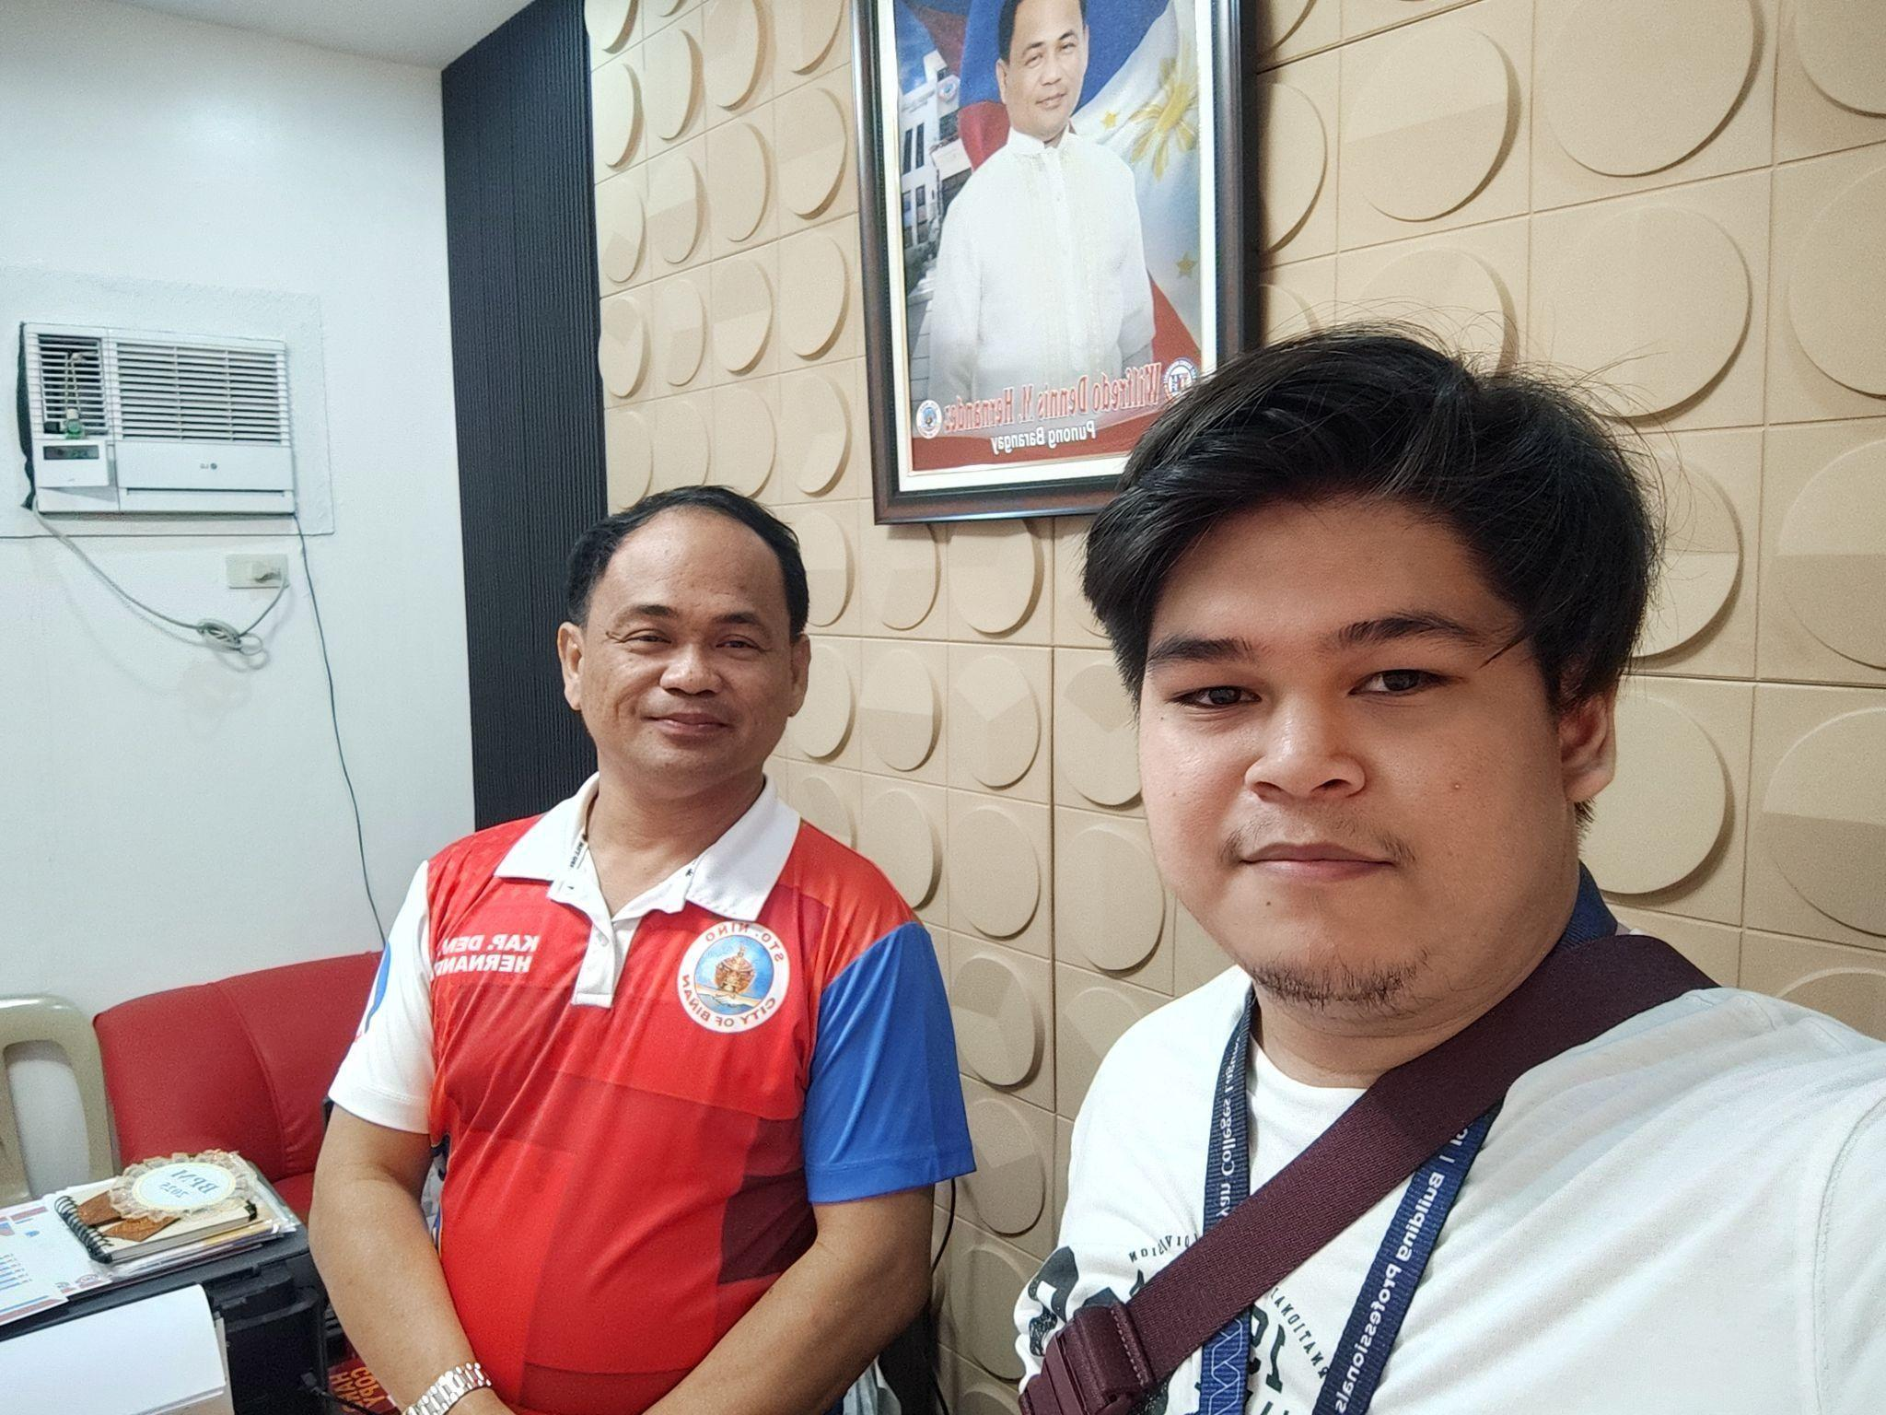

Appendix N. Location of Barangay
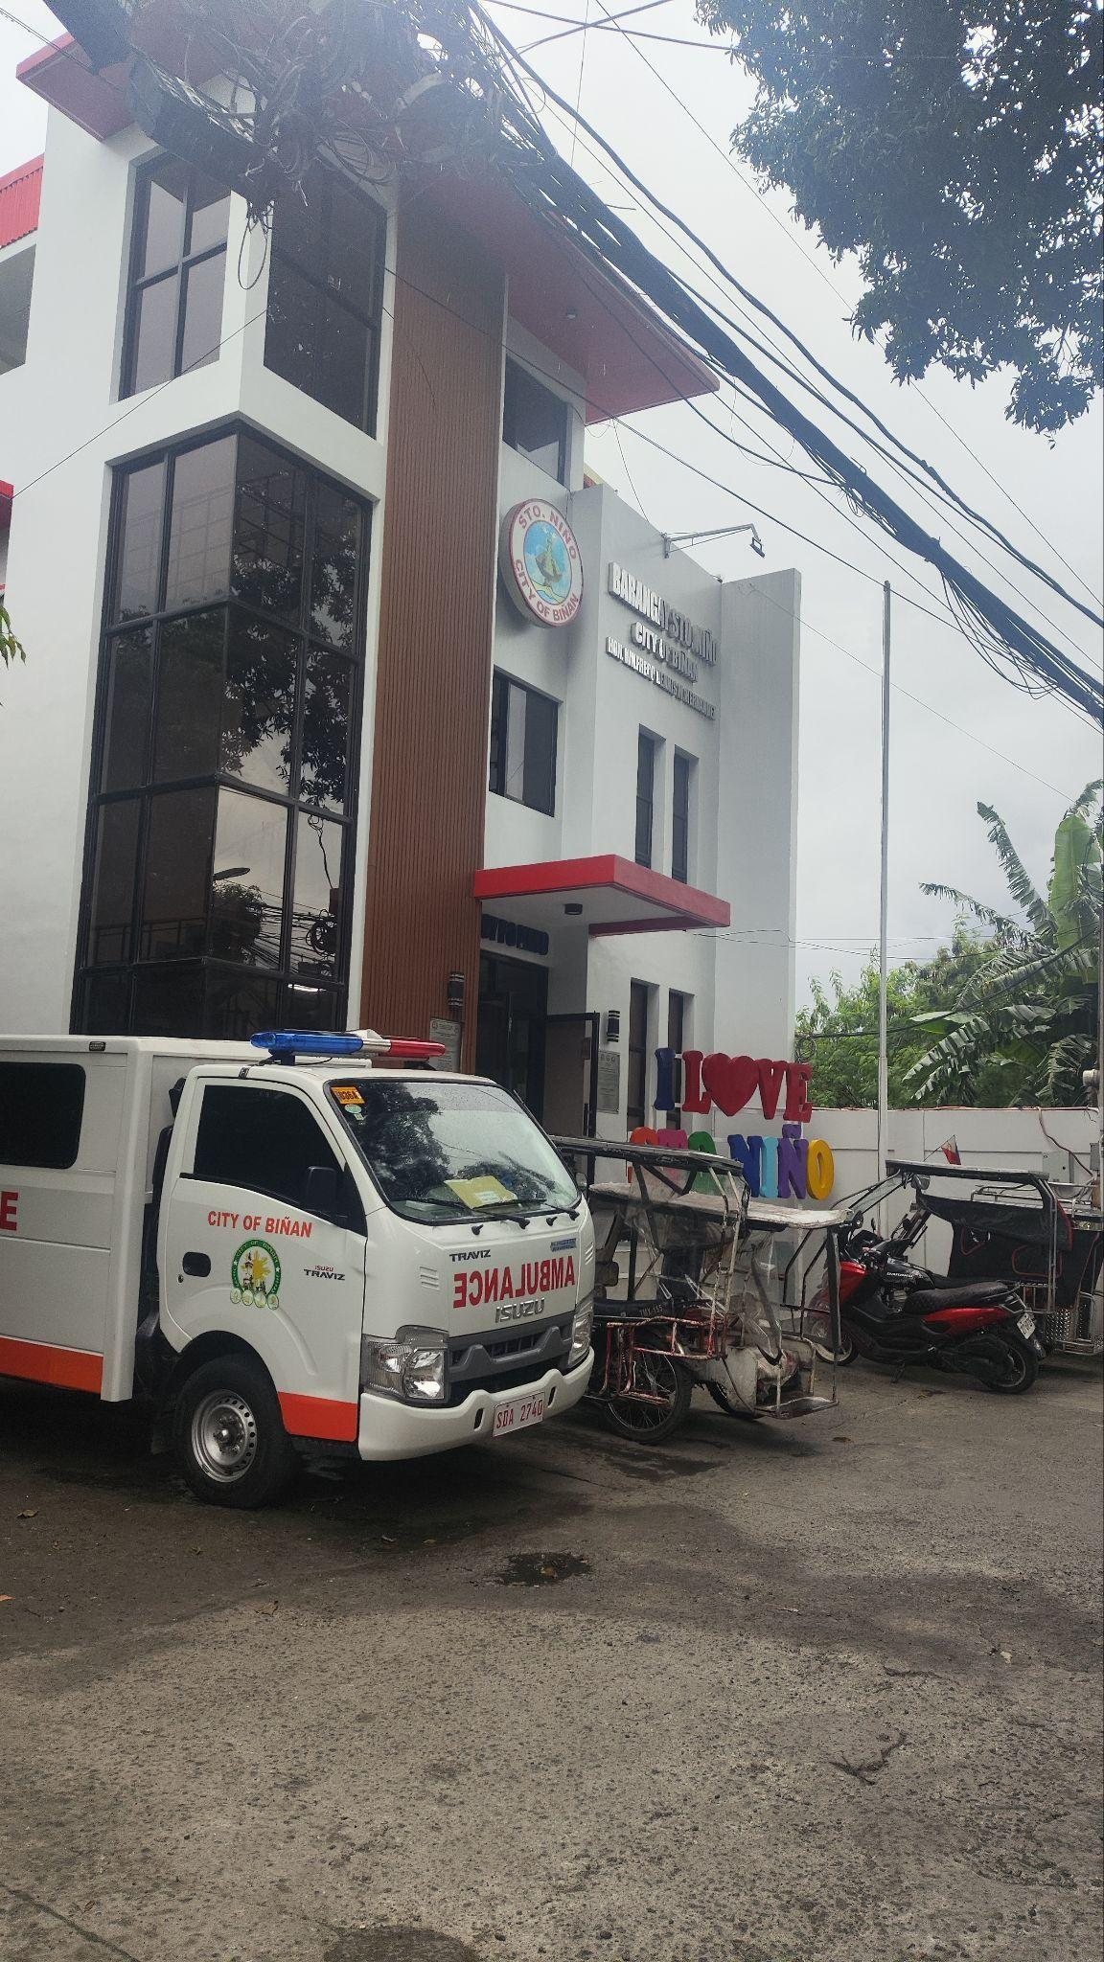

Appendix O. Organizational Chart

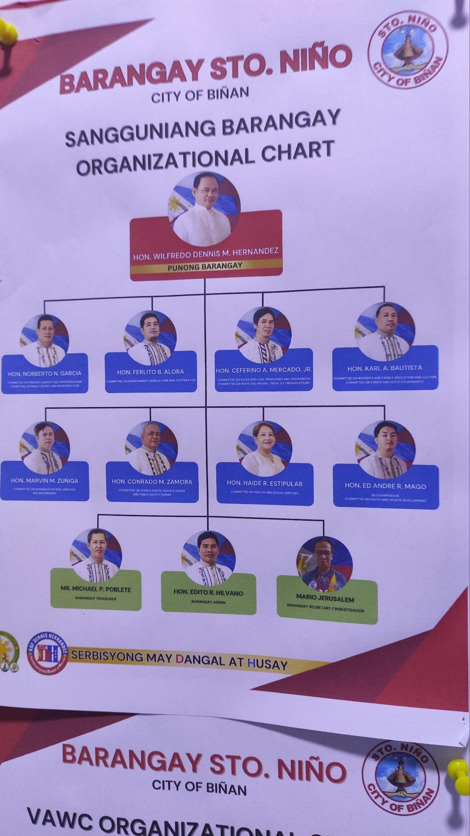

Appendix P. Annual Procurement Plan (Barangay Sto. Niño, 2025)
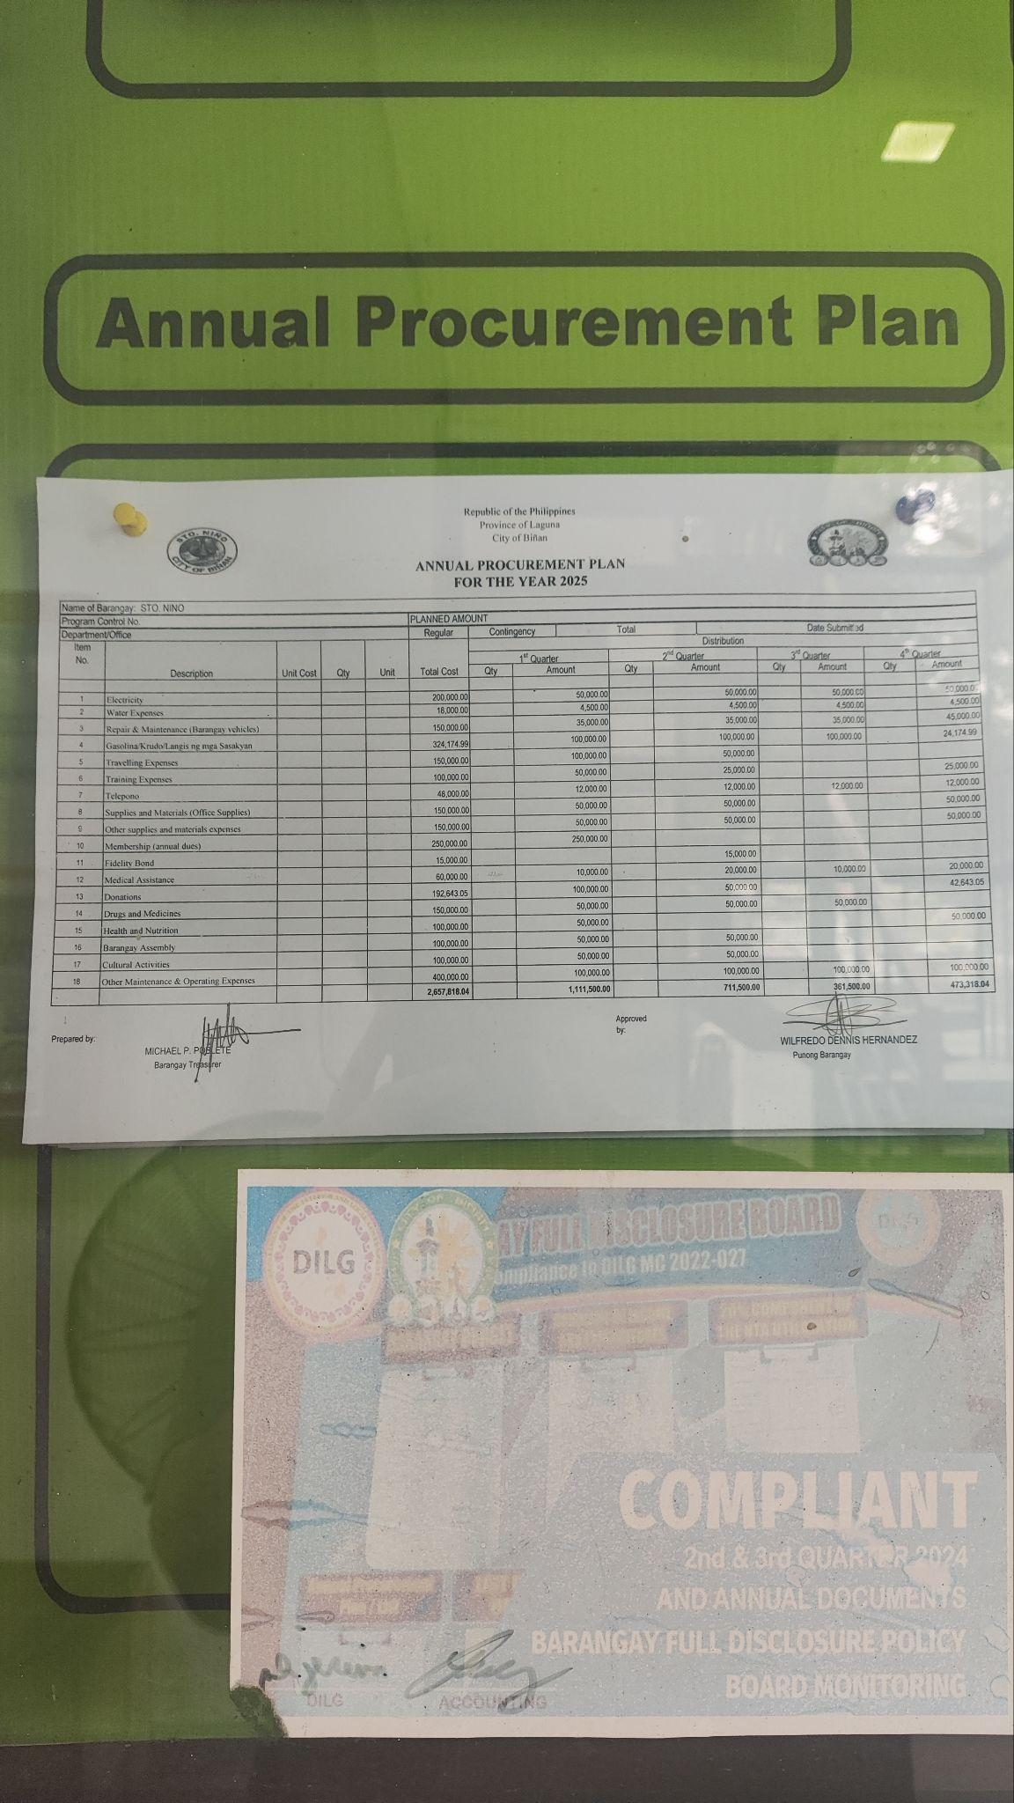

Appendix Q. Disbursement Records
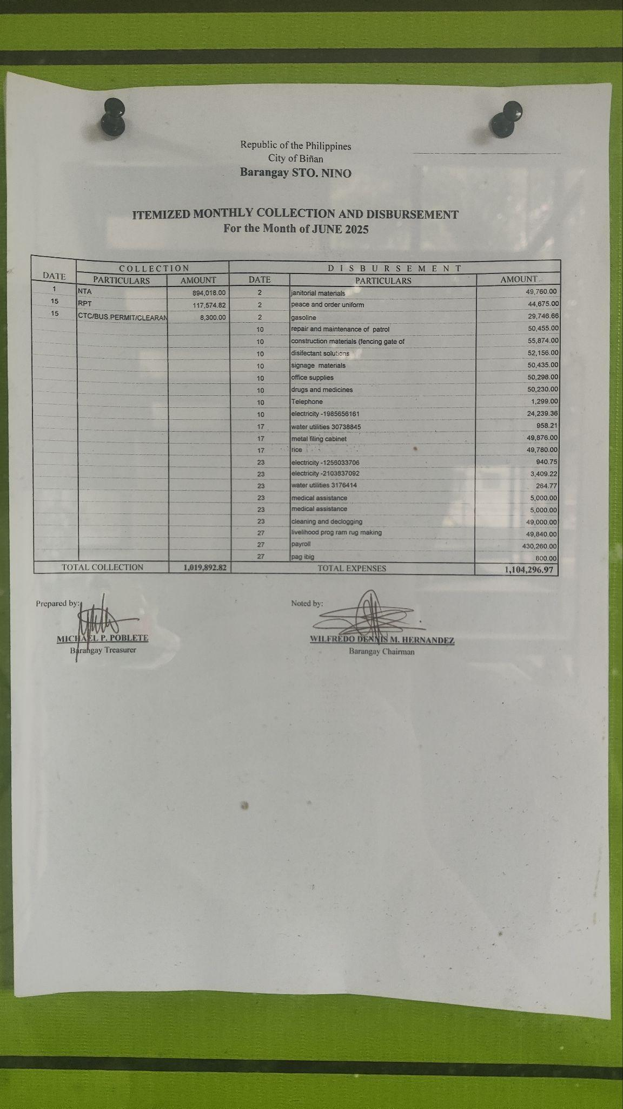

Appendix R. Republic Act No. 9184 – Government Procurement Reform Act (Sections: 3,4,8,10, 12, 35)
SEC . 3. Governing Principles on Government Procurement. – All

procurement of the national government, its departments, bureaus, offices and agencies, including state universities and colleges, government-owned and/or -controlled corporations, government financial institutions and local government units, shall, in all cases, be governed by these principles:
- Transparency in the procurement process and in the implementation of procurement contracts.
- Competitiveness by extending equal opportunity to enable private contracting parties who are eligible and qualified to participate in public bidding.
- Streamlined procurement process that will uniformly apply to all government procurement. The procurement process shall be simple and made adaptable to advances in modern technology in order to ensure an effective and efficient method.
- System of accountability where both the public officials directly or indirectly involved in the procurement process as well as in the implementation of procurement contracts and the private parties that deal with government are, when warranted by circumstances, investigated and held liable for their actions relative thereto.
- Public monitoring of the procurement process and the implementation of

awarded contracts with the end in view of guaranteeing that these contracts are awarded pursuant to the provisions of this Act and its implementing rules and regulations, and that all these contracts are performed strictly according to specifications.
SEC . 4. Scope and Application. – This Act shall apply to the Procurement of Infrastructure Projects, Goods, and Consulting Services, regardless of source of funds, whether local or foreign, by all branches and instrumentalities of government, its departments, offices and agencies, including government-owned and/or -controlled
corporations and local government units, subject to the provisions of Commonwealth Act No.

138. Any treaty or international or executive agreement affecting the subject matter of this Act to which the Philippine government is a signatory shall be observed.
SEC. 8. Procurement By Electronic Means. – To promote transparency and efficiency, information and communications technology shall be utilized in the conduct of procurement procedures. Accordingly, there shall be a single portal that shall serve as the primary source of information on all government procurement. The G-EPS shall serve as the primary and definitive source of information on government procurement. Further, the GPPB is authorized to approve changes in the procurement process to adapt to improvements in modern technology, provided that such modifications are consistent with the provisions of Section 3 of this Act.
To take advantage of the significant built-in efficiencies of the G-EPS and the volume discounts inherent in bulk purchasing, all Procuring Entities shall utilize the G-EPS for the procurement of
common supplies in accordance with the rules and procedures to be established by the GPPB. With regard to the procurement of non-common use items, infrastructure projects and consulting services, agencies may hire service providers to undertake their electronic procurement provided these service providers meet the minimum requirements set by the GPPB.
SEC . 10. Competitive Bidding. – All Procurement shall be done through Competitive Bidding, except as provided for in Article XVI of this Act.
SEC . 12. Functions of the BAC. – The BAC shall have the following functions: advertise and/or post the invitation to bid, conduct pre-procurement and pre-bid conferences, determine the eligibility of prospective bidders, receive bids, conduct the
evaluation of bids, undertake post-qualification proceedings, recommend award of contracts

to the Head of the Procuring Entity or his duly authorized representative: Provided, That in the event the Head of the Procuring Entity shall disapprove such recommendation, such disapproval shall be based only on valid, reasonable and justifiable grounds to be expressed
in writing, copy furnished the BAC; recommend the imposition of sanctions in accordance with Article XXIII, and perform such other related functions as may be necessary, including the creation of a Technical Working Group from a pool of technical, financial and/or legal experts to assist in the procurement process.
SEC . 35. Failure of Bidding. – There shall be a failure of bidding if:

- No bids are received;
- No bid qualifies as the Lowest Calculated Responsive Bid or Highest Rated Responsive Bid; or,
- Whenever the bidder with the highest rated/lowest calculated responsive bid refuses, without justifiable cause to accept the award of contract, as the case may be. Under any of the above instances, the contract shall be re-advertised and re-bid.
The BAC shall observe the same process and set the new periods according to the same rules followed during the first bidding. After the second failed bidding, however, the BAC may resort to negotiated procurement as provided for in Section 53 of this Act.

Appendix X: Risk Assessment Matrix
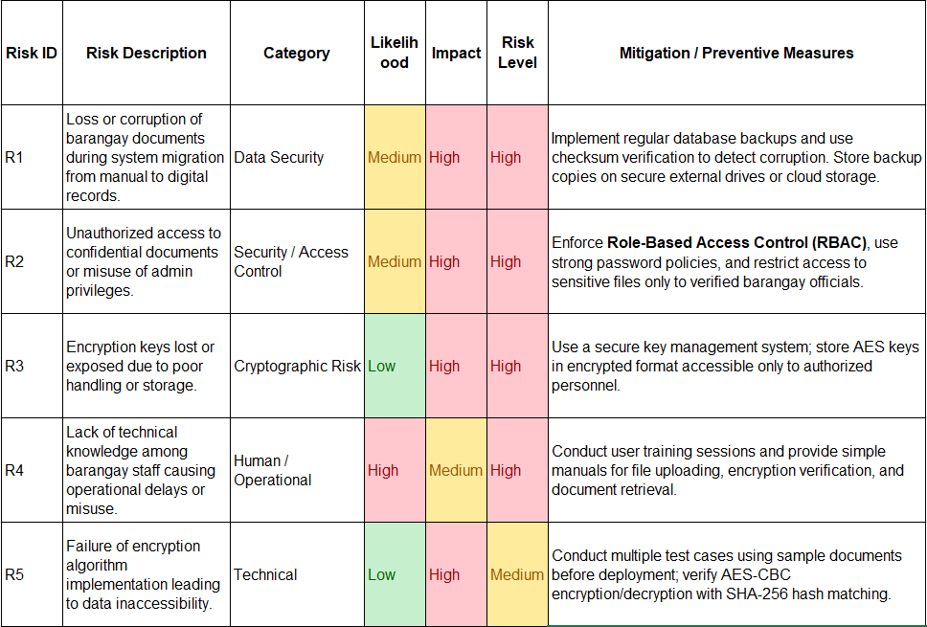
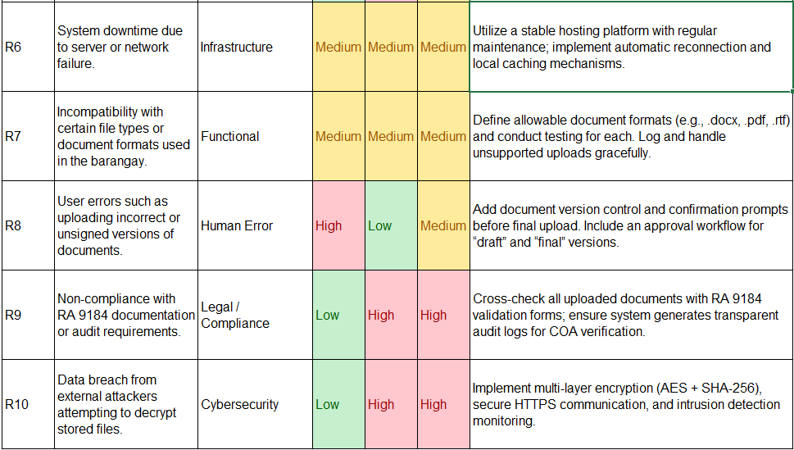

Appendix Y. Current System Workflow Signed
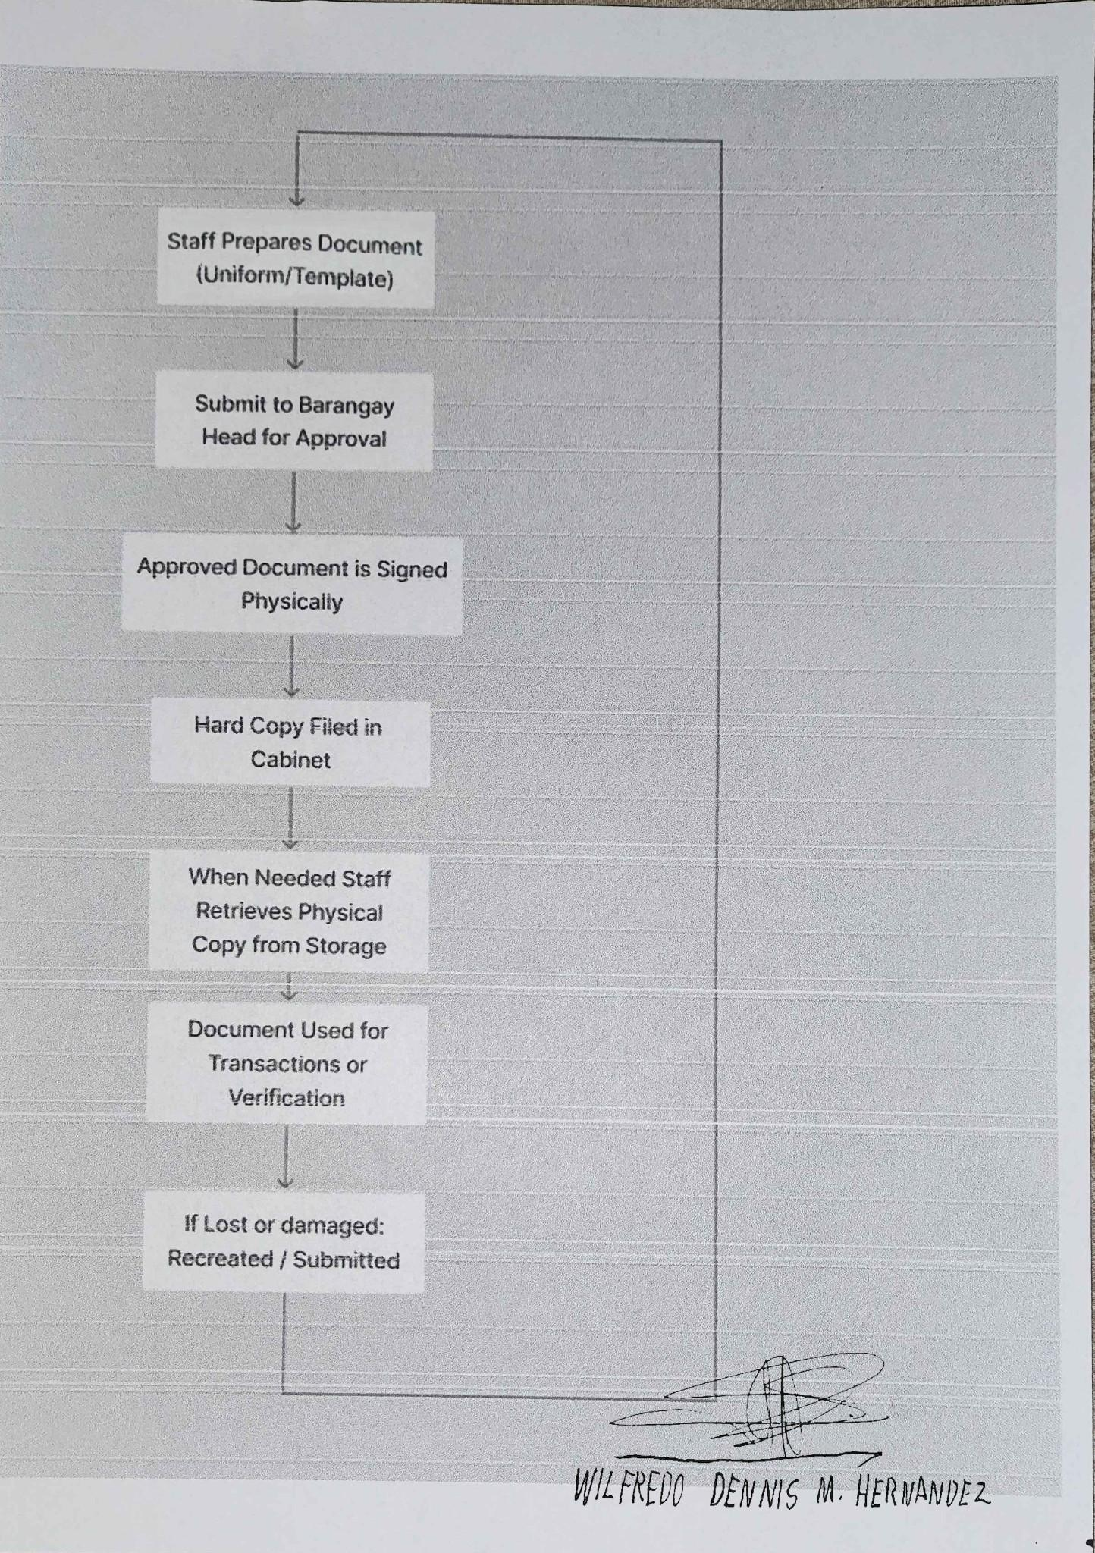

Appendix Z. Gantt Chart
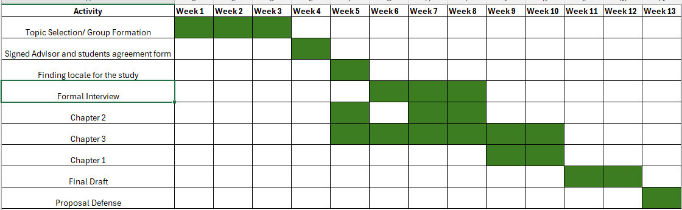

Appendix AA. Data Flow Chart
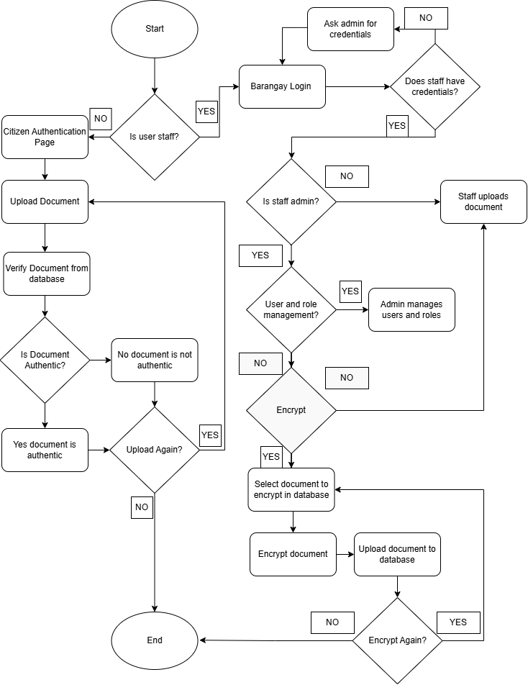

Appendix AB. Interview Guide With Answers

CAPSTONE STUDY INTERVIEW QUESTIONS

SECTION A: Procurement Overview
- How often does the barangay conduct procurement activities (monthly, quarterly, annually)?
A: Annually.
- Approximately how many procurement-related contracts are produced per year?
A: 10-13 contracts a year

SECTION B: Contract Preparation Process
- How are contracts prepared?
  - Who drafts them?
A: the drafting of contracts and legal documents is generally handled by the following officials and personnel, depending on the nature of the document, it can either come from the secretary or captain
  - What software is used (MS Word, Google Docs, etc.)?
A: Usually word ang ginagamit namin through a template
- Once finalized, how are contracts approved or signed?
A: the contracts are signed ibig sabihin final na, ang magsisign nito usually ay ang barangay captain pati na rin yung supplier
- Are contracts stored as physical copies, digital copies, or both?
A: Meron kaming dalawang copy both physical saka digital in case magka problema sa physical copy.

SECTION C: Storage and Access
- Where are digital copies stored?
A: yung mga copya nasa office computer lang
- Who has access to digital contract files?
A: Barangay officials kagaya ng secretary o captain
- Is there any version control or tracking mechanism for contract updates?
A: wala kaming version control pero siguro yung filenames at kung kailan ito na modify.

SECTION D: Document Integrity and Accountability
- How does the barangay ensure that a contract has not been altered after issuance?
A: Gumagamit kami ng official sign documents para maging reference namin, pero medyo mahirap mahanap kung ang document na alter, lalo na kapag ang kontrata ay iilan yung pages.
- Have there been instances of:
- Lost documents? Minsan meron mga document na namimissplace kapag di nailagay sa storage ng maayos, pero retrievable pa naman siya
- Confusion over versions? Oo lalo na kapag madaming drafts o revisions na ginawa.
- Requests for verification of authenticity? Yes, galing sa contractors or during audits.
- Is there currently any system used to verify whether a contract is original and unmodified?
A: Wala pa naman.

SECTION E: Public Requests and Transparency
16: How often are procurement documents requested?
A: madalas galing sa contractors para dun sa contracts or supporting documents or coa for audit and compliance checks
17.How are document requests processed (manual retrieval, email, photocopy, etc.)?
A: Kadalasan ibibigay namin yung physical sa nangangailangan, minsan photocopy

SECTION F: Technology Capacity
- Are staff comfortable using web-based systems?
A: Lahat naman ng staff namin ay merons basic computer skills, pero kung medyo advanced baka hindi.
- Would a digital verification system for contracts be useful in your operations?
A: oo lalo na sa kapag malayuan ang nangangailangan ng contracts namin.

Appendix AC. Interview Guide Signed
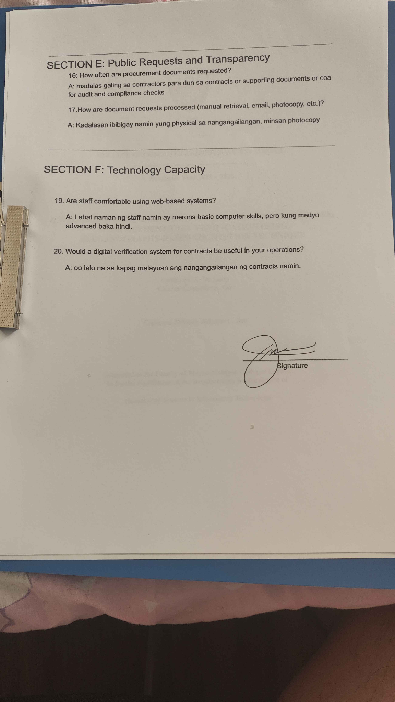

Appendix AD. Filing Cabinet that contains Important Documents
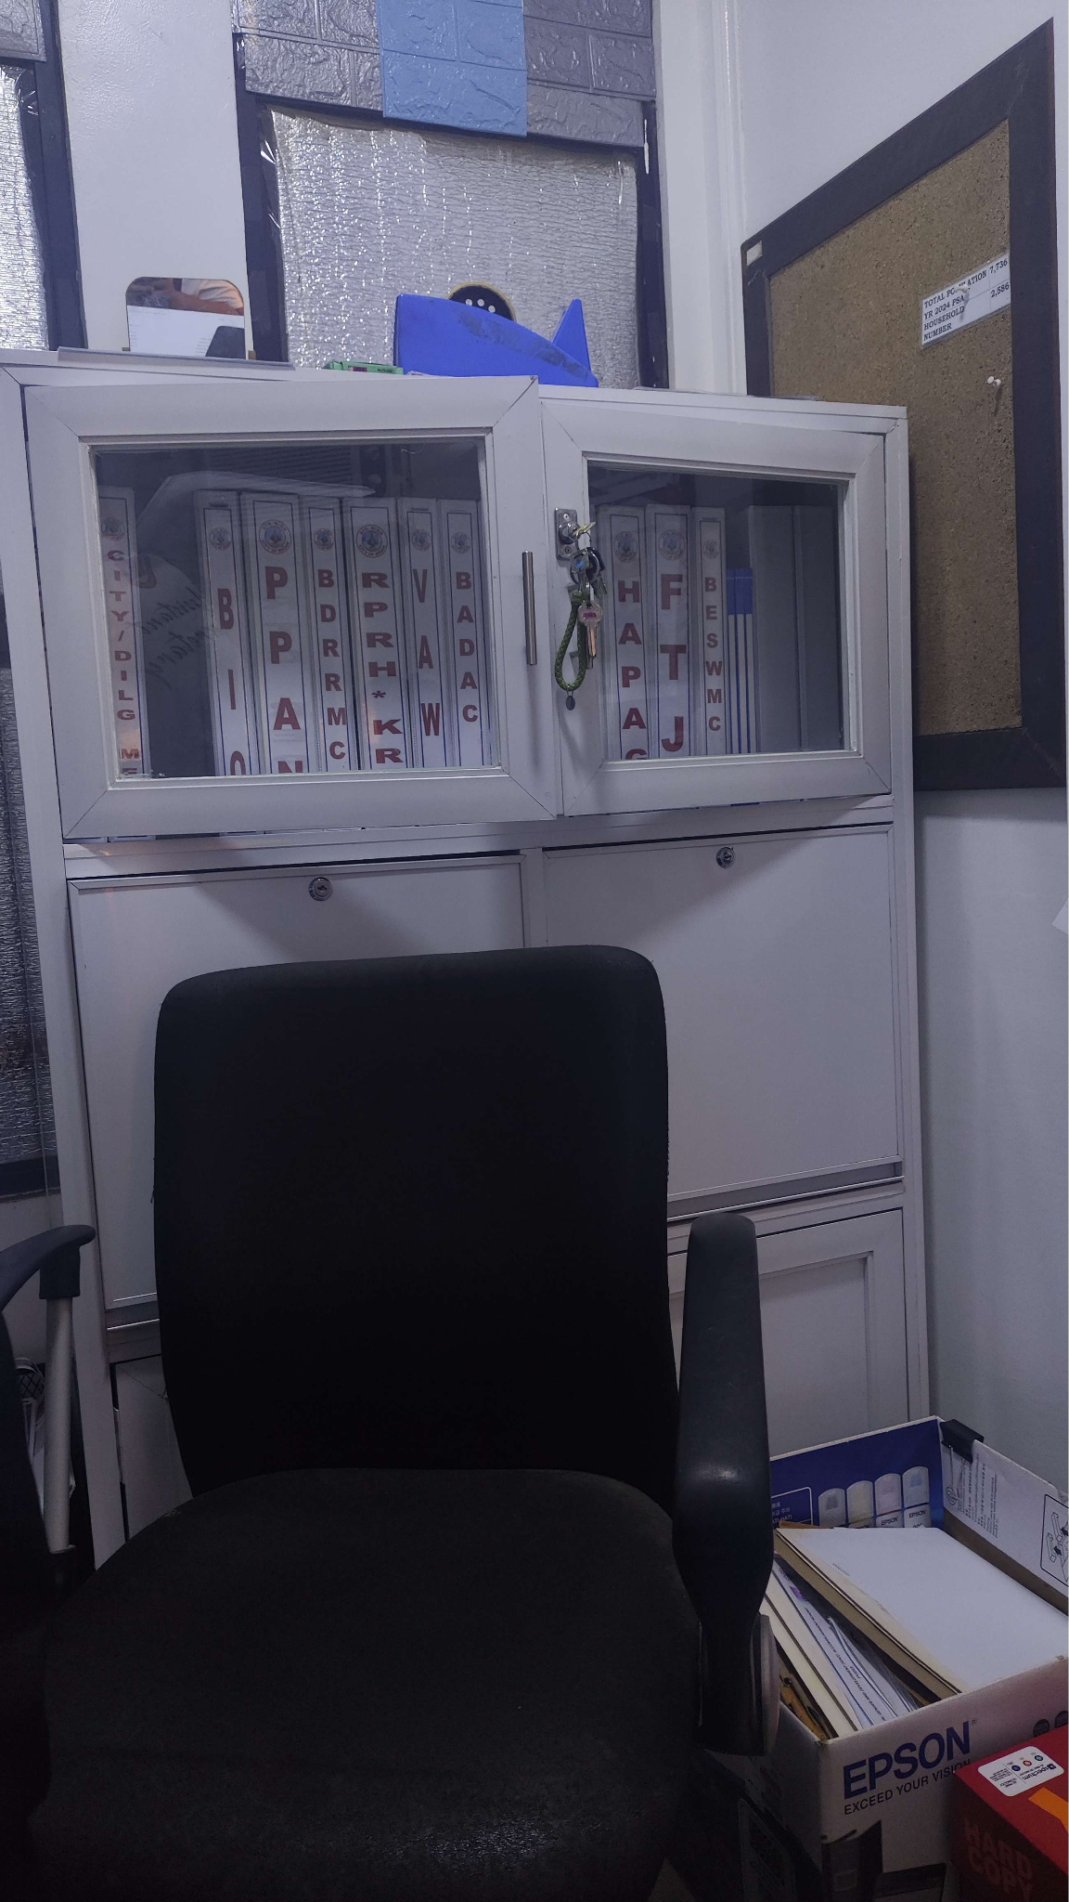

Appendix AE Authentication and Authorization Testing

Test ID | Test | Planned Parameters | Expected Results
AUTH-01 | Successful login | 30 attempts: 15 Administrator and 15 Clerk; begin a new session for every attempt. | 30/30 accepted; correct role and landing page; session and audit entry created.
AUTH-02 | Unsuccessful login | 30 attempts: 10 wrong passwords for existing users, 10 unknown usernames, 5 blank submissions, and 5 whitespace or overlong inputs. | 30/30 denied; no authenticated session; no sensitive error information.
AUTH-03 | Brute-force lockout | Use 3 disposable accounts. For each: 4 wrong attempts followed by 1 correct attempt; reset; then 5 wrong attempts followed by a correct attempt. | Correct login works after 4 failures but is blocked after the fifth failure, using the proposed five-attempt threshold.
AUTH-04 | Lockout duration | For each of three locked accounts, test correct credentials during and after the configured 30-second lockout. | Login remains unavailable during lockout and becomes available after expiration.
AUTH-05 | Logout | 20 cycles: 10 per staff role; revisit a protected URL after logout. | Session becomes invalid and protected pages cannot be reopened.
AUTH-06 | Unauthenticated access | Test 8 protected actions: dashboard, upload, edit, archive, delete, private download, folder reorder, and reports. | All 8 actions redirect to login or return 401/403.
AUTH-07 | RBAC permission matrix | Test the same 8 actions using Administrator, Clerk, and unauthenticated/public access: 8 x 3 = 24 attempts. | Every allowed and prohibited action follows the approved role-permission matrix.
AUTH-08 | Shared staff authorization | For 10 documents uploaded by one staff member, test viewing, editing, deletion, and downloading by another staff member: 40 checks. | Shared staff access follows the workspace policy; restricted and destructive actions require the applicable permissions.
AUTH-09 | Authentication audit logs | Check all 30 successful attempts, 30 failed attempts, 3 lockouts, and 20 logouts: 83 expected events. | 83/83 events contain the correct actor, action, result, and timestamp.
AUTH-10 | Session reuse | Capture 10 authenticated sessions, log out, and attempt to reuse each session. | 10/10 old sessions rejected.

These tests evaluated login, session handling, and access permissions to confirm that authorized users could perform permitted actions while invalid credentials and restricted requests were rejected.

Basis of Item Counts
The number of attempts in each test follows the categories being tested. AUTH-01 uses 15 attempts for each of the two staff roles (30), and AUTH-07 tests the eight protected actions under three access levels (8 × 3 = 24). AUTH-09 counts all authentication events produced by AUTH-01, AUTH-02, AUTH-03, and AUTH-05 (83).
Test ID | Count | How the count was obtained
AUTH-01 | 30 | 15 Administrator and 15 Clerk logins (2 roles × 15).
AUTH-02 | 30 | 10 wrong passwords, 10 unknown usernames, 5 blank submissions, and 5 whitespace or overlong inputs.
AUTH-03 | 3 accounts | Each account tested twice: four failures followed by the correct password, then five failures followed by the correct password.
AUTH-04 | 12 | 3 accounts × 4 timed attempts after lockout (at 5, 20, 25, and about 31 seconds).
AUTH-05 | 20 | 10 login-and-logout cycles for each of the 2 roles.
AUTH-06 | 8 | One request for each protected action: dashboard, upload, edit, archive, delete, private download, folder reorder, and reports.
AUTH-07 | 24 | The 8 protected actions × 3 access levels (Administrator, Clerk, and public).
AUTH-08 | 40 | 10 documents × 4 actions (view, edit, delete, and download).
AUTH-09 | 83 | Total of the authentication events produced by the tests above: 30 logins, 30 failed logins, 3 lockouts, and 20 logouts.
AUTH-10 | 10 | 10 authenticated sessions captured and reused after logout.

Appendix AF Document Management Testing
Test ID | Test | Planned Parameters | Expected Results
DOC-01 | Valid PDF upload | 30 PDFs: 10 below 1 MB, 10 from 1-5 MB, 5 near M, and 5 multi-page mixed-content PDFs. | 30/30 accepted and stored correctly.
DOC-02 | Invalid upload rejection | 30 files: 5 non-PDFs, 5 zero-byte files, 5 malformed PDFs, 5 harmless files renamed .pdf, 5 files larger than M, and 5 password-protected PDFs if unsupported. | 30/30 safely rejected with understandable errors.
DOC-03 | Metadata storage | Inspect 20 uploaded documents. | 20/20 contain the correct title, owner, timestamp, version, folder, and other required metadata.
DOC-04 | Authorized view and download | 20 view attempts and 20 downloads using permitted staff accounts. | 40/40 succeed and create the required audit records.
DOC-05 | Unauthorized view and download | 20 private-document views and 20 downloads using unauthorized accounts. | 40/40 denied.
DOC-06 | Archive lifecycle | Use 10 documents; check archiving, restoration, and subsequent archive/deletion transitions. | Correct status and permissions at each transition; required audit history retained.
DOC-07 | Version control | Use 10 documents with 3 versions each: 30 versions. | Correct sequence, timestamps, fingerprints, and previous-version links.
DOC-08 | Version-chain tampering | Alter the previous-fingerprint link in 10 version chains. | All altered version-chain relationships are detected and are not accepted as intact.
DOC-09 | Search | 40 queries: 10 exact titles, 10 partial titles, 10 case variations, and 10 no-match queries. | Correct result set for all 40.
DOC-10 | Filter and pagination | Create 50 records; test 5 filter combinations at 10, 25, and 50 items per page: 15 executions. | Correct totals and preserved filters.
DOC-11 | Duplicate submission | Submit the same upload request 20 times, including 10 rapid double-click submissions. | Duplicate detection follows the revision or separate-enrollment workflow without unintended records or inconsistent audit entries.
DOC-12 | Archive and reports | Run 20 report combinations covering date, user, action, status, and document filters. | Correct counts and records; exports open correctly if export is implemented.

These tests evaluated document upload, organization, retrieval, revision, and disposal to confirm that SealGuard handled contract records correctly throughout their lifecycle.

Basis of Item Counts
Each count is the number of categories multiplied by the cases in each category, such as six invalid file types with five files each in DOC-02 (30) and four query types with ten queries each in DOC-09 (40). Viewing and downloading tests count each view and each download separately (20 + 20 = 40).
Test ID | Count | How the count was obtained
DOC-01 | 30 | 4 file types: 10 small, 10 of about 1 MB, 5 near the 15 MB limit, and 5 multi-page PDFs.
DOC-02 | 30 | 6 invalid file types × 5 each (non-PDF, empty, malformed, renamed non-PDF, over 15 MB, and password-protected).
DOC-03 | 20 | 20 stored documents checked for their metadata.
DOC-04 | 40 | 20 views and 20 downloads by permitted accounts.
DOC-05 | 40 | 20 views and 20 downloads attempted without access.
DOC-06 | 30 | 10 documents × 3 lifecycle transitions (move to Trash, restore, and move to Trash again).
DOC-07 | 30 | 10 documents × 3 versions each.
DOC-08 | 10 | 10 version chains, each with an altered previous-version link.
DOC-09 | 40 | 4 query types × 10 (exact titles, partial titles, case variations, and no-match queries).
DOC-10 | 15 | 5 status filters × 3 page sizes (10, 25, and 50 items per page).
DOC-11 | 20 | The same PDF submitted 20 times.
DOC-12 | 20 | 10 report filter types (date, user, action, status, and document filters and their combinations), each run twice, plus CSV export.

Appendix AG Cryptographic Unit Testing
Test ID | Test | Planned Parameters | Expected Results
CRY-01 | SHA-256 consistency | Hash 30 unchanged inputs twice: 60 operations. | Both hashes match for all 30 pairs.
CRY-02 | Canonical Fingerprint consistency | Generate the Canonical Fingerprint 3 times for each of 20 unchanged PDFs: 60 operations. | All 3 values match for every PDF.
CRY-03 | Fingerprint change detection | 10 changes each to text, images, vectors, included metadata, and structure. Vector changes use the separate fingerprint mechanism described in Branch E. | Protected component changes alter the corresponding fingerprint; supported modifications are detectable during verification.
CRY-04 | AES encryption and decryption | 30 round trips: 10 small payloads, 10 medium payloads, and 10 large payloads. | Decrypted output matches the original in 30/30 cases.
CRY-05 | Incorrect AES key | Attempt to decrypt 10 encrypted payloads using incorrect keys. | All 10 fail safely; no plaintext returned.
CRY-06 | Corrupted ciphertext | Modify 10 encrypted payloads before decryption. | All 10 rejected or detected; no corrupted plaintext treated as valid.
CRY-07 | HMAC validation | 20 valid and 20 altered HMAC cases. | 20 valid accepted and 20 altered rejected.
CRY-08 | RSA key wrapping | Wrap and unwrap 20 AES keys; attempt 10 unwraps using incorrect private keys. | 20 correct round trips; 10 incorrect-key attempts rejected.
CRY-09 | LSB embed/extract | 30 payloads: 10 small, 10 medium, and 10 near carrier capacity. | Extracted payload matches embedded payload in 30/30 cases.
CRY-10 | Invalid LSB payload | Test 10 absent seals, 10 corrupted seals, and 10 over-capacity payloads. | All 30 produce controlled errors and are not reported as Authentic.
CRY-11 | Authorization coverage reference | Original target: 20 unauthorized attempts. Evaluated through AUTH/DOC access-control tests rather than counted as a cryptographic unit test. | Requests without required permissions are denied before protected operations are performed.
CRY-12 | Sensitive-data inspection | Inspect 20 database records, 20 logs, and 20 HTTP responses. | No plaintext key, password, or protected document content exposed.

These tests evaluated hashing, encryption, key protection, and Digital Seal processing to confirm consistent cryptographic behavior and safe rejection of invalid data.

Basis of Item Counts
Counts use ten cases for each payload size, change type, or failure type, so three payload sizes give 30 cases (CRY-04 and CRY-09) and five change types give 50 (CRY-03). Tests with both accepted and rejected cases count both, such as 20 valid and 20 altered HMAC values in CRY-07 (40).
Test ID | Count | How the count was obtained
CRY-01 | 30 | 30 unchanged inputs, each hashed twice and compared.
CRY-02 | 20 | 20 unchanged PDFs, each fingerprinted 3 times.
CRY-03 | 50 | 5 change types × 10 (text, image, metadata, structure, and vector drawing).
CRY-04 | 30 | 3 payload sizes × 10 (small, medium, and large).
CRY-05 | 10 | 10 decryption attempts with an incorrect key.
CRY-06 | 10 | 10 deliberately corrupted ciphertexts.
CRY-07 | 40 | 20 valid and 20 altered HMAC values.
CRY-08 | 30 | 20 correct wrap-and-unwrap round trips and 10 incorrect-key attempts.
CRY-09 | 30 | 3 payload sizes × 10 (small, medium, and near carrier capacity).
CRY-10 | 30 | 3 invalid seal types × 10 (missing, corrupted, and oversized payloads).
CRY-12 | 60 | 3 locations × 20 (database records, audit-log records, and HTTP responses).

Appendix AH Integration Testing
Original / Final ID | Integration Test | Planned Parameters | Expected Results
E2E-01 / INT-01 | Complete document lifecycle | Process 30 actual PDFs through upload, fingerprinting, cryptographic protection, sealing, storage, retrieval, and verification. | Components exchange correct data; documents and associated records remain complete and verifiable.
E2E-02 / ACC-05 | Authorized cryptographic recovery | Original plan specified 30 whole-PDF decryption checks. The supplied report instead documents fingerprint-payload recovery under ACC-05. | Recovered fingerprints match their originals. Whole-PDF decryption requires separate implementation and evidence if claimed.
E2E-03 / INT-02 | Verification logging | Verify 30 documents once as staff and once through the public portal: 60 operations. | Each operation produces the expected classification and audit entry.
E2E-04 / INT-03 | Persistence | Original target: restart after processing 20 documents, then retrieve and verify them again. | Completed documents and verification data remain retrievable and consistent.
E2E-05 / INT-04 | Storage integration | Original target: store, retrieve, and verify 20 documents using the configured storage service. | Files remain correctly linked to database and audit records.
E2E-06 / REL-02 to REL-08 | Failure rollback | Introduce 10 encryption failures, 10 seal-generation failures, and 10 storage failures. | Failures are handled consistently; incomplete processing is not presented as successful.
Added INT-05 | Cross-session persistence | Repeat uploads, close the browser, start new sessions, and retrieve and verify processed documents. | Files and associated verification records remain available across sessions.

These tests evaluated interactions among document management, cryptographic processing, storage, verification, and audit logging to confirm that the components supported a complete document workflow.

Basis of Item Counts
INT-01 counts documents, while INT-02 counts verification operations: each of the same 30 documents was verified through two channels, a signed-in staff session and the public portal, giving 30 × 2 = 60. The persistence, storage, and cross-session checks (INT-03 to INT-05) each used 20 of the processed documents.
Test ID | Count | How the count was obtained
INT-01 | 30 | 30 documents, each passing or failing the complete lifecycle once.
INT-02 | 60 | The same 30 documents × 2 verification channels (signed-in staff and anonymous public).
INT-03 | 20 | 20 processed documents retrieved, downloaded, and verified after the server restart.
INT-04 | 20 | The same 20 documents checked for file, database, and audit-record linkage.
INT-05 | 20 | 2 sign-in sessions × 10 uploads.

Appendix AI System Accuracy and Tamper Detection

Dataset Composition
Dataset | Concrete Composition | Expected Results
Authentic controls | 30 files: 5 single-word, 5 short-phrase, 5 paragraph, 5 special-character, 5 mixed text/image, and 5 realistic procurement PDFs. | Authentic
Text tampering | 10 files: 4 with text inserted, 3 with text replaced, and 3 with text deleted. | Possible Modification
Image tampering | 10 files: 4 with an image inserted, 3 with an image removed, and 3 with an image replaced. | Possible Modification
Vector tampering | 10 files: 5 with a line added and 5 with a rectangle added. | Possible Modification
Metadata tampering | 10 files: 4 with the Subject, 3 with the Author, and 3 with the Title field changed. | Possible Modification
Structural tampering | 10 files: 4 with a page inserted, 3 with a page deleted, and 3 with the pages reordered. | Possible Modification
Unknown documents | 20 valid PDFs never registered in SealGuard. | Not Found
Total | 100 files | -

Accuracy Measurements
Test ID | Test | Planned Parameters | Expected Results
ACC-01 | Classification accuracy | 100 files x 3 repetitions = 300 verification operations. | Record correct and incorrect classifications.
ACC-02 | False positives | Count authentic files incorrectly classified as tampered or unknown. | Report count and rate.
ACC-03 | False negatives | Count tampered files incorrectly classified as Authentic. | Report count and rate separately.
ACC-04 | Unknown-document accuracy | 20 unknown files x 3 = 60 operations. | All should return Not Found.
ACC-05 | Encrypted fingerprint recovery | Compare original and decrypted Canonical Fingerprints for 30 documents. | All recovered fingerprints match their originals.
ACC-06 | Sealed-document distinction | Compare source-PDF and final sealed-PDF hashes for 30 documents. | Hashes differ following sealing. This measures document distinction, not proof of whole-file encryption.
ACC-07 | Manuscript interpretation | Calculate correct classifications / 300 x 100. | At least 95% corresponds to Highly Reliable under the manuscript's current Table 3.3; report the actual result regardless.

Per-Document Results
Executed through the upload and public verification functions of the final build. Each file was submitted three times (R1 to R3). A = Authentic; PM = Possible Modification; NF = Not Found. Source identifies the sealed control from which a modified copy was made.
Doc ID | Category | Modification | Source | Exp. | R1 | R2 | R3 | Outcome
ACC-A01 | Authentic control | None (single-word profile, sealed copy) | — | A | A | A | A | Correct
ACC-A02 | Authentic control | None (single-word profile, sealed copy) | — | A | A | A | A | Correct
ACC-A03 | Authentic control | None (single-word profile, sealed copy) | — | A | A | A | A | Correct
ACC-A04 | Authentic control | None (single-word profile, sealed copy) | — | A | A | A | A | Correct
ACC-A05 | Authentic control | None (single-word profile, sealed copy) | — | A | A | A | A | Correct
ACC-A06 | Authentic control | None (short-phrase profile, sealed copy) | — | A | A | A | A | Correct
ACC-A07 | Authentic control | None (short-phrase profile, sealed copy) | — | A | A | A | A | Correct
ACC-A08 | Authentic control | None (short-phrase profile, sealed copy) | — | A | A | A | A | Correct
ACC-A09 | Authentic control | None (short-phrase profile, sealed copy) | — | A | A | A | A | Correct
ACC-A10 | Authentic control | None (short-phrase profile, sealed copy) | — | A | A | A | A | Correct
ACC-A11 | Authentic control | None (paragraph profile, sealed copy) | — | A | A | A | A | Correct
ACC-A12 | Authentic control | None (paragraph profile, sealed copy) | — | A | A | A | A | Correct
ACC-A13 | Authentic control | None (paragraph profile, sealed copy) | — | A | A | A | A | Correct
ACC-A14 | Authentic control | None (paragraph profile, sealed copy) | — | A | A | A | A | Correct
ACC-A15 | Authentic control | None (paragraph profile, sealed copy) | — | A | A | A | A | Correct
ACC-A16 | Authentic control | None (special-character profile, sealed copy) | — | A | A | A | A | Correct
ACC-A17 | Authentic control | None (special-character profile, sealed copy) | — | A | A | A | A | Correct
ACC-A18 | Authentic control | None (special-character profile, sealed copy) | — | A | A | A | A | Correct
ACC-A19 | Authentic control | None (special-character profile, sealed copy) | — | A | A | A | A | Correct
ACC-A20 | Authentic control | None (special-character profile, sealed copy) | — | A | A | A | A | Correct
ACC-A21 | Authentic control | None (mixed profile, sealed copy) | — | A | A | A | A | Correct
ACC-A22 | Authentic control | None (mixed profile, sealed copy) | — | A | A | A | A | Correct
ACC-A23 | Authentic control | None (mixed profile, sealed copy) | — | A | A | A | A | Correct
ACC-A24 | Authentic control | None (mixed profile, sealed copy) | — | A | A | A | A | Correct
ACC-A25 | Authentic control | None (mixed profile, sealed copy) | — | A | A | A | A | Correct
ACC-A26 | Authentic control | None (realistic profile, sealed copy) | — | A | A | A | A | Correct
ACC-A27 | Authentic control | None (realistic profile, sealed copy) | — | A | A | A | A | Correct
ACC-A28 | Authentic control | None (realistic profile, sealed copy) | — | A | A | A | A | Correct
ACC-A29 | Authentic control | None (realistic profile, sealed copy) | — | A | A | A | A | Correct
ACC-A30 | Authentic control | None (realistic profile, sealed copy) | — | A | A | A | A | Correct
ACC-T01 | Text | Inserted a new text line on page 1 | ACC-A12 | PM | PM | PM | PM | Correct
ACC-T02 | Text | Inserted a new text line on page 1 | ACC-A19 | PM | PM | PM | PM | Correct
ACC-T03 | Text | Inserted a new text line on page 1 | ACC-A26 | PM | PM | PM | PM | Correct
ACC-T04 | Text | Inserted a new text line on page 1 | ACC-A03 | PM | PM | PM | PM | Correct
ACC-T05 | Text | Replaced the first word of the page-1 text with "ALTERED" (redaction + insertion) | ACC-A10 | PM | PM | PM | PM | Correct
ACC-T06 | Text | Replaced the first word of the page-1 text with "ALTERED" (redaction + insertion) | ACC-A17 | PM | PM | PM | PM | Correct
ACC-T07 | Text | Replaced the first word of the page-1 text with "ALTERED" (redaction + insertion) | ACC-A24 | PM | PM | PM | PM | Correct
ACC-T08 | Text | Deleted the first word of the page-1 text (redaction) | ACC-A01 | PM | PM | PM | PM | Correct
ACC-T09 | Text | Deleted the first word of the page-1 text (redaction) | ACC-A08 | PM | PM | PM | PM | Correct
ACC-T10 | Text | Deleted the first word of the page-1 text (redaction) | ACC-A15 | PM | PM | PM | PM | Correct
ACC-I01 | Image | Inserted a new 40x40 image on page 1 | ACC-A13 | PM | PM | PM | PM | Correct
ACC-I02 | Image | Inserted a new 40x40 image on page 1 | ACC-A20 | PM | PM | PM | PM | Correct
ACC-I03 | Image | Inserted a new 40x40 image on page 1 | ACC-A27 | PM | PM | PM | PM | Correct
ACC-I04 | Image | Inserted a new 40x40 image on page 1 | ACC-A04 | PM | PM | PM | PM | Correct
ACC-I05 | Image | Removed the content image from page 1 | ACC-A21 | PM | PM | PM | PM | Correct
ACC-I06 | Image | Removed the content image from page 1 | ACC-A23 | PM | PM | PM | PM | Correct
ACC-I07 | Image | Removed the content image from page 1 | ACC-A25 | PM | PM | PM | PM | Correct
ACC-I08 | Image | Replaced the content image on page 1 with a different image | ACC-A24 | PM | PM | PM | PM | Correct
ACC-I09 | Image | Replaced the content image on page 1 with a different image | ACC-A21 | PM | PM | PM | PM | Correct
ACC-I10 | Image | Replaced the content image on page 1 with a different image | ACC-A23 | PM | PM | PM | PM | Correct
ACC-V01 | Vector | Drew a new red line on page 1 | ACC-A14 | PM | PM | PM | PM | Correct
ACC-V02 | Vector | Drew a new red line on page 1 | ACC-A21 | PM | PM | PM | PM | Correct
ACC-V03 | Vector | Drew a new red line on page 1 | ACC-A28 | PM | PM | PM | PM | Correct
ACC-V04 | Vector | Drew a new red line on page 1 | ACC-A05 | PM | PM | PM | PM | Correct
ACC-V05 | Vector | Drew a new red line on page 1 | ACC-A12 | PM | PM | PM | PM | Correct
ACC-V06 | Vector | Drew a new red rectangle outline on page 1 | ACC-A19 | PM | PM | PM | PM | Correct
ACC-V07 | Vector | Drew a new red rectangle outline on page 1 | ACC-A26 | PM | PM | PM | PM | Correct
ACC-V08 | Vector | Drew a new red rectangle outline on page 1 | ACC-A03 | PM | PM | PM | PM | Correct
ACC-V09 | Vector | Drew a new red rectangle outline on page 1 | ACC-A10 | PM | PM | PM | PM | Correct
ACC-V10 | Vector | Drew a new red rectangle outline on page 1 | ACC-A17 | PM | PM | PM | PM | Correct
ACC-M01 | Metadata | Changed the PDF Subject metadata field | ACC-A16 | PM | PM | PM | PM | Correct
ACC-M02 | Metadata | Changed the PDF Subject metadata field | ACC-A23 | PM | PM | PM | PM | Correct
ACC-M03 | Metadata | Changed the PDF Subject metadata field | ACC-A30 | PM | PM | PM | PM | Correct
ACC-M04 | Metadata | Changed the PDF Subject metadata field | ACC-A07 | PM | PM | PM | PM | Correct
ACC-M05 | Metadata | Changed the PDF Author metadata field | ACC-A14 | PM | PM | PM | PM | Correct
ACC-M06 | Metadata | Changed the PDF Author metadata field | ACC-A21 | PM | PM | PM | PM | Correct
ACC-M07 | Metadata | Changed the PDF Author metadata field | ACC-A28 | PM | PM | PM | PM | Correct
ACC-M08 | Metadata | Changed the PDF Title metadata field | ACC-A05 | PM | PM | PM | PM | Correct
ACC-M09 | Metadata | Changed the PDF Title metadata field | ACC-A12 | PM | PM | PM | PM | Correct
ACC-M10 | Metadata | Changed the PDF Title metadata field | ACC-A19 | PM | PM | PM | PM | Correct
ACC-S01 | Structural | Appended a blank page | ACC-A18 | PM | PM | PM | PM | Correct
ACC-S02 | Structural | Appended a blank page | ACC-A25 | PM | PM | PM | PM | Correct
ACC-S03 | Structural | Appended a blank page | ACC-A02 | PM | PM | PM | PM | Correct
ACC-S04 | Structural | Appended a blank page | ACC-A09 | PM | PM | PM | PM | Correct
ACC-S05 | Structural | Deleted page 2 | ACC-A16 | PM | PM | PM | PM | Correct
ACC-S06 | Structural | Deleted page 2 | ACC-A23 | PM | PM | PM | PM | Correct
ACC-S07 | Structural | Deleted page 2 | ACC-A30 | PM | PM | PM | PM | Correct
ACC-S08 | Structural | Moved page 2 before page 1 | ACC-A07 | PM | PM | PM | PM | Correct
ACC-S09 | Structural | Moved page 2 before page 1 | ACC-A14 | PM | PM | PM | PM | Correct
ACC-S10 | Structural | Moved page 2 before page 1 | ACC-A21 | PM | PM | PM | PM | Correct
ACC-U01 | Unregistered | Never enrolled (single-word profile) | — | NF | NF | NF | NF | Correct
ACC-U02 | Unregistered | Never enrolled (short-phrase profile) | — | NF | NF | NF | NF | Correct
ACC-U03 | Unregistered | Never enrolled (paragraph profile) | — | NF | NF | NF | NF | Correct
ACC-U04 | Unregistered | Never enrolled (special-character profile) | — | NF | NF | NF | NF | Correct
ACC-U05 | Unregistered | Never enrolled (mixed profile) | — | NF | NF | NF | NF | Correct
ACC-U06 | Unregistered | Never enrolled (realistic profile) | — | NF | NF | NF | NF | Correct
ACC-U07 | Unregistered | Never enrolled (single-word profile) | — | NF | NF | NF | NF | Correct
ACC-U08 | Unregistered | Never enrolled (short-phrase profile) | — | NF | NF | NF | NF | Correct
ACC-U09 | Unregistered | Never enrolled (paragraph profile) | — | NF | NF | NF | NF | Correct
ACC-U10 | Unregistered | Never enrolled (special-character profile) | — | NF | NF | NF | NF | Correct
ACC-U11 | Unregistered | Never enrolled (mixed profile) | — | NF | NF | NF | NF | Correct
ACC-U12 | Unregistered | Never enrolled (realistic profile) | — | NF | NF | NF | NF | Correct
ACC-U13 | Unregistered | Never enrolled (single-word profile) | — | NF | NF | NF | NF | Correct
ACC-U14 | Unregistered | Never enrolled (short-phrase profile) | — | NF | NF | NF | NF | Correct
ACC-U15 | Unregistered | Never enrolled (paragraph profile) | — | NF | NF | NF | NF | Correct
ACC-U16 | Unregistered | Never enrolled (special-character profile) | — | NF | NF | NF | NF | Correct
ACC-U17 | Unregistered | Never enrolled (mixed profile) | — | NF | NF | NF | NF | Correct
ACC-U18 | Unregistered | Never enrolled (realistic profile) | — | NF | NF | NF | NF | Correct
ACC-U19 | Unregistered | Never enrolled (single-word profile) | — | NF | NF | NF | NF | Correct
ACC-U20 | Unregistered | Never enrolled (short-phrase profile) | — | NF | NF | NF | NF | Correct

These tests evaluated the classification of authentic, modified, and unregistered PDFs to measure verification accuracy and the detection of supported document alterations.

Basis of Item Counts
The dataset combines 30 authentic documents (six content types × five), 50 modified documents (five modification types × ten), and 20 unregistered documents. Each of the 100 files was verified three times, giving 300 verification operations: 90 authentic, 150 modified, and 60 unregistered.
Test ID | Count | How the count was obtained
Dataset | 100 | 30 authentic documents (6 content types × 5), 50 modified documents (5 modification types × 10), and 20 unregistered documents.
ACC-01 | 300 | 100 files × 3 repetitions.
ACC-02 | 90 | 30 authentic documents × 3 repetitions.
ACC-03 | 150 | 50 modified documents × 3 repetitions.
ACC-04 | 60 | 20 unregistered documents × 3 repetitions.
ACC-05, ACC-06 | 30 | One check for each of the 30 authentic documents.

Appendix AJ Cybersecurity and Penetration Testing
Test ID | Test | Planned Parameters | Expected Results
SEC-01 | SQL injection | Test every database-related parameter, with a minimum of 20 parameters x 5 safe payload categories = 100 requests. | No query manipulation, data disclosure, authentication bypass, or database error details.
SEC-02 | XSS | 20 inputs across reflected, stored, and client-rendered contexts: 60 checks. Browser execution is checked separately. | Submitted payloads are rejected or safely encoded and do not execute in the browser; legitimate application scripts are not misclassified.
SEC-03 | CSRF | Test 10 state-changing endpoints under 3 conditions: missing token, invalid token, and cross-origin request = 30 requests. | All 30 rejected.
SEC-04 | Authorization bypass | Test 8 protected endpoints as Administrator, Clerk, and unauthenticated user = 24 attempts. | No prohibited action succeeds.
SEC-05 | IDOR | 10 documents x viewing, editing, deletion, and downloading: 40 checks against the applicable permission policy. | Unauthorized access is denied; legitimate shared staff access remains permitted. Unauthenticated and authenticated cross-user checks are distinguished.
SEC-06 | Upload abuse | Use the 30 invalid files from DOC-02; evaluate execution and storage-escape behavior separately. | Invalid files are rejected without successful enrollment; uploaded content cannot execute or escape permitted storage.
SEC-07 | Direct protected-file access | 10 direct URL attempts and 10 copied-storage-path attempts. | 20/20 denied.
SEC-08 | Error disclosure | Send 30 malformed requests across login, upload, search, verification, and folder endpoints. | No stack trace, key, password, storage path, or sensitive configuration exposed.
SEC-09 | Session protection | 10 login/logout cycles; inspect session rotation and reuse. Validate cookies, HTTPS redirects, and HSTS in the deployed environment. | Old sessions are invalidated; cookie and transport controls match the deployment policy.
SEC-10 | Automated staging scan | Run 3 complete authorized scans after manual tests. | Record all findings; no unresolved Critical or High finding before deployment.

These checks evaluated selected security controls against malicious input and unauthorized requests to assess application protection and identify security findings requiring further validation.

Basis of Item Counts
Each count is the number of inputs multiplied by the conditions tested, for example 23 input parameters with five payload types in SEC-01 (115), twenty payloads in three contexts in SEC-02 (60), and ten endpoints under three token conditions in SEC-03 (30).
Test ID | Count | How the count was obtained
SEC-01 | 115 | 23 input parameters × 5 SQL-injection payload types.
SEC-02 | 60 | 20 XSS payloads × 3 contexts (reflected, stored, and dashboard).
SEC-03 | 30 | 10 state-changing endpoints × 3 CSRF conditions (missing, invalid, and cross-origin token).
SEC-04 | 24 | 8 protected endpoints × 3 roles.
SEC-05 | 40 | 10 private documents × 4 actions.
SEC-06 | 30 | The 30 invalid files from DOC-02, sent through the upload endpoint.
SEC-07 | 20 | 10 guessed file URLs and 10 copied storage paths.
SEC-08 | 30 | Malformed requests spread across 5 endpoint groups (login, upload, search, verification, and folders).
SEC-09 | 10 | 10 login-and-logout session cycles.
SEC-10 | 3 | 3 complete automated scans.

Appendix AK Performance and Stress Testing
Test ID | Test | Planned Parameters | Expected Results
PERF-01 | Sequential baseline | 100 requests each for login, document list, search, public view, and verification = 500 requests. | Normal-page 95th percentile <= 3 seconds.
PERF-02 | Load ramp | 1, 5, 10, 20, 30, and 50 concurrent users; 5 minutes per level; spawn 1 user/second. | Record throughput, failures, average, and 95th-percentile response time.
PERF-03 | Concurrent login | 30 users logging in within 30 seconds; repeat 3 times = 90 login attempts. | No data corruption; <= 1% unexpected server-error rate.
PERF-04 | Concurrent upload | 5, 10, and 20 users; 3 rounds per level; use 1 MB, 5 MB, and near-M PDFs = 105 uploads. | No unintended duplicate or incomplete records; processing remains correct. HTTP success and document correctness are evaluated separately.
PERF-05 | Concurrent verification | 10, 20, and 50 users; 20 verification requests per user = 1,600 requests. | Correct classifications; no cross-user data leakage.
PERF-06 | Mixed workload | 50 users for 15 minutes: 40% view/search, 25% verify, 15% login, 10% upload, and 10% dashboard/report. | <= 5% failures at peak; zero security bypass or data corruption.
PERF-07 | Sudden spike | Increase from 5 to 50 users within 10 seconds; repeat 3 times. | System recovers without restart or corrupted data.
PERF-08 | Endurance | 10 concurrent users performing mixed tasks continuously for 2 hours. | No memory-related crash, record loss, or progressive response-time failure.
PERF-09 | PDF response time | Process 30 PDFs: 10 at 1 MB, 10 at 5 MB, and 10 near M. | Proposed processing-time p95 <= 10 seconds for files up to 5 MB; near-limit results reported separately. Aggregate request-window time is distinguished from upload-processing time.

These tests measured response times, request failures, and stability under varying workloads to evaluate system performance as concurrent activity increased.

Basis of Item Counts
Workloads are defined by concurrent users, repetitions, and duration rather than item counts. Load increased in steps from 1 to 50 users, login and spike tests were repeated three times, and upload tests used three file sizes with ten files each (PERF-09).
Test ID | Count | How the count was obtained
PERF-01 | 5 operations | About 100 sequential requests for each of 5 operations (login, document list, search, verification page, and verification submission).
PERF-02 | 6 levels | Load increased in steps of 1, 5, 10, 20, 30, and 50 concurrent users to observe response time as use grows.
PERF-03 | 3 runs | 30 concurrent users logging in, repeated 3 times.
PERF-04 | 105 | (5 + 10 + 20 users) × 3 rounds, using 1 MB, 5 MB, and 14.5 MB PDFs.
PERF-05 | 15,302 | All verification requests sent by the concurrent users during the test window.
PERF-06 | 15 minutes | 50 users performing a fixed mix of tasks: 40% viewing and searching, 25% verification, 15% login, 10% upload, and 10% dashboard.
PERF-07 | 3 runs | 50 users added at 5 users per second, repeated 3 times.
PERF-08 | 2 hours | 10 concurrent users performing mixed tasks continuously.
PERF-09 | 30 | 3 file sizes × 10 (1 MB, 5 MB, and 14.5 MB).

Appendix AL Reliability and Fault Testing
Test ID | Test | Planned Parameters | Expected Results
REL-01 | Repeated lifecycle | Perform 100 consecutive upload-and-verification cycles. | 100 completed or every failure clearly recorded; no silent corruption.
REL-02 | Interrupted upload | Disconnect or cancel 10 uploads at different processing stages. | No incomplete record marked successful.
REL-03 | Database interruption | Simulate database unavailability during 10 controlled operations. | Controlled error; no corrupted record; recovery after service returns.
REL-04 | Storage interruption | Simulate storage unavailability during 10 operations. | Controlled error and safe rollback.
REL-05 | Application restart | Restart after 10 different completed operations and verify data afterward. | All completed records remain consistent.
REL-06 | Duplicate request | Replay each of 20 state-changing requests once: 40 submissions. | No unintended duplicate documents or inconsistent audit behavior; deliberate revisions or separate enrollments follow the defined workflow.
REL-07 | Failed cryptographic task | Use 10 invalid keys and 10 corrupted payloads. | All 20 fail safely and are logged.
REL-08 | Fault-response timing | Introduce 30 faults: 10 invalid inputs, 10 unauthorized attempts, and 10 encryption failures. | Every fault receives the appropriate controlled response, with detection and response timings recorded. Functional pass rate and timings are reported separately; no numerical timing threshold was specified.

These tests evaluated repeated operations and controlled interruptions to confirm that records remained consistent and the system handled failures and recovery correctly.

Basis of Item Counts
REL-01 uses 100 consecutive cycles to show stability over repeated use, and each interruption test uses ten controlled faults. REL-07 combines three failure types with ten cases each (30), and REL-08 totals the invalid-input, unauthorized-access, and encryption-failure cases (100).
Test ID | Count | How the count was obtained
REL-01 | 100 | 100 consecutive upload-and-verification cycles to show stability over repeated use.
REL-02 | 10 | 10 uploads interrupted at different points of the transfer (10% to 95%).
REL-03 | 10 | 10 controlled operations during a database interruption.
REL-04 | 10 | 5 uploads and 5 document retrievals during a storage interruption.
REL-05 | 20 | 20 processed documents checked after the application restart.
REL-06 | 20 | 20 repeated submissions of the same request.
REL-07 | 30 | 3 failure types × 10 (incorrect AES keys, corrupted ciphertexts, and incorrect RSA keys).
REL-08 | 100 | Total of the fault cases: 30 invalid uploads, 40 unauthorized requests, and 30 encryption failures.

Appendix AM Browser and Viewport Compatibility Testing
Test ID | Test | Planned Parameters | Expected Results
COMP-01 | Automated browser matrix | Chromium, Firefox, and WebKit x 4 viewports x 10 workflows = 120 executions. | All workflows complete without functional differences.
COMP-02 | Viewports | 360 x 800, 768 x 1024, 1366 x 768, and 1920 x 1080. | No clipped text, overlap, inaccessible controls, or horizontal page overflow.
COMP-03 | Physical Windows testing | 2 Windows computers x Chrome, Edge, and Firefox x 10 workflows = 60 executions. | Same functional results across browsers.
COMP-04 (Android browser) and COMP-05 (orientation) were moved to Section C.4 as MOB-01 and MOB-02. COMP-01 was carried out as manual checks in Chrome, Edge, Firefox, Brave, and Zen.

These tests evaluated interface behavior across browsers, screen sizes, devices, and orientations to confirm that content and controls remained accessible and usable.

Basis of Item Counts
Counts reflect the browsers, screen sizes, and computers checked: five browsers (COMP-01), four screen sizes (COMP-02), and two Windows computers with three browsers each (COMP-03, 2 × 3 = 6).
Test ID | Count | How the count was obtained
COMP-01 | 5 | One check per browser: Chrome, Edge, Firefox, Brave, and Zen.
COMP-02 | 4 | One check per screen size: phone, tablet, laptop, and desktop.
COMP-03 | 6 | 2 Windows computers × 3 browsers.

Appendix AN Certificate of Quality Assurance and File Integrity
Certificate issued by Manuel V. Go, Service Delivery Program Manager, TELUS Digital Solutions, on September 27, 2026 (Document Reference QA-VER-2026-SG01), covering quality assurance testing, PDF document encryption verification, and file comparison and modification analysis of SealGuard. Annex A shows the SealGuard verification results for the original/edited 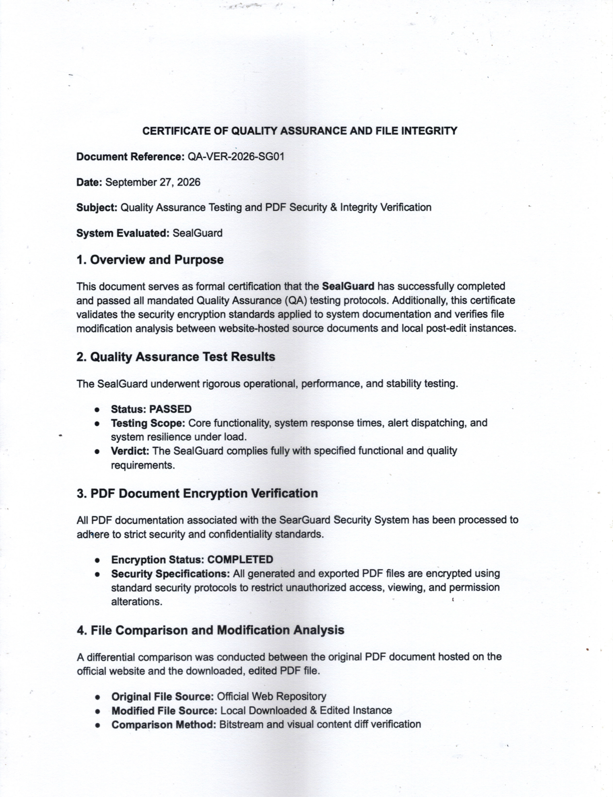

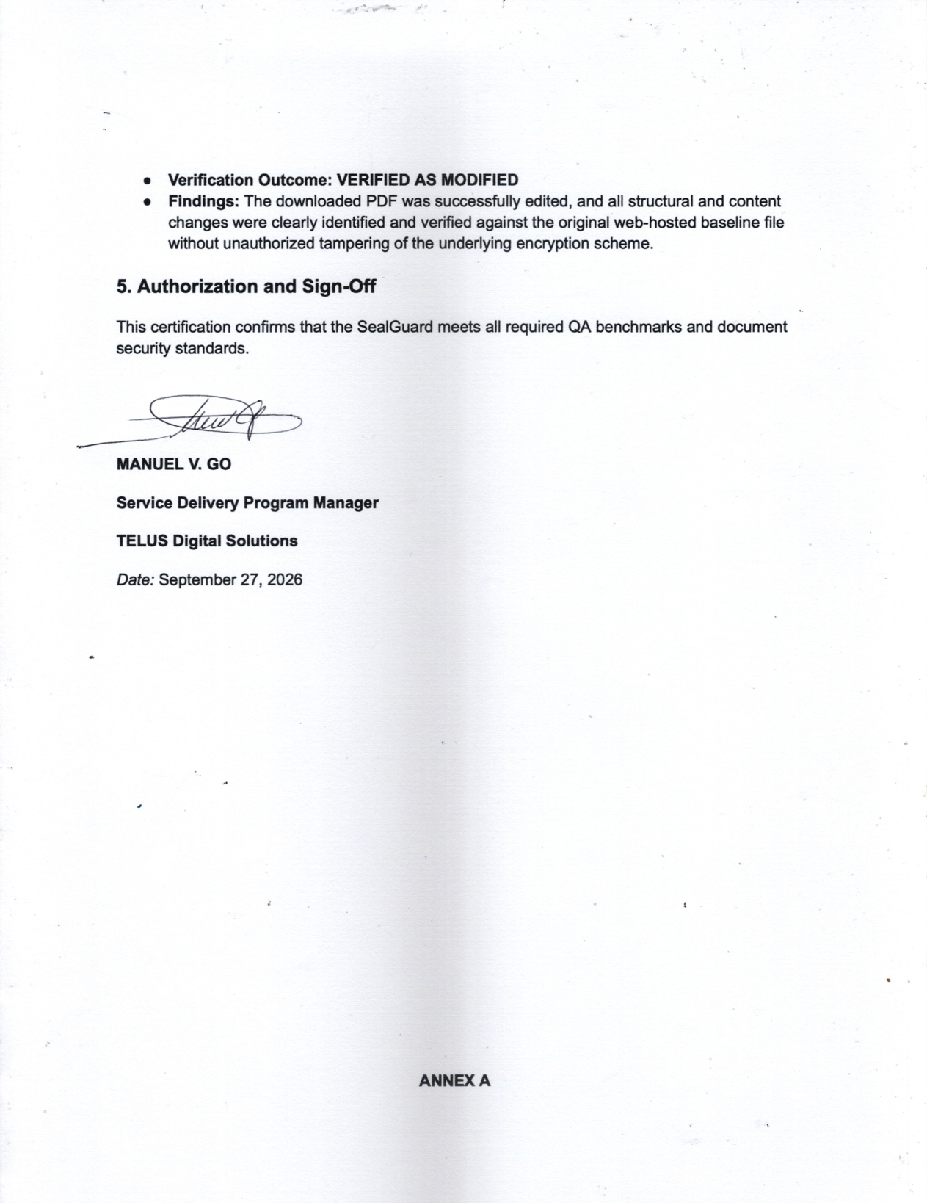
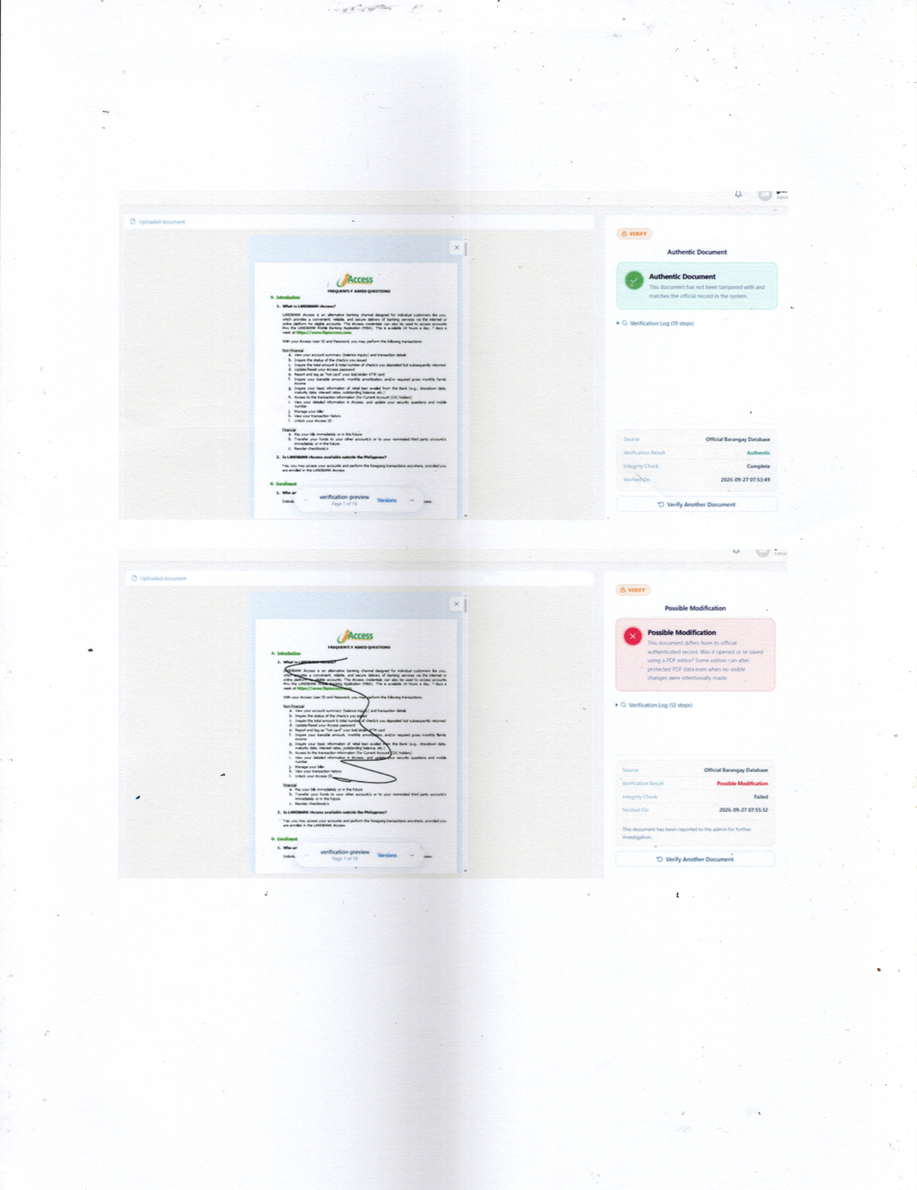

Appendix AO Mobile Authentication Testing
Test ID | Test | Planned Parameters | Expected Results
MOB-01 | Mobile authentication on Android | Sign-in, public browsing, document viewing, and public verification in Chrome on 3 Android phones (POCO F5, POCO F4, and Samsung Galaxy A24). | Pages, viewer, and verification remain usable without lost controls on all 3 phones.
MOB-02 | Orientation | Mobile authentication and document viewing in portrait and landscape on 4 devices: 4 x 2 = 8 checks. | Layout adapts without lost content or controls.
MOB-03 | Mobile authentication on iOS and iPadOS | The same workflows in Safari on an iPhone 13 and a 13-inch iPad Pro: 2 devices. | Same as MOB-01.
MOB-04 | Camera QR scanning | Physical verification of printed sealed documents on 5 devices under normal light, dim light, glare, an angled page, and partial blur: 5 x 5 = 25 checks. | Registered page identified; no failed scan reported as Authentic.
MOB-05 | QR verification response time | 130 QR checks: 90 registered codes and 40 unregistered codes (20 altered and 20 unrelated). | Correct response for every check; average, median, and 95th-percentile times recorded.
These tests evaluated mobile authentication on Android and Apple devices to confirm that document verification, viewing, and QR scanning worked correctly on phones and tablets.

Basis of Item Counts
Counts reflect the devices and conditions checked: three Android phones (MOB-01), four devices in two orientations (MOB-02, 4 × 2 = 8), two Apple devices (MOB-03), and five devices under five scanning conditions (MOB-04, 5 × 5 = 25). MOB-05 combines 90 registered and 40 unregistered QR codes (130).
Test ID | Count | How the count was obtained
MOB-01 | 3 | One check per Android phone.
MOB-02 | 8 | 4 devices × 2 orientations (portrait and landscape).
MOB-03 | 2 | One check per Apple device (iPhone and iPad).
MOB-04 | 25 | 5 devices × 5 scanning conditions (normal, dim light, glare, angled page, and partial blur).
MOB-05 | 130 | 90 registered QR codes and 40 unregistered codes (20 altered and 20 unrelated).

